PROJECT TITLE: ONLINE GIFT STORE

By Semester-VI of III Year M.Sc.(2023-24) Submitted By: -

1. Urvashi Padhiyar: - 3043
2. Sanskruti Darji: - 3200
3. Khushbu Parmar: - 3230 Group ID: - 26

Gift Store Name: - Glorious Gifts

Submitted to: -

K.S. School of Business Management and IT

M.Sc. - Computer Applications and Information Technology.





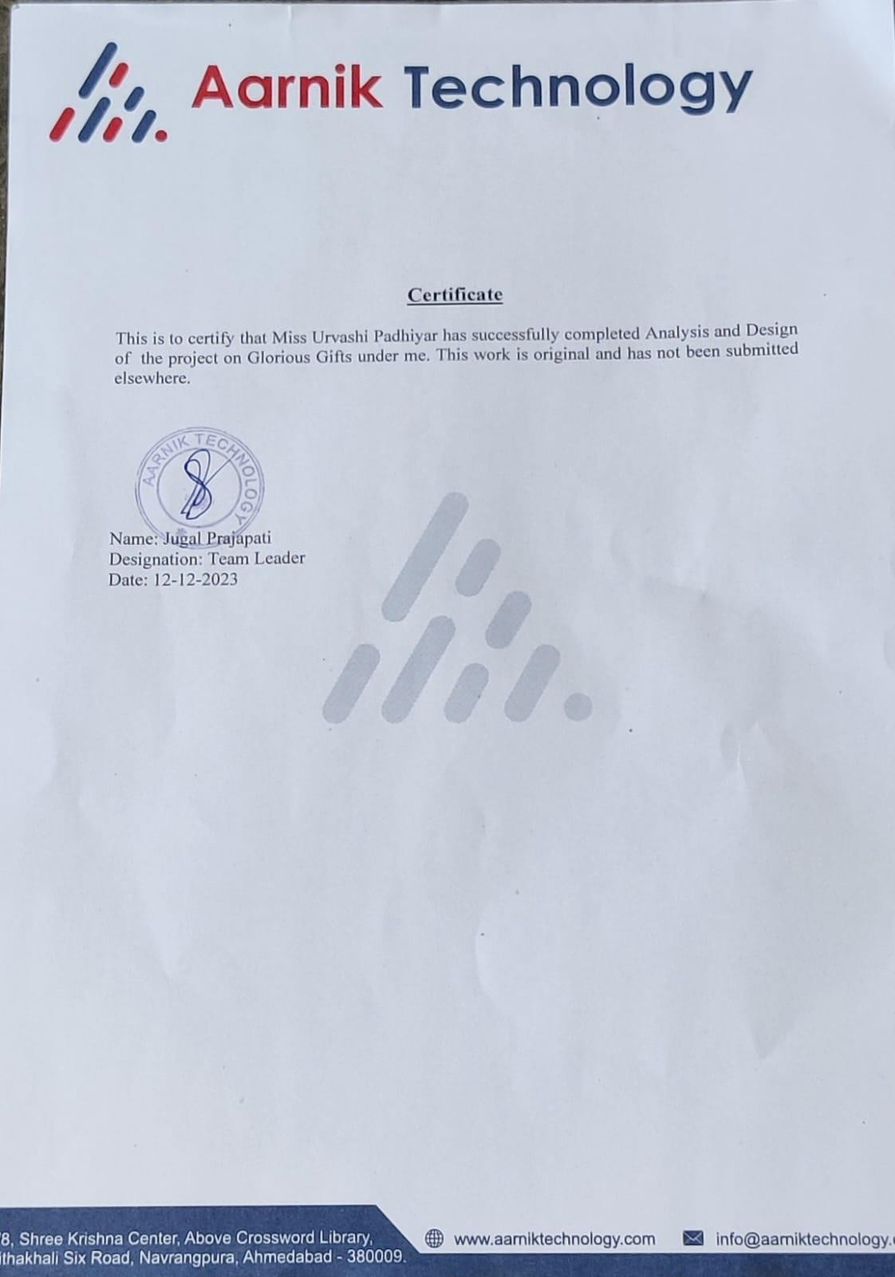

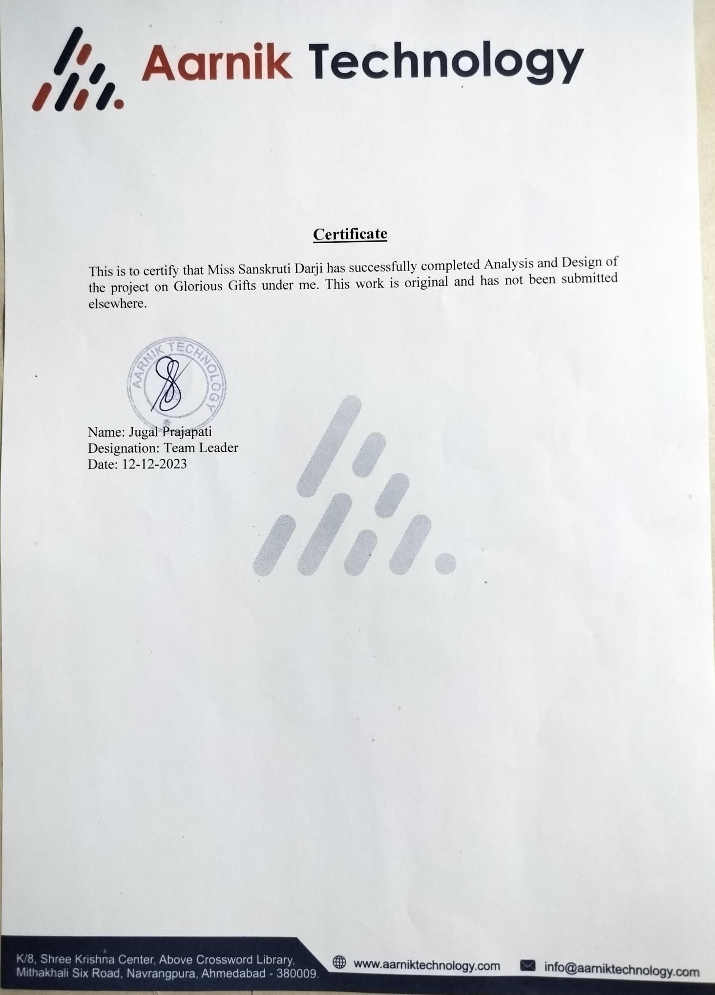

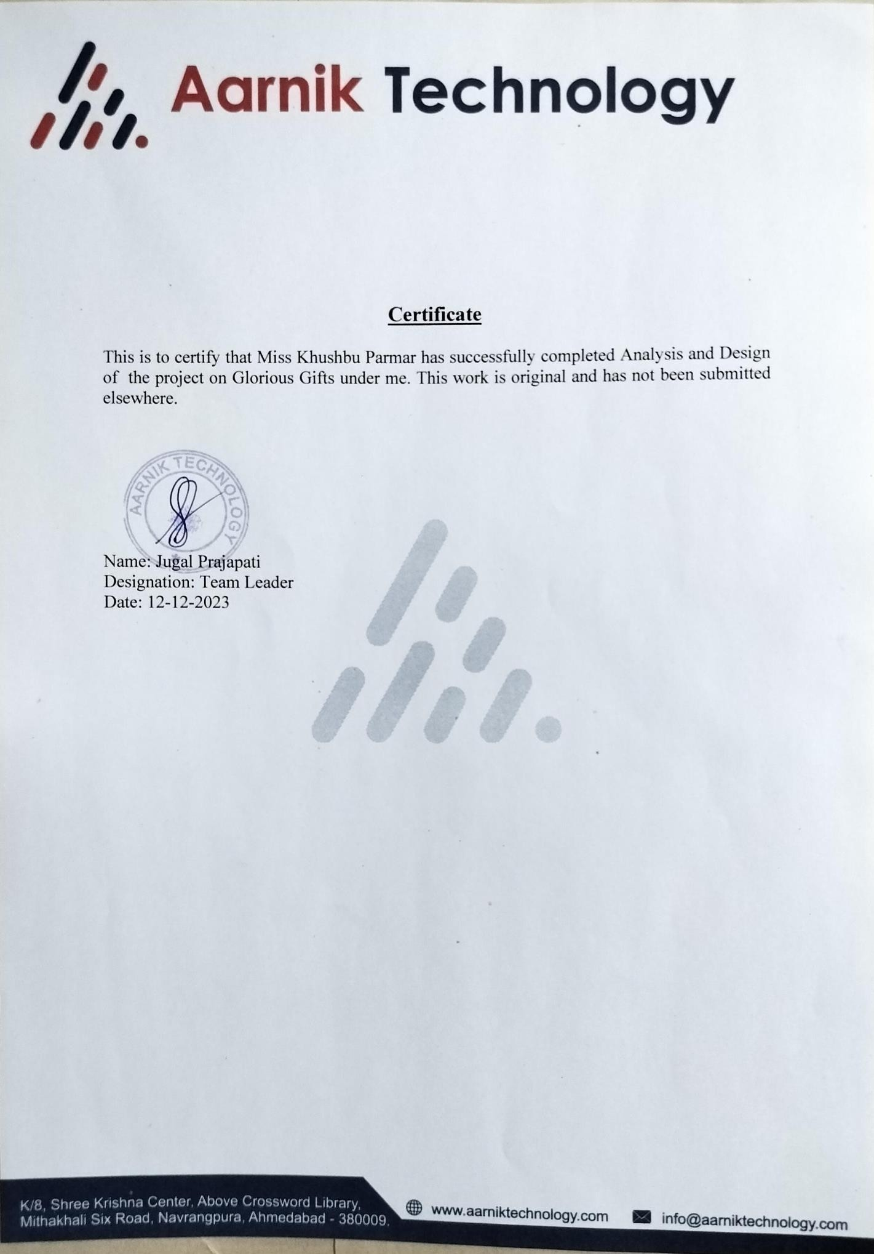

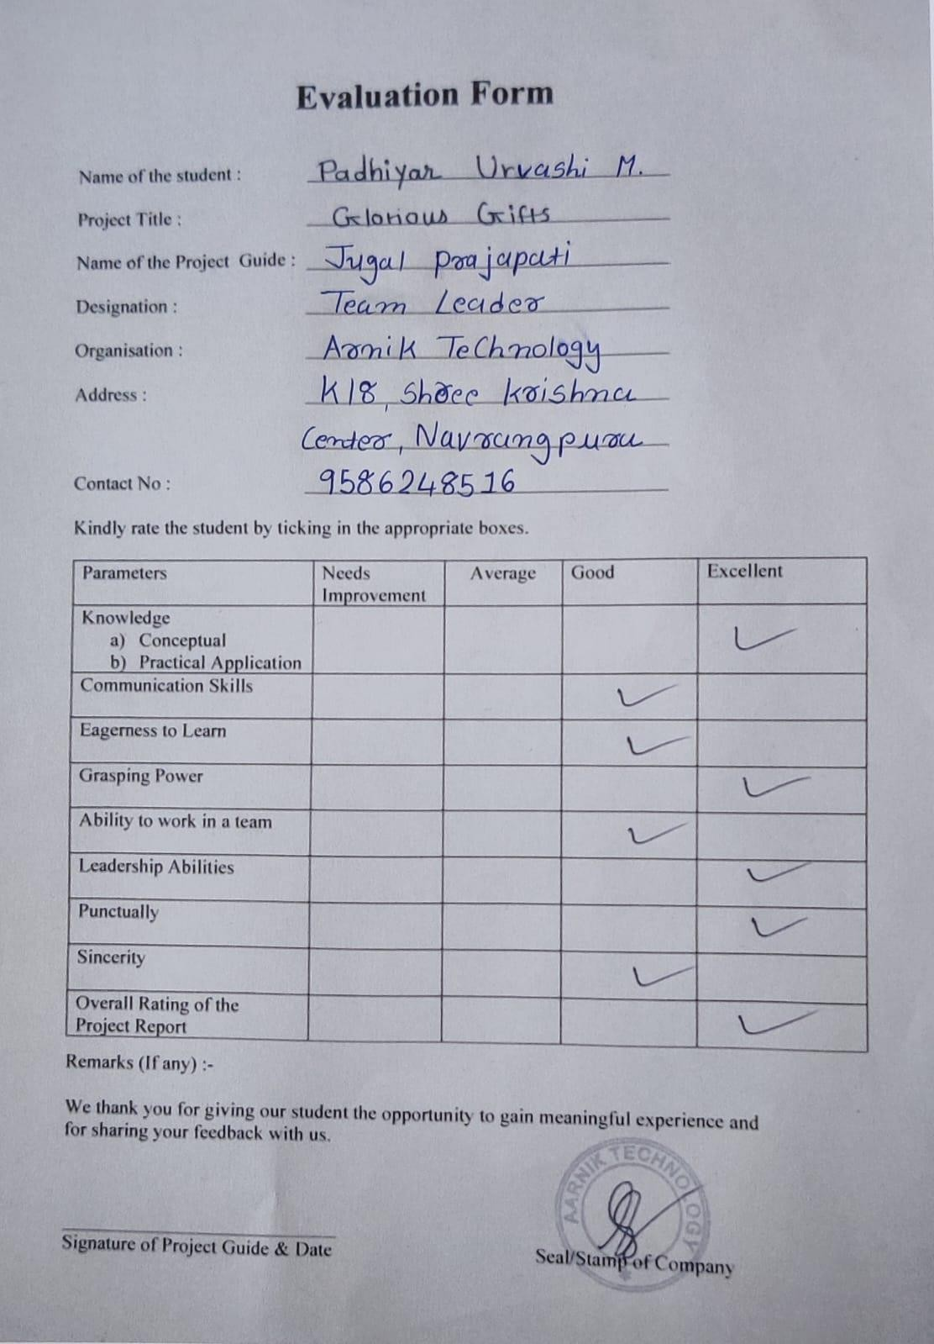

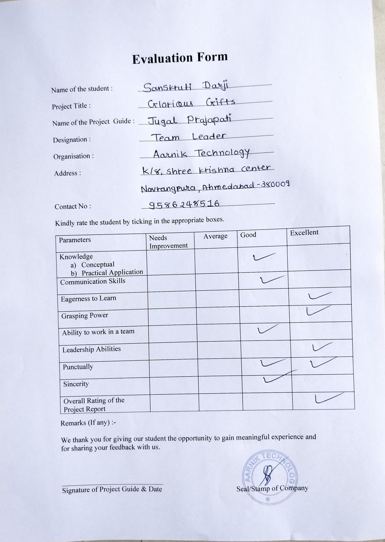

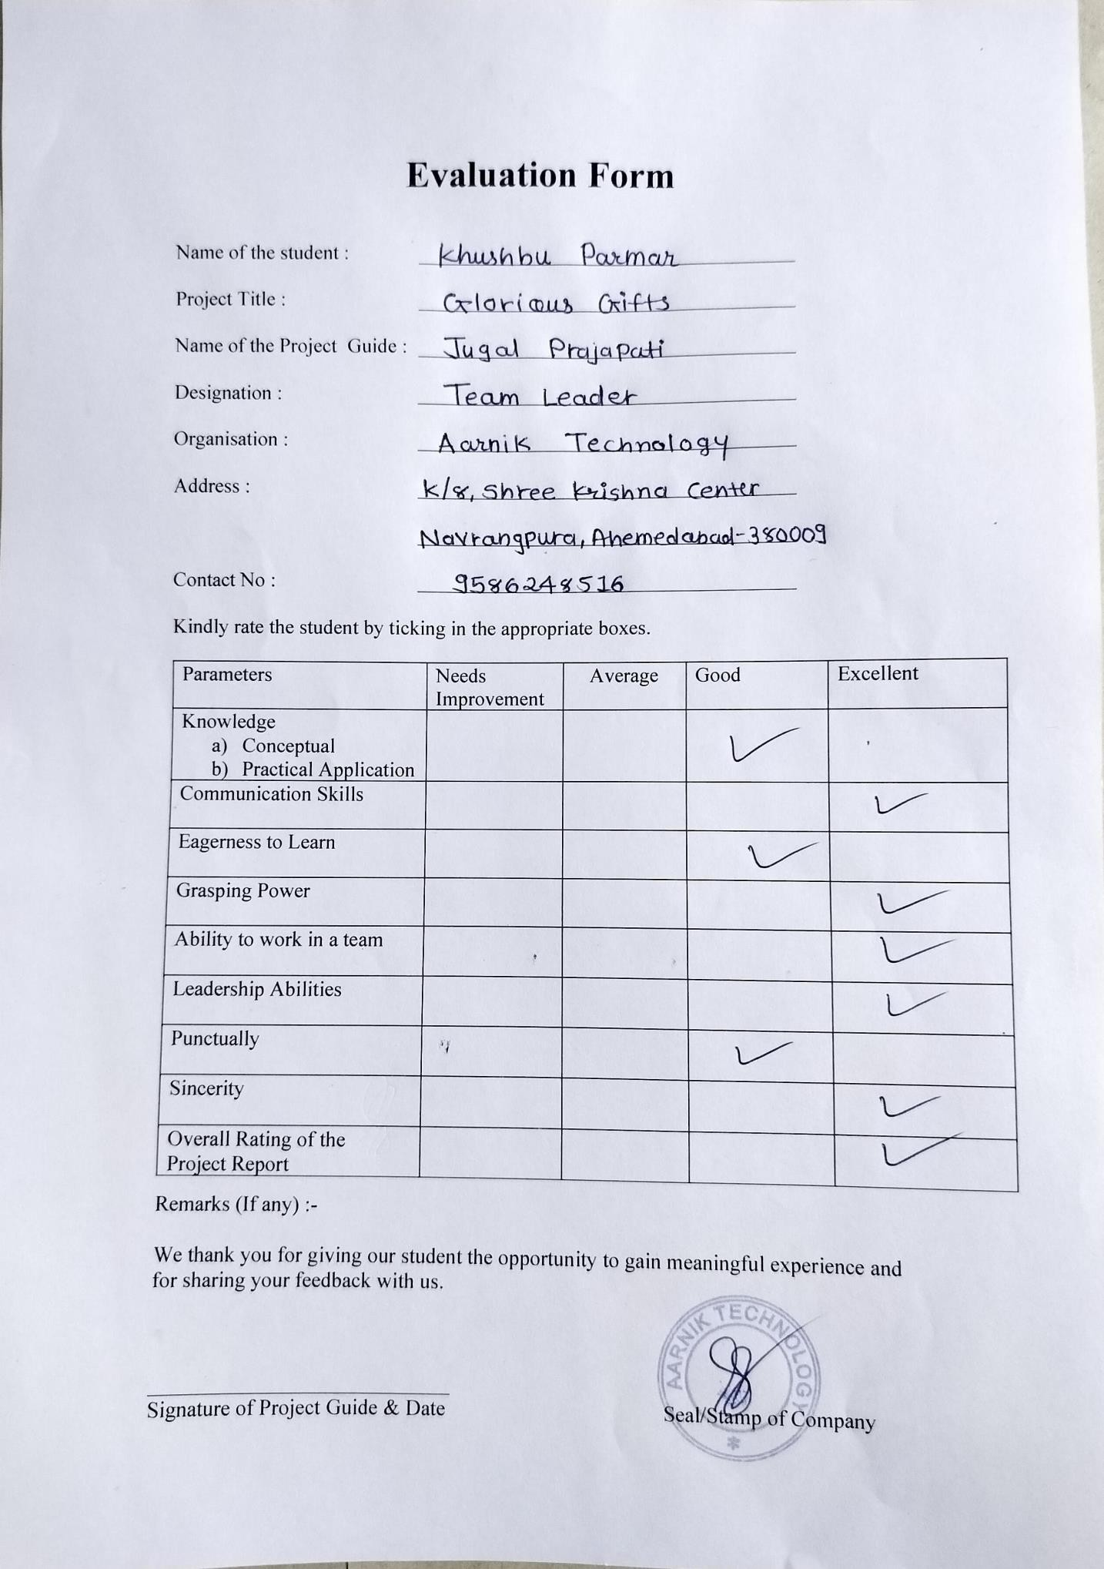







# ACKNOWLEDGEMENT

It was a great experience working on the project of “Glorious Gifts”. We express our Gratitude towards those who were constantly involved with us during our project. They will always occupy a special place in our heart, throughout our career, for both personal and professional reason. The phenomenon remains same that no project ever can be executed proficiently and efficiently without sharing the meticulous ideas, technical expertise and innovative thoughts put forwarded by technical and non-technical veterans. Whenever a technical project is developed, eventually it requires conductive technical environment and technical guidance to get involved in the assigned project enthusiastically.

We also grateful to Mr. Jugal Prajapati for being extremely friendly and co-operative during entire course of our project. Their continuous help and support made the project much easy. There is no exact word to express our regards and legitimate gratitude to one of our esteemed techno personalities, without him this project could not get an entrance towards the execution. Our project mentor is Mr. Sudeep Soni who availed this magnificent to us to move ahead.

He is always inspired and guided us for the right track to be followed for all the system analysis section of this project. Thank you for providing proper guidance.

Thanking You, 3043 Urvashi Padhiyar

3200 Sanskruti Darji

3230 Khushbu Parmar

**INDEX**

1. **INTRODUCTION**
   1. Organization Profile
   2. System Details
      1. Existing system
      2. Proposed system
   3. Scope of System
   4. Objectives

## PROPOSED SYSTEM REQUIREMENT GATHERING

* 1. Stakeholder of System
  2. Requirement gathering Technique used
  3. Consolidated list of Requirement
  4. Project Definition

## SYSTEM MANAGEMENT AND PLANNING

* 1. Feasibility Study
     1. Technical Study
     2. Economical Study
     3. Operational Study
  2. Hardware – Software Requirement
  3. System Planning
     1. Work Breakdown Structure
     2. Gantt Chart
  4. Process Model

## SYSTEM ANALYSIS AND PLANNING

* 1. UML (Unified Modelling System)
     1. Use Case
     2. Class Diagram
     3. Activity Diagram
     4. Sequence Diagram
  2. System Flow Diagram
  3. Data Dictionary
  4. User Interface
  5. System Navigation

1. **INPUT/OUTPUT DESIG**
2. **TESTING**
3. **Summary**

7.1 Assumption

7.2 Limitation

7.3 Future Scope

7.4 Conclusion

**Bibliography**

## Chapter 1

**INTRODUCTION**

In present time to sell any type of products and services one of the main things which one can do is an E-commerce store. Each and every businessman who want to make more customers attract with the system and want more benefits the first thing they look for is an online store which can engage customers which are not in the range of the local shop. To do business e-Commerce is the revolutionized way for the companies. In present time all the customers want to purchase things 24*7 with the device which is in their hand and for fulfilling that thing. Each and every thing comes with some good and some bad things and an E- commerce store can be also one of them. Some good things about an E-commerce store are it’s easy to use and also convenient, it can decrease the cost of maintaining the things manually and also get benefits of time saving, money saving and man power saving.

Information which a business is storing manually they can store multiples of times information with the help of Information and technology and with use of database and E- commerce.

## General purpose of the Glorious Gifts

Our main aim is to provide the customers with their desire gifts. We are also providing the gifts for every person from kids to old age people.

## Why we should Choose Glorious Gifts?

The main focus of the Glorious Gifts is to provide Customer with the best quality of the gifts within shortest time. Glorious Gifts also provide the information for upcoming latest brand of the gifts with notification.

## How Glorious Gifts is useful to Customers?

Glorious Gifts provides the suggestion box to the customers for getting the suggestions of the gifts within a few seconds and they also get the suggestions through the WhatsApp.

## [1.1] Organization Profile:

Name of organization: Aarnik Technology

Address: K8 Shree Krishna Center, Navrangpura, Ahmedabad, Gujarat 380009 Contact: 9586248516

E-mail: [info@aarniktechnology.com](mailto:info@aarniktechnology.com)

## [1.2] System Details:

### Existing System:

* + - * Currently, we do not have any system for gift selling, all work is done manually.
      * In Existing system customers have to visit the shop and select the gifts what they want to buy. Which is time consuming.
      * It is Online and interactive web application where the customers can view the variety of Gifts products for different occasion and for different persons (for different age group people) which will save their time.
      * We have referred some website like: - <https://www.winni.in/gifts> [https://giftcart.com](https://giftcart.com/) [https://www.indiagift.in](https://www.indiagift.in/) [https://www.giftalove.com](https://www.giftalove.com/)

### Proposed System:

* + - * The proposed system has many advantages over existing system.
      * Our proposed system will work in less time and effort for selling gifts with more efficiency and productivity of work.
      * Though, our current system and proposed system are differed.
      * We will be going to add so many new features and functionality in proposed system which would make our shop much better for easily reaching out to our customer.
      * Some of the functions of our proposed system that attract customers to choose our website to buy gifts:
      * Suggestion box that suggests customer according to age group to buy gifts.
      * Customers will get notification as new gifts uploaded on our website to buy it with discount.
      * Take help for alteration.

## [1.3] Scope of System:

* Simply go to website do sign up and login in our system.
* After that, you can search for gifts, get suggestion and detail about trendy fashionable gifts and can purchase anytime at Glorious Gifts.

## [1.4] Objectives:

* People can send their feedback and we also work on it as per their feedback we try to improve functionality and services.
* Customers can return, exchange gifts and also take help if require.
* Without using any type of marketing, we can create a large number of customer range with a good website which is user friendly and very helpful.
* Glorious Gifts is here to provide immediate service through store also.

## Chapter 2

**PROPOSED SYSTEM REQUIREMENT AND GATHERING**

## [2.1] Stakeholders of System:

There are 3 stakeholders for our website:

* + Admin
  + User
  + Visitor

## Admin:

* Admin will be log in website and can view order details and customer details.
* Admin can Reviews web content, links, and design, provides necessary updates and enhancements in a timely manner.
* Admin would confirm the product for adding it into website.
* Admin will Monitors site security, reports suspected or actual security breaches and denial of service attacks to appropriate staff.

## User:

* To buy any product user will have to first register themselves.
* After registration user will have to log in with the correct password and the email id.
* User can search any gift products and buy it with minimum period of time.
* User can get discount and free delivery on their first order. If the user forgets their password, then they can reset it using verification code provided by server.

## Visitor:

* Visitors are the general people who visits the website but not registered.
* They can see the products, read the description and other stuff of website but they can’t perform any action.

## [2.2] Requirement Gathering Techniques:

“Requirements gathering is the process of determining what your projects need to achieve and what needs to be created to make that happen”. 47% of unmet project goals tie back to poor requirements management.

1. Questionnaires
2. Interview
3. Observation
4. Group Interview
5. Prototyping
6. Document Analysis
7. Survey
8. Brainstorming

In which, we are selecting Questionnaires Technique for our System to make a better Performance in Requirement Gathering.

### Questionnaire: -

Questionnaires are much more informal, and they are good tool, together requirement, from stakeholders in remote locations. In this create the form of questions and give it to the owner of the organization to complete it. So that, we easily get the requirement for the system. The questionnaires are as follows:

* How do you handle current system?
  + By record the data in manually.
* What’s the requirement to build the computerized system?
  + To make Process easy for users and for us also.
* How does Glorious Gifts communicate with the user?
  1. Telephone
  2. Computer (Mail/SMS)
  3. Cell Phone
  4. At store
  5. Other
* Is there any web-based system for your organization?

1. Yes
2. No

* Which method you prefer to do online payment?

1. Cash on Delivery
2. By Online
   * How do you manage the Glorious Gifts details?
3. In files
4. in computers
   * How do you provide the invoice details to the customers?
     + Manual bill.

## [2.3] Consolidated List of Requirements:

* Simple and user-friendly interface.
* An easy to use.
* Order cancelled should be notified to the Admin.
* Order management, security, search product, category are very easy to access.
* Return policy and Replacement policy are also included.
* When order placed at that time the email notification will send.
* Platform to store information about user and products.
* Access level will be filtered according to their role in the organization.
* Specific window will open after login by specific user.
* Password will store in a database in a unique key format (encrypted password).

**[2.4] PROJECT DEFINITION**

* **Project title**: - Glorious Gifts

 **Project definition**: -

This website is online gift shopping website for user. It aims at providing best services as per the user’s desire requirement of gifts. Our website will show all kinds of gifts in different categories. User can browse any products and buy it. User can order the gifts products by online payment and also through cash on delivery.

Firstly, the people go over to see many gift products as per their requirement manually which is basically a waste of time. Through this, peoples can choose best gift for different occasion for different person and much more on best price. Peoples sitting at home can get all the information of the gifts products they would like just at one click. Peoples can order gifts, get the price details, get to know about others reviews, can provide their personal feedback and much more.

User can get the suggestion at home through the suggestion box and also can get the suggestion through talking with us on WhatsApp and this feature helps the users to save their time as well to find out their desire gift.

User can also search the gifts products on search bar and also through the voice feature of search bar.

# Chapter 3

## System Management and Planning

Planning is one of the most important parts of any project. Proper planning is needed to execute any project or running a company. With proper planning team or an individual get a perfect idea about scope and appropriate methods for completing the project.

## [3.1] Feasibility study:

A feasibility study is a detailed analysis that considers all of the critical aspects of a proposed project in order to determine the likelihood of it succeeding.

Although feasibility studies can help project managers determine the risk and return of pursuing a plan of action, several steps should be considered before moving forward.

The main aim of the feasibility study is to determine that it would be financially and technically feasible to develop the System. The purpose of feasibility study is not to solve the problem, but to determine whether the problem is worth solving.

Types of Feasibility:

* + Technical Feasibility
  + Economic Feasibility
  + Operation Feasibility

### [3.1.1] TECHNICAL FEASIBILITY

* + - “The process of proving that the concept is technically possible”.
    - The technology is stable and established, resource is easily available/accessible and also expertise is available. No special hardware or software is required. So, the system is technically feasible.
    - Internet is required to use the system.
    - The technical feasibility will usually result in knowledge about the product or process design, performance, production requirements, and preliminary production costs.
    - If the system is capable of producing outputs in a given time, response time a under certain conditions and the organization is having the required gadgets then proposed system can be technically feasible.

### [3.1.2] ECONOMIC FEASIBILITY

* As there is no paperwork required so it reduce the cost of working it manually.
* All people are aware of new technology so there is no problem to run the system and no special skills are required.
* To use and make the system nominal cost is required at client side and server side some hardware and software required only.
* At the time of development there should be one thing in mind that the system should not much costly to develop.
* Economic feasibility means to analyses economic factor while developing or working on any project.

### Possible questions raised in economic analysis are:

* + Is the system cost effective?
  + Do benefits outweigh cost?
  + The cost of doing full system study
  + The cost of business employee time
  + Estimated cost of hardware

### [3.1.3] OPERATIONAL FEASIBILITY

* “Operational feasibility is the measure of how well a proposed system solves the problems, and takes advantages of the opportunities identified during scope definition and how it satisfies the requirements identified in the requirements analysis phase of system development”.
* Operational feasibility is a critical aspect of systems engineering that needs to be an integral part of the early design phases.

## [3.2] Hardware and Software Requirement:

### SYSTEM REQUIREMENT



|  |  |  |
| --- | --- | --- |
| **Platform** | **Frontend** | **Backend** |
| **PHP** | **HTML CSS**  **JavaScript** | **MySQL** |

* **HARDWARE REQUIREMENT**

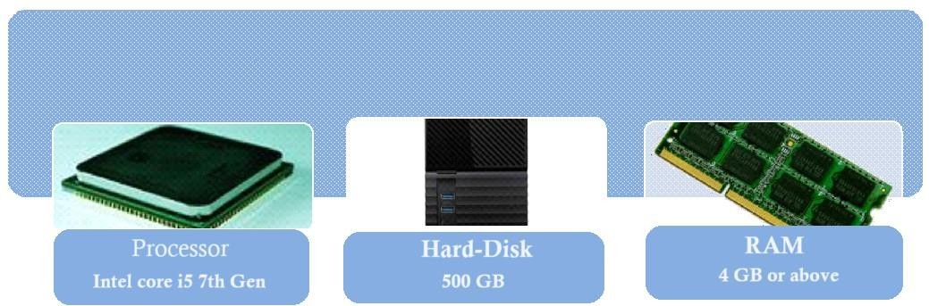

## [3.3] System Planning:

Here’s some points about System planning,

1. Work Breakdown Structure.
2. Gantt chart.

### WORK BREAKDOWN STRUCTURE:

* Definition of Work Breakdown Structure-

“Deliverable oriented hierarchical decomposition of the work to be executed by the project team”.

-Project Management Institute (PMI).

Project Management Book of Knowledge (PMBOK)

* A work breakdown structure can show control points and milestones.
* WBS provides the visual of entire scope.

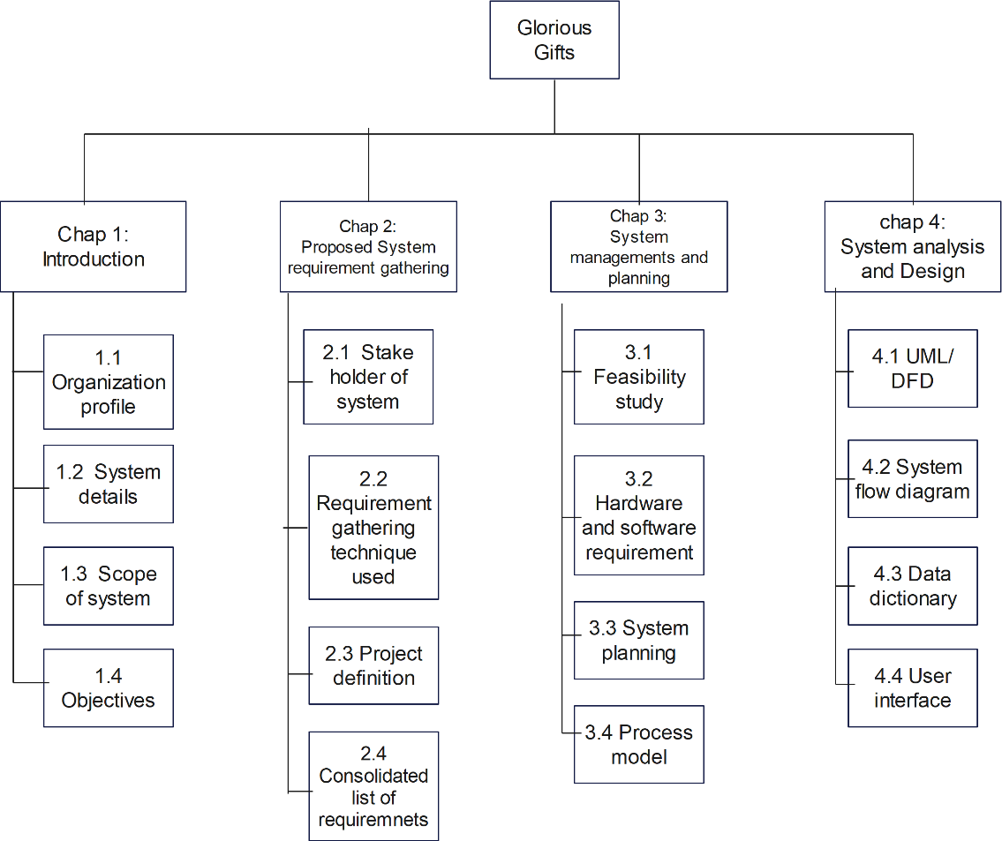

### GANTT CHART

* A **Gantt chart** is a horizontal bar chart developed as a production control tool in 1917 by **Henry L. Gantt**, an American engineer and social scientist. Frequently used in project management, a Gantt chart provides a graphical illustration of a schedule that helps to plan, coordinate, and track specific tasks in a project.
* A Gantt chart, commonly used in project management, is one of the most popular and useful ways of showing activities (tasks or events) displayed against time.
* On the left of the chart is a list of the activities and along the top is a suitable time scale.

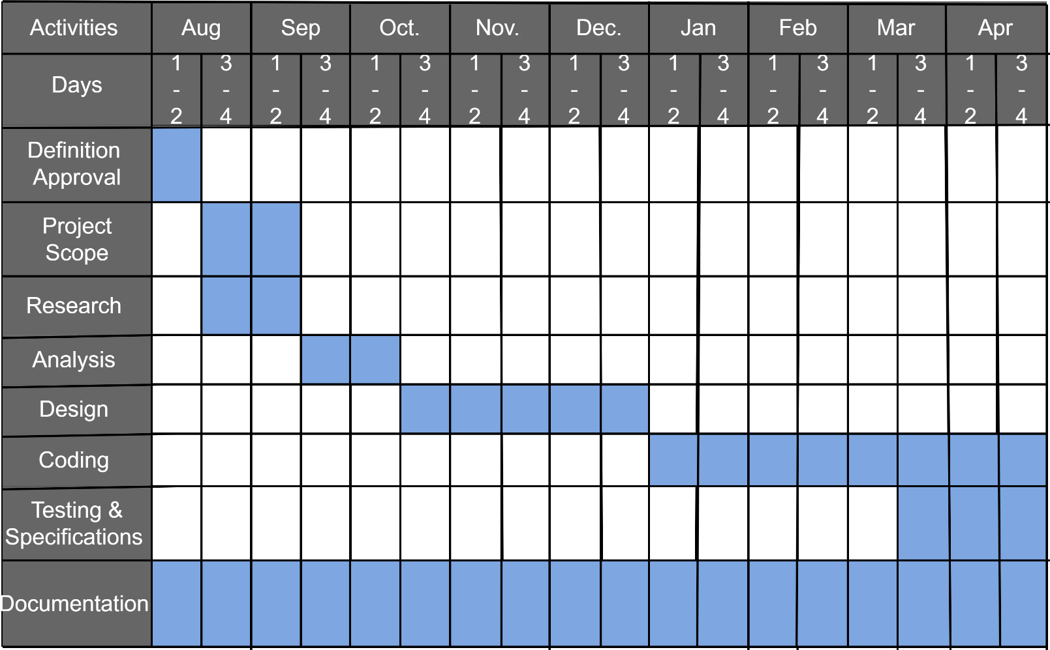

## [3.4] Process Model: -

There are many processes model available as shown below. For our system we are going to use Incremental Model.

1. Waterfall Model
2. Incremental Model iii. Prototype Model
3. Spiral Model
4. Concurrent Model

### Incremental Model: -

* Incremental model in software engineering is one which combines the element of waterfall model which are then applied in an iterative manner. It basically derives a series of release called increments which provide progressively more functionality for the client as each increment is delivered.
* In incremental model of software engineering, waterfall model is repeatedly applied in each increment. The incremental model applies linear sequence in a required pattern as calendar time passes. Each linear sequence produces an increment in the world.

### Diagram of Incremental Model

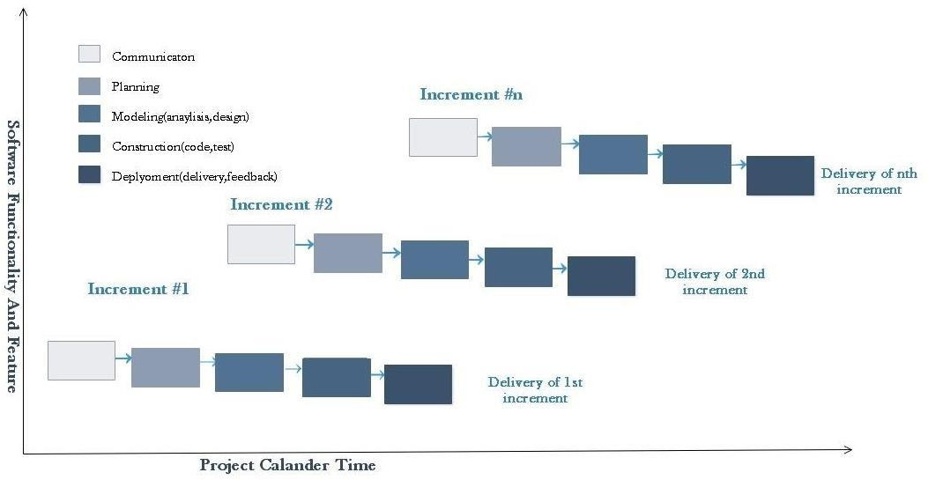

* + **Why Incremental Model:** -

Though there are many system development models are available, but incremental model is more suitable as per our project Definition and other criteria (time, team members) of the project.

Here`s the main reason of using the advantages of incremental model:

* Errors are easy to be recognized.
* This model is more flexible- less costly to change scope and requirements.
* It is easier to test and debug during a smaller iteration.
* In this model customer can respond to each activity.
* Lower initial delivery cost.
* This process model helps to manage technical risk.
* Initial product delivery is faster.
* Risk of changing requirement is reduced.

### Disadvantages of Incremental Model: -

* Total cost is high.
* Need for good planning and designing.
* Each face of iteration is Digit.
* Each iteration phase is rigid and does not overlap each other.
* Well defined module interfaces are needed.

## Chapter 4

**[4.1] UML Diagram**

### [4.1.1] Use case:

* + The use case model for system consists of a set if use users can use cases. Intuitively, use cases represent the different ways in which a system. Following is the use case representation of the advantages immigration system.
  + Use case diagram is a graphic depiction of the interactions among the elements of a system. A Use case is methodology used in system analysis to identify, clarity and organize system requirements.

|  |  |
| --- | --- |
|  | **Boundary of the System** |
|  | **Actor of the system** |
|  | **For Use case** |
|  | **Connector between the Actor and Use case.** |

### Admin Usecase

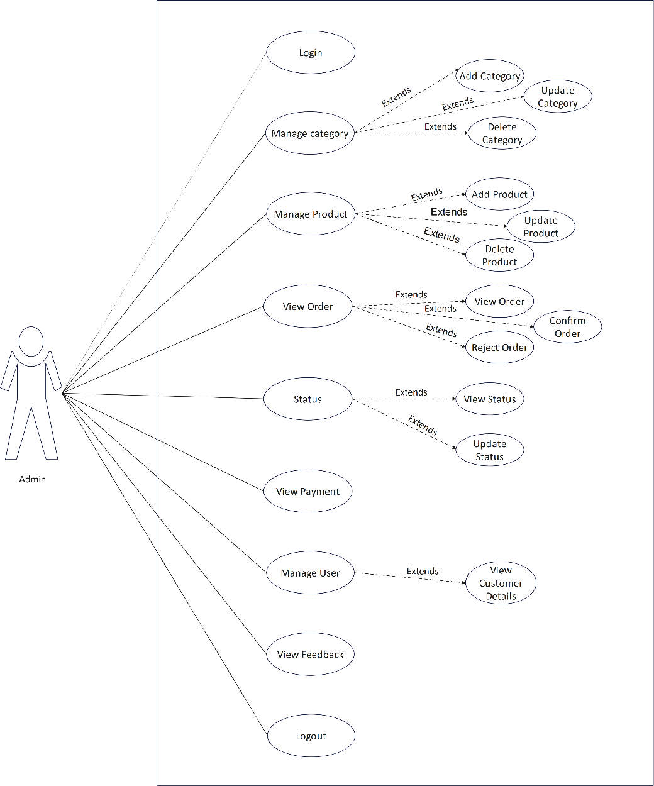

* + **User Usecase**

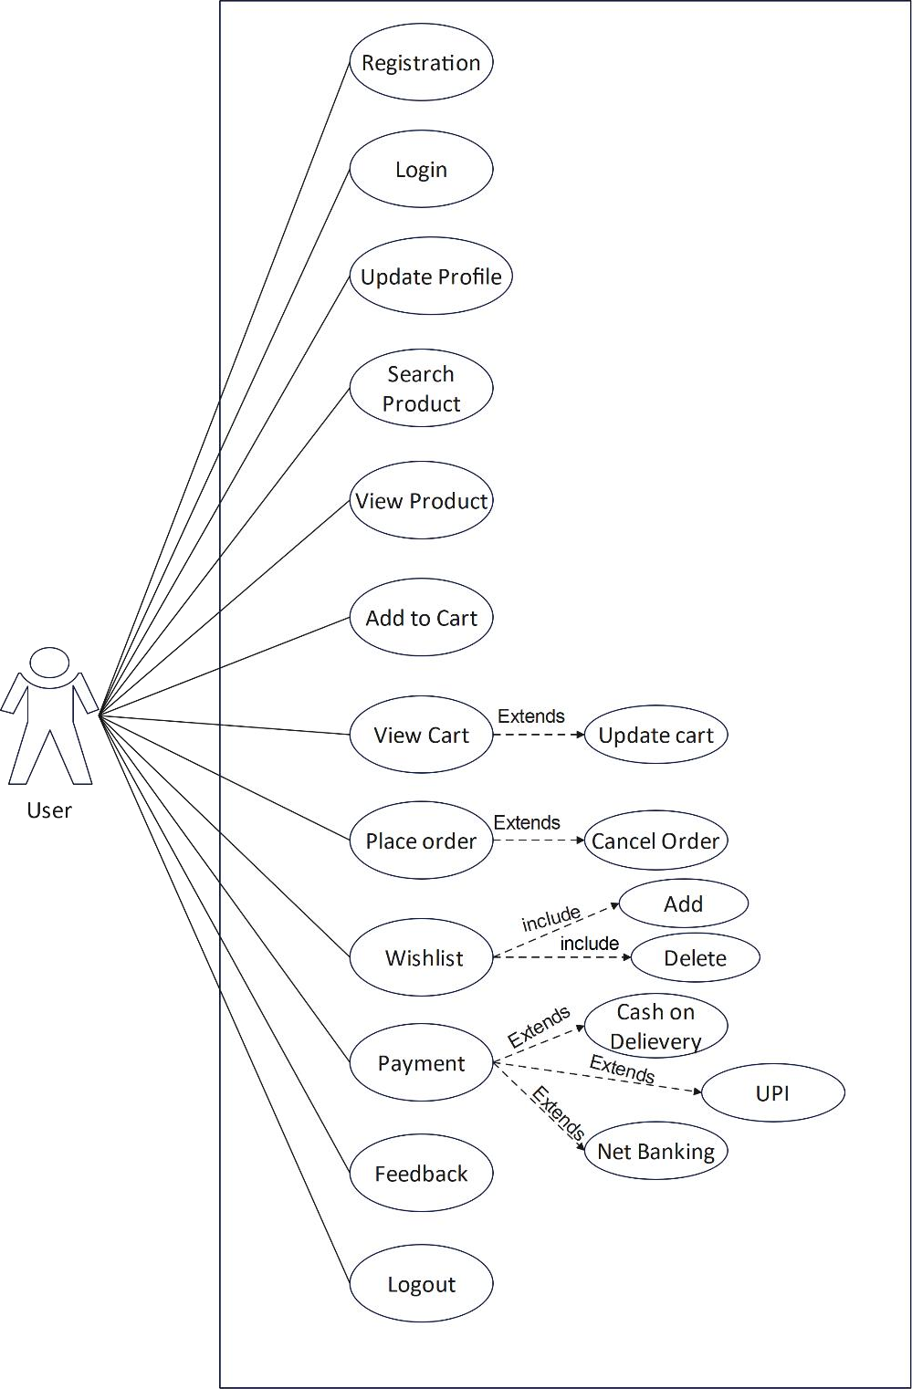

### Visitor Usecase

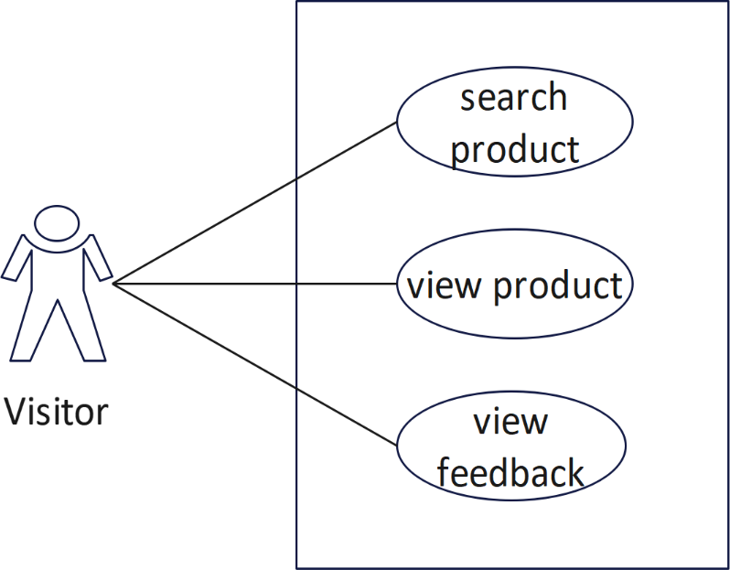

**[4.1.2] Class Diagram**

A class comprises of three sections:

* 1. Class name
  2. Structure(attributes)
  3. Behaviour(operations)

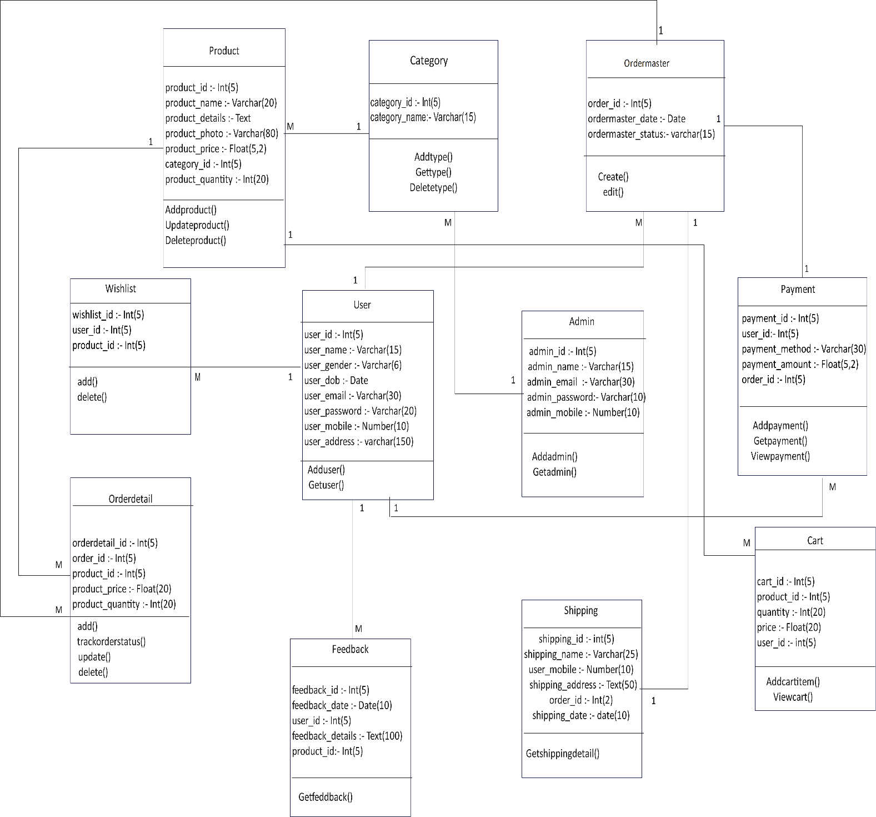

### [4.1.3] Activity Diagram:

Activity diagram is another important diagram in UML diagram describe dynamic aspects of the system. Activity diagram is basically a flow chart to represent the floe form one activity to another activity. The activity can be described as an operation of the system.

### Activity Admin

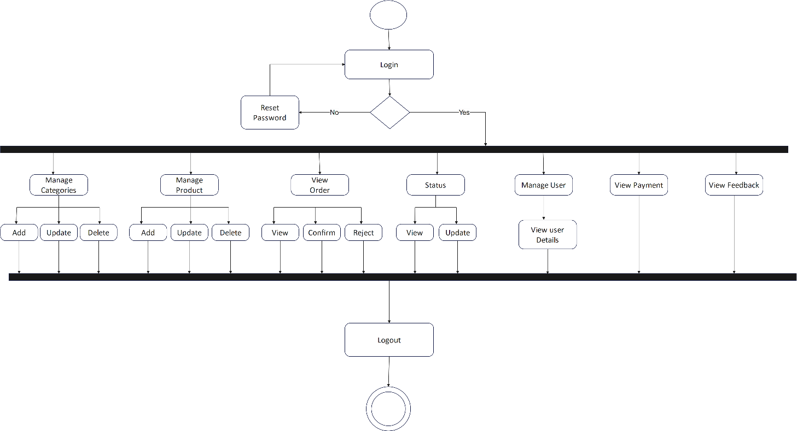

* + **Activity User**

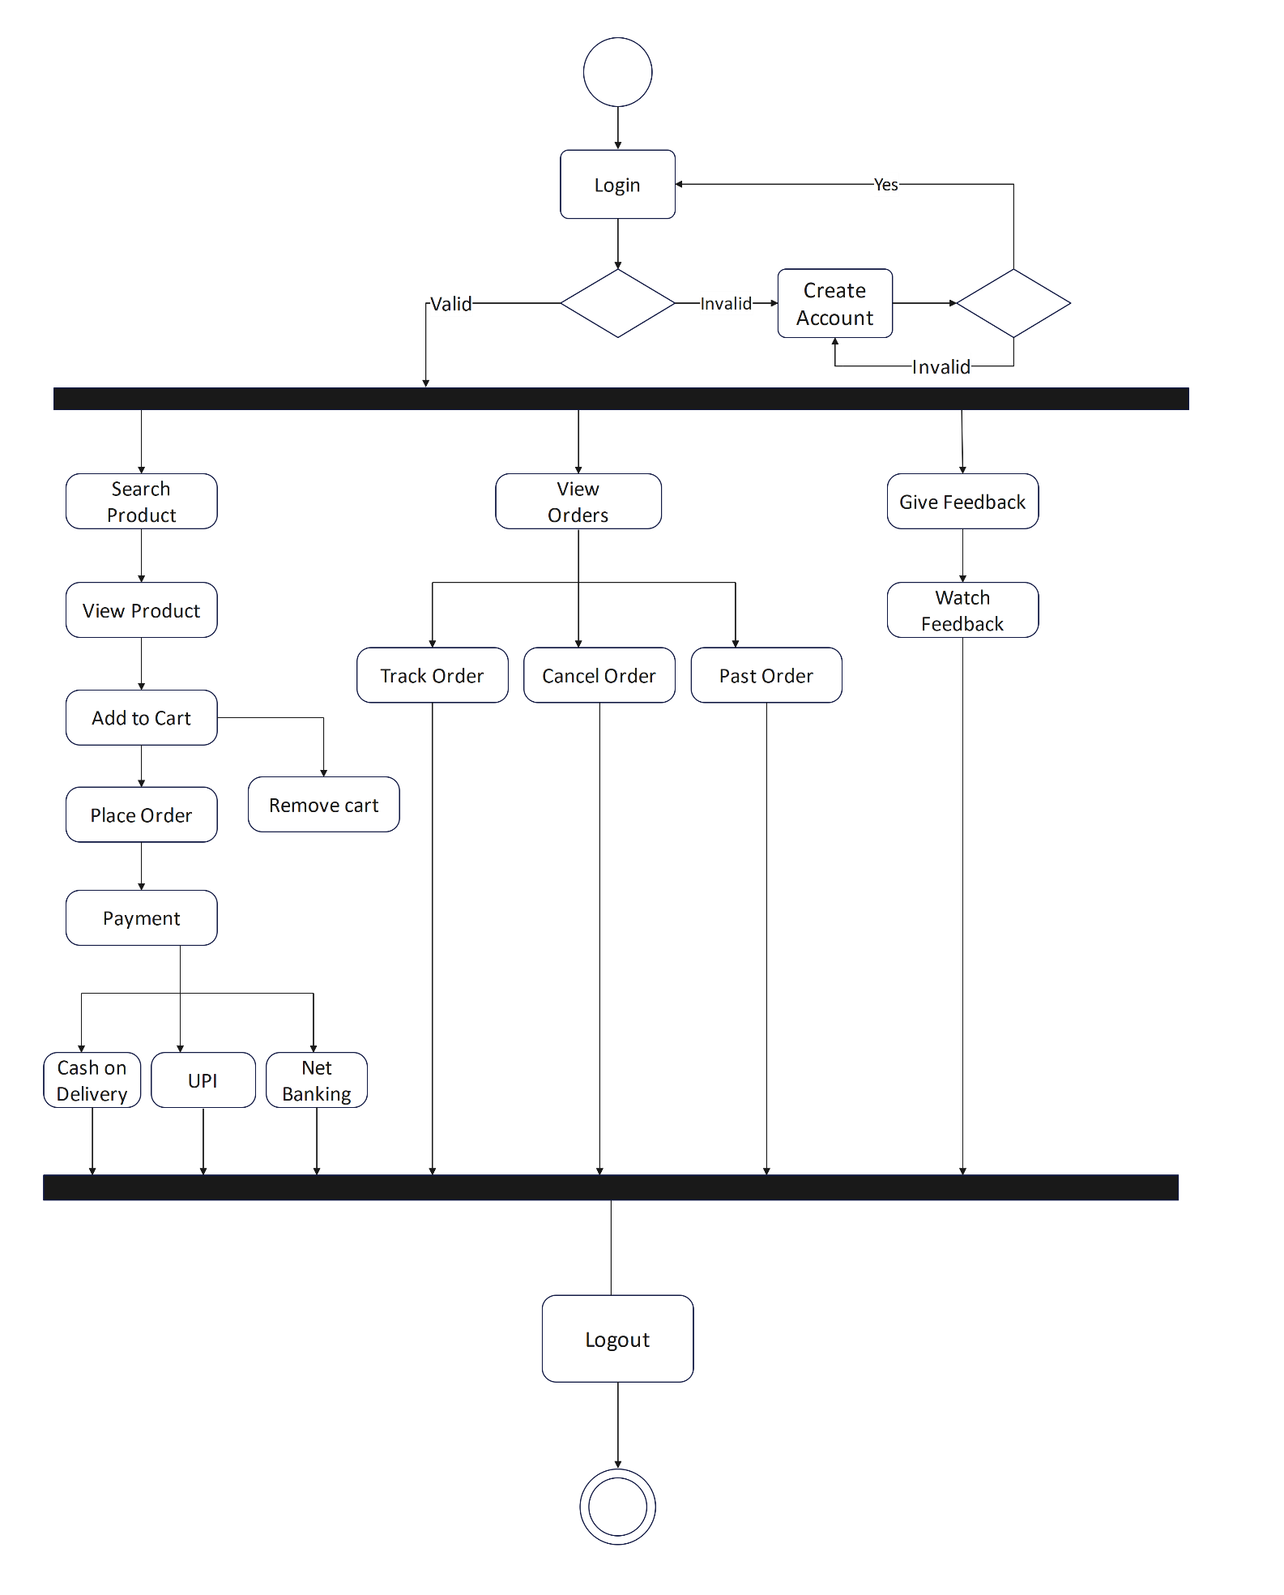

### Activity Visitor

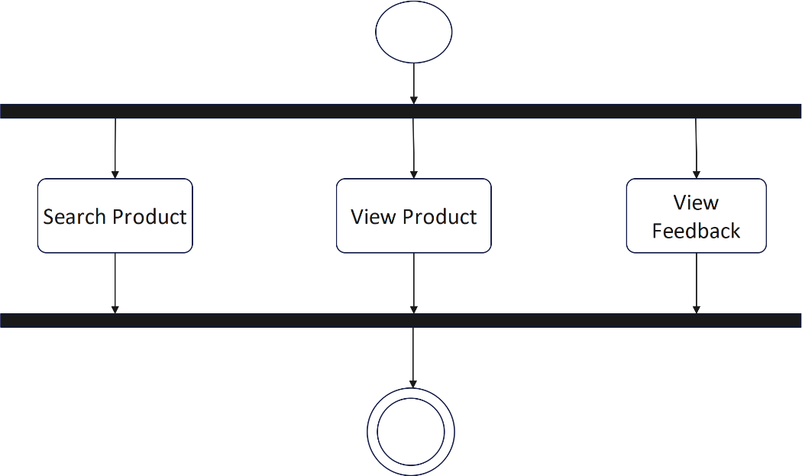

**[4.1.4] Sequence Diagram:**

* + - A sequence diagram simply depicts interaction between objects in a sequential order.
    - A sequence diagram is an interaction diagram that shows how objects operate with one another and in what order objects. In is a construct of a message sequence chart. A sequence diagram shows object interactions arranged in time sequence.

|  |  |
| --- | --- |
|  | Arrow represents and event occur between objects. |
|  | Rectangle represents Objects in Diagram. |
|  | Represents the Time occur between request and response of the object. |
|  | Back arrow represents response of the event to the objects. |

### Registration & Login Sequence Diagram: -

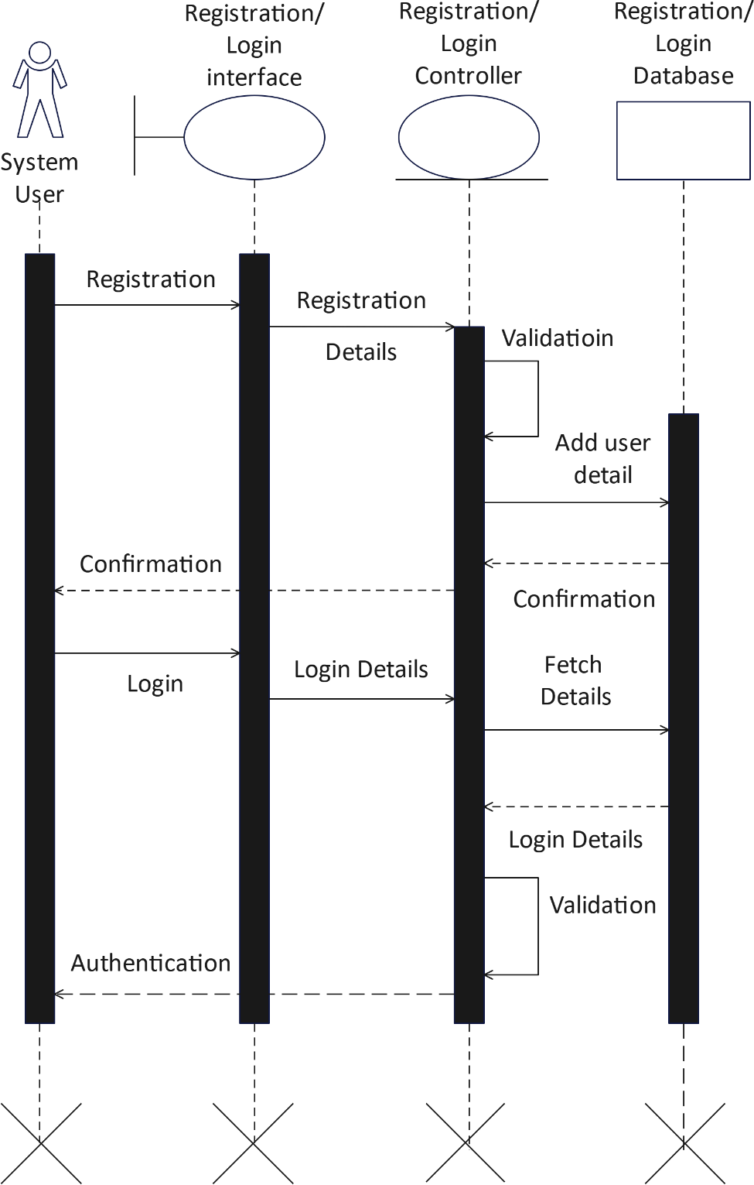

* + **Sequence Diagram for Admin: -**

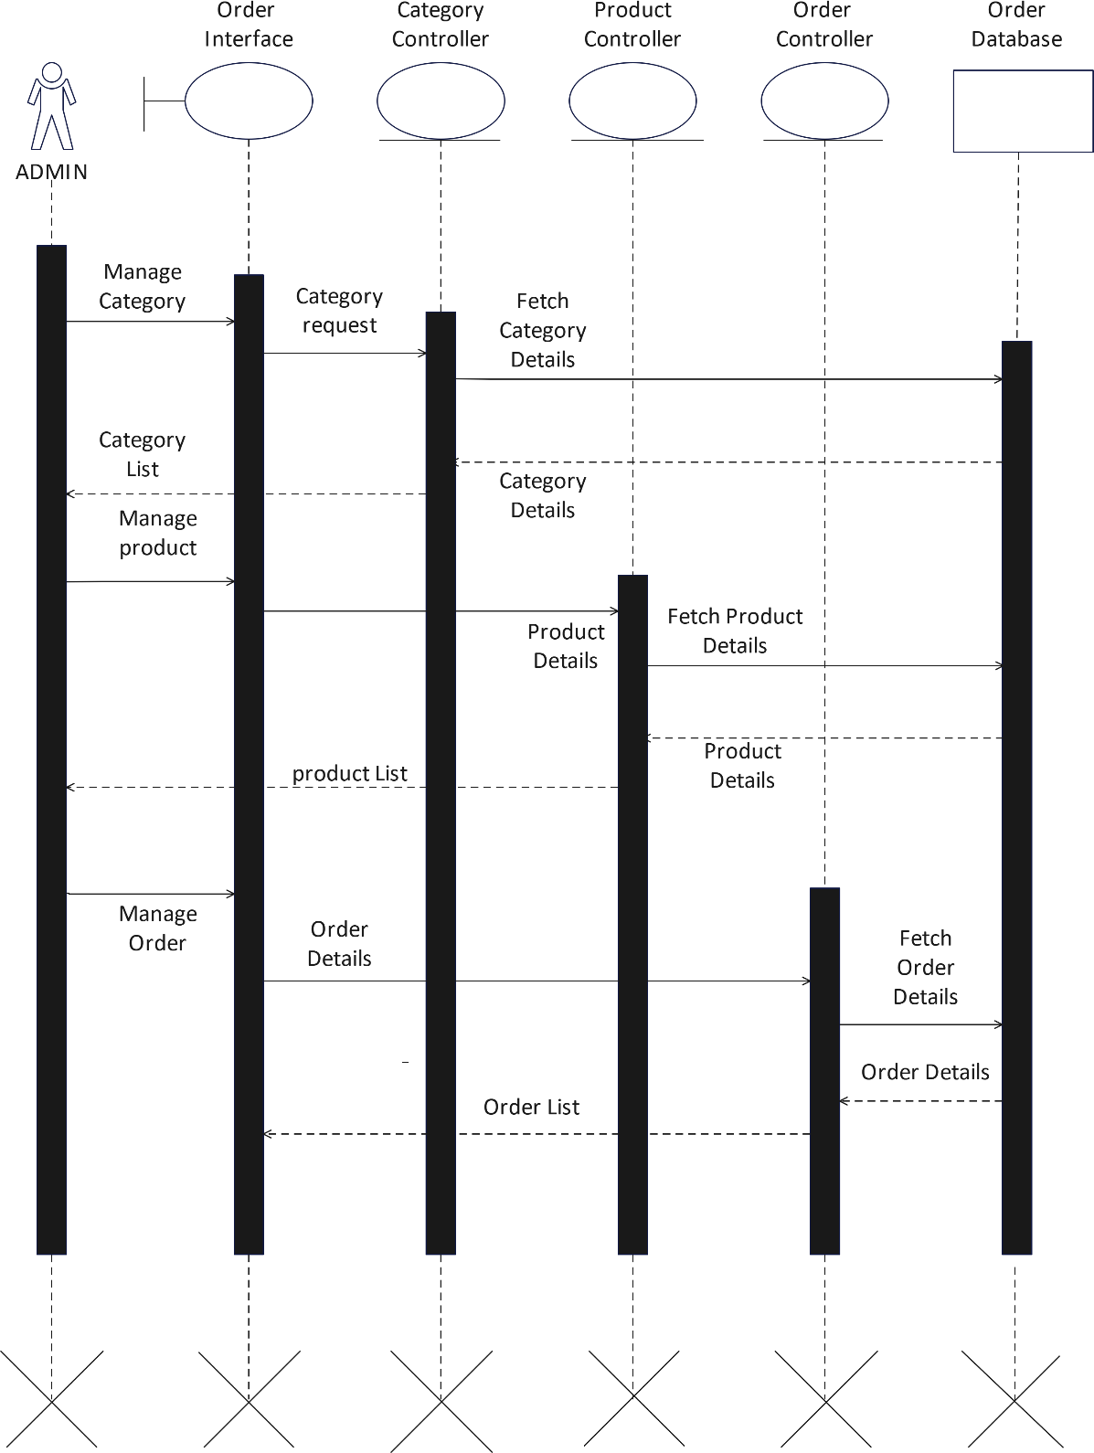

### Sequence Diagram for User: -

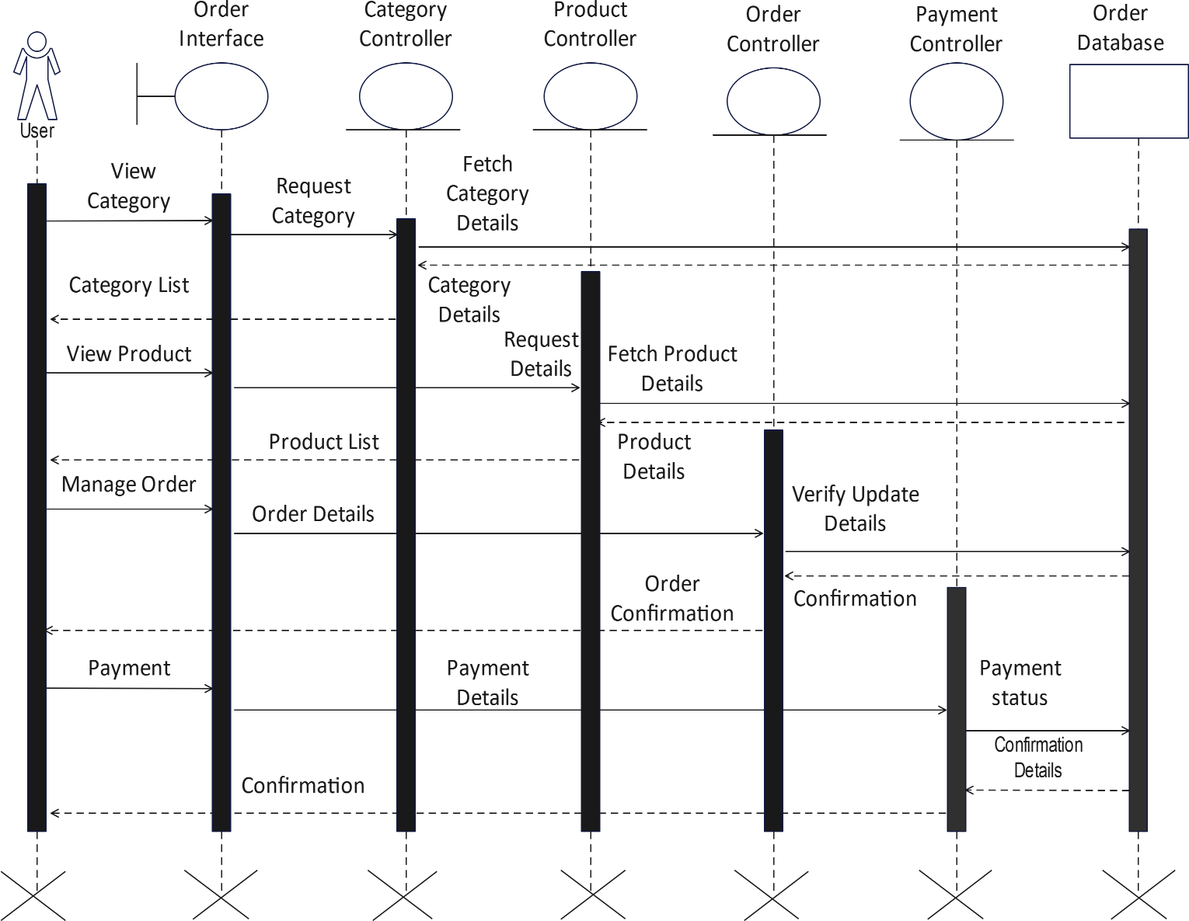

* + 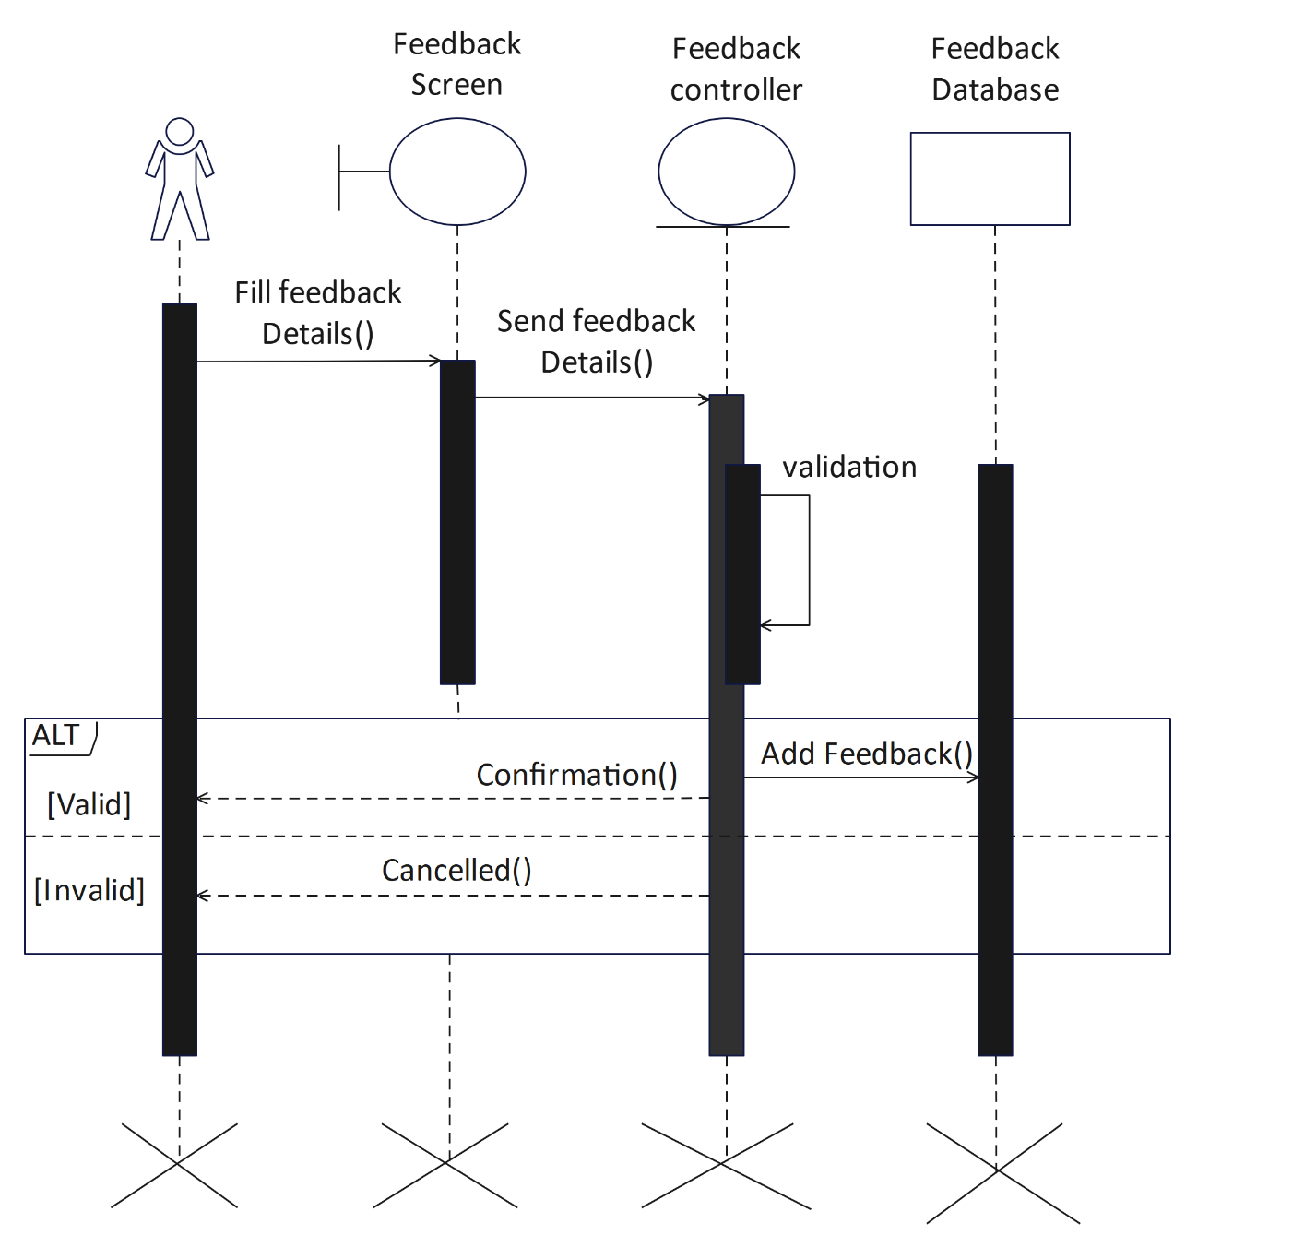**Feedback sequence diagram: -**

## [4.2] System Flow Diagram:

* + This is diagram which helps to show the actual flow of the system that is how a system is going to work and what is its flow, from where it is starting and what are its functionalities and how we are going to exit out from our system.
  + A SFD (System Flow Diagram) shows what kind of information will be input to and output from the system where the data will come from and go to, and where the data will be stored. It gives the clear idea about the whole process, say it an application or a normal data flow.

|  |  |
| --- | --- |
|  | **Start/End** |
|  | **Arrows** |
|  | **Data** |
|  | **Process** |
|  | **Decision** |

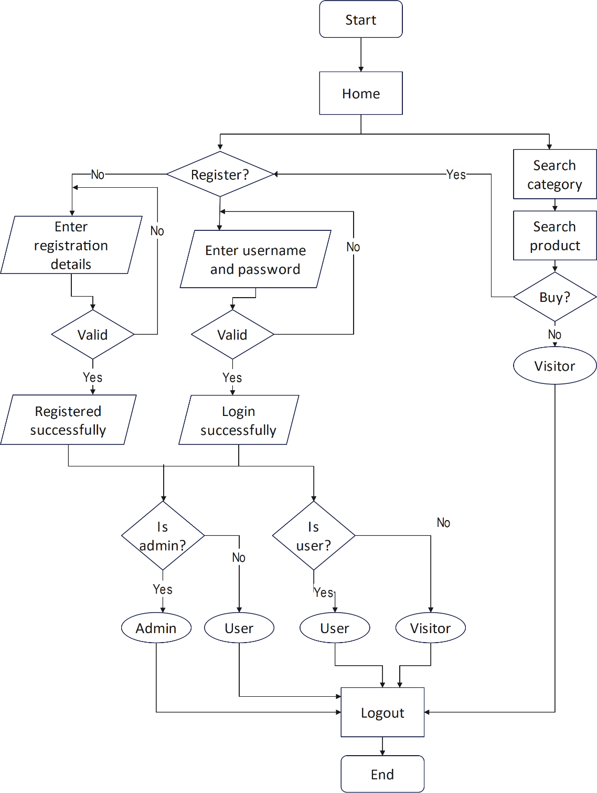

### System Flow Diagram for Admin: -

* + **System Flow Diagram for User: -**

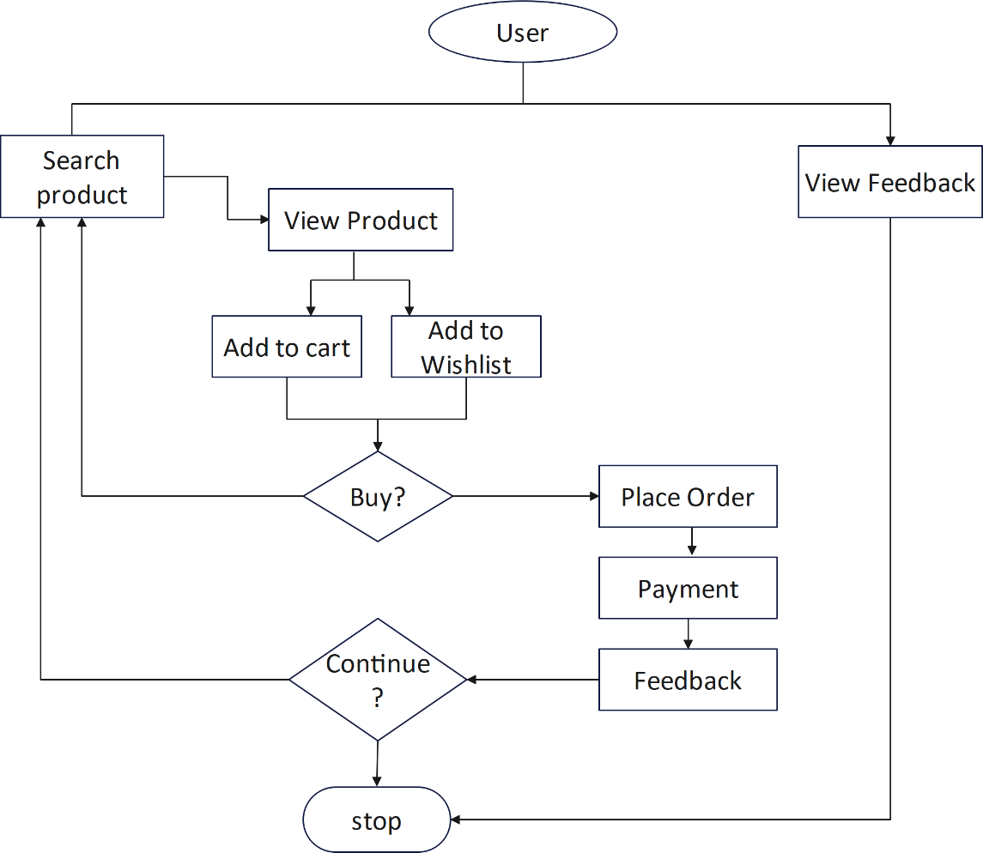

* + **System Flow Diagram for Visitor: -**

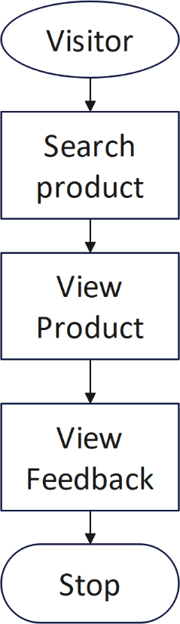

## [4.3] Data Dictionary: -

#### tbl_admin:

primary key: admin_id

|  |  |  |  |  |
| --- | --- | --- | --- | --- |
| Column name | Data type | Size | Constraint | Description |
| admin_id | Int | 5 | Primary key | It stores unique id of admin. |
| admin_name | Varchar | 15 | Not Null | It stores name of admin. |
| admin_email | Varchar | 30 | Not Null | It stores email of admin. |
| admin_password | Varchar | 10 | Unique key | It verifies password of admin. |

|  |  |  |  |  |
| --- | --- | --- | --- | --- |
| admin_mobile | Number | 10 | Not Null | It stores Mobile number of admin. |

#### tbl_user:

primary key: user_mobile primary key: user_id

|  |  |  |  |  |
| --- | --- | --- | --- | --- |
| Column name | Data type | Size | Constraint | Description |
| user_id | Int | 5 | Primary key | It stores unique id of User. |
| user_name | Varchar | 15 | Not Null | It stores Name of user. |
| user_gender | Varchar | 6 | Not Null | It stores Gender of user. |
| user_dob | Date |  | Not Null | It stores Date of birth of user. |
| user_email | Varchar | 30 | Not Null | It stores email of user. |
| user_password | Varchar | 20 | Not Null | It stores password of user. |
| user_mobile | Number | 10 | Primary key | It stores mobile number of user. |
| user_address | varchar | 150 | Not Null | It stores address of user. |

#### tbl_category:

primary key: category_id

|  |  |  |  |  |
| --- | --- | --- | --- | --- |
| Column name | Data type | Size | Constraint | Description |
| category_id | Int | 5 | Primary key | Category id for categories. |
| category_name | Varchar | 15 | Not Null | Contains name of categories. |

#### tbl_product:

primary key: product_id foreign key:category_id

|  |  |  |  |  |
| --- | --- | --- | --- | --- |
| Column name | Data type | Size | Constraint | Description |
| product_id | Int | 5 | Primary key | It stores unique id of Product. |
| product_name | Varchar | 20 | Not Null | It stores Name of Product. |
| product_details | Text |  | Not Null | It stores Details of Product. |
| product_photo | Varchar | 80 | Not Null | It stores Photo of Product. |
| product_price | Float | 5,2 | Not Null | It stores Price of Product. |

|  |  |  |  |  |
| --- | --- | --- | --- | --- |
| category_id | Int | 5 | Foreign key | It stores Category id of Product. |
| product_quantity | Int | 20 | Not Null | It stores product Quantity. |

#### tbl_wishlist:

primary key:wishlist_id

|  |  |  |  |  |
| --- | --- | --- | --- | --- |
| Column name | Data type | Size | Constraint | Description |
| wishlist_id | Int | 5 | Primary key | It stores wishlist id. |
| user_id | Int | 5 | Foreign key | It stores user id. |
| product_id | Int | 5 | Foreign key | It stores product id. |

#### tbl_cart:

primary key:cart_id foreign key:product_id foreign key: user_id

|  |  |  |  |  |
| --- | --- | --- | --- | --- |
| Column name | Data type | Size | Constraint | Description |
| cart_id | Int | 5 | Primary key | It stores Unique cart id. |
| product_id | Int | 5 | foreign key | It stores Id of product. |
| quantity | Int | 20 | Not Null | It stores quantity of cart. |
| price | Float | 5,2 | Not Null | It stores Price of Cart. |
| user_id | Varchar | 5 | foreign key | It stores user id. |

#### tbl_ordermaster:

primary key:order_id foreign key:user_id

|  |  |  |  |  |
| --- | --- | --- | --- | --- |
| Column name | Data type | Size | Constraint | Description |
| order_id | Int | 5 | Primary key | It stores unique id of Order. |
| ordermaster_date | Date |  | Not Null | It stores Order date of order. |
| ordermaster_status | Varchar | 20 | Not Null | It stores order Status. |
| user_id | Int | 5 | Foreign key | It store User id. |

#### tbl_orderdetail:

primary key:orderdetail_id foreign key:order_id

foreign key:product_id foreign key:product_price

|  |  |  |  |  |
| --- | --- | --- | --- | --- |
| Column name | Data type | Size | Constraint | Description |
| orderdetail_id | Int | 5 | Primary key | It stores detail of order. |
| order_id | Int | 5 | Foreign key | It stores Order id. |
| product_id | Int | 5 | Foreign key | It stores id of Product. |
| product_price | Float | 5,2 | Foreign key | It stores Price of orderdetail. |
| Orderdetail_quantity | Int | 20 | Not Null | It stores quantity. |

#### tbl_shipping:

primary key:shipping_id foreign key:user_mobile foreign key:user_id foreign key:order_id

|  |  |  |  |  |
| --- | --- | --- | --- | --- |
| Column name | Data type | Size | Constraint | Description |
| shipping_name | Varchar | 25 | Not Null | It stores name of Shipping. |
| user_mobile | Number | 10 | Foreign key | It stores mobile number of user. |
| shipping_address | Text |  | Not Null | It stores address of Shipping. |
| shipping_id | Int | 5 | Primary key | It store shipping id. |
| order_id | Int | 5 | Foreign key | It stores unique id of Order. |
| shipping_date | date | 10 | Not Null | It stores date of Shipping. |

#### tbl_payment:

primary key:payment_id foreign key:user_id foreign key:order_id

|  |  |  |  |  |
| --- | --- | --- | --- | --- |
| Column name | Data type | Size | Constraint | Description |
| payment_id | Int | 5 | Primary key | It stores unique id of Payment. |
| user_id | Int | 5 | Foreign key | It stores unique id of User. |
| payment_method | Varchar | 30 | Not Null | It stores payment method. |
| payment_amount | Float | 20 | Not Null | It stores total amount to be paid. |
| order_id | Int | 5 | Foreign key | It stores Order id. |

#### tbl_feedback:

primarykey:feedback_id foreign key:user_id foreign key:product_id

|  |  |  |  |  |
| --- | --- | --- | --- | --- |
| Column name | Data type | Size | Constraint | Description |
| feedback_id | Int | 5 | Primary key | It stores unique id of Feedback. |
| feedback_date | Date |  | Not Null | It stores feedback date. |
| user_id | Int | 5 | Foreign key | It stores user id. |
| feedback_details | Text |  | Not Null | It stores feedback description given by user |
| product_id | Int | 5 | Foreign key | It stores product id. |

## [4.4] User Interface: -

### Home

### 

1. **Login**

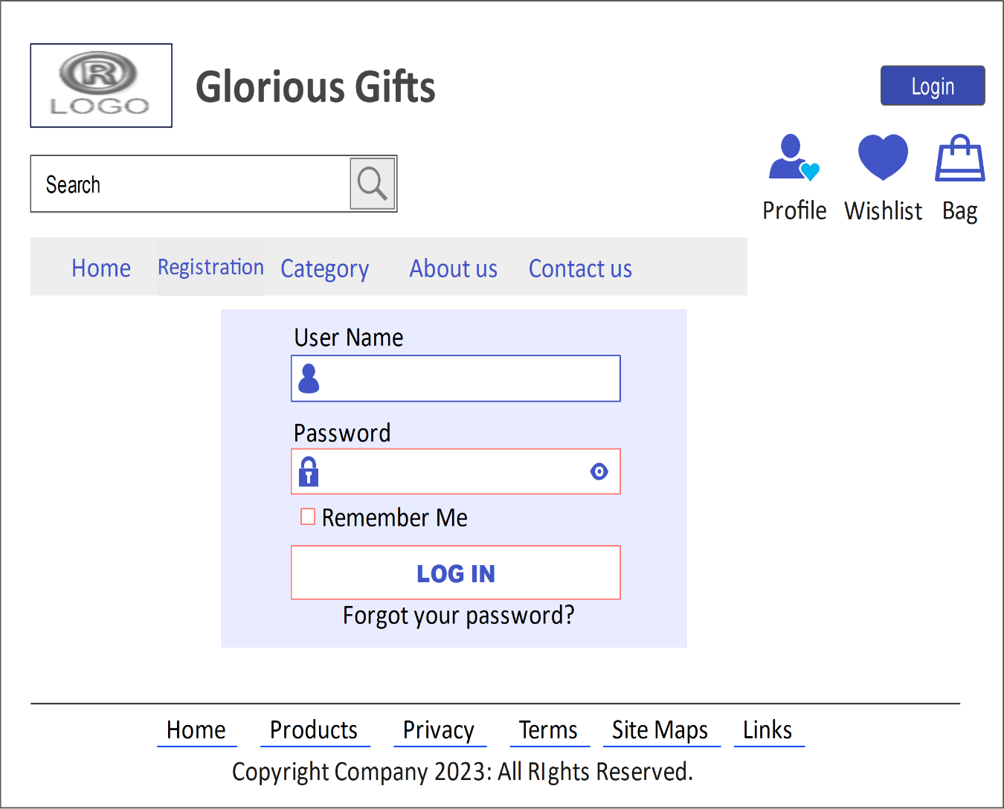

### Registration

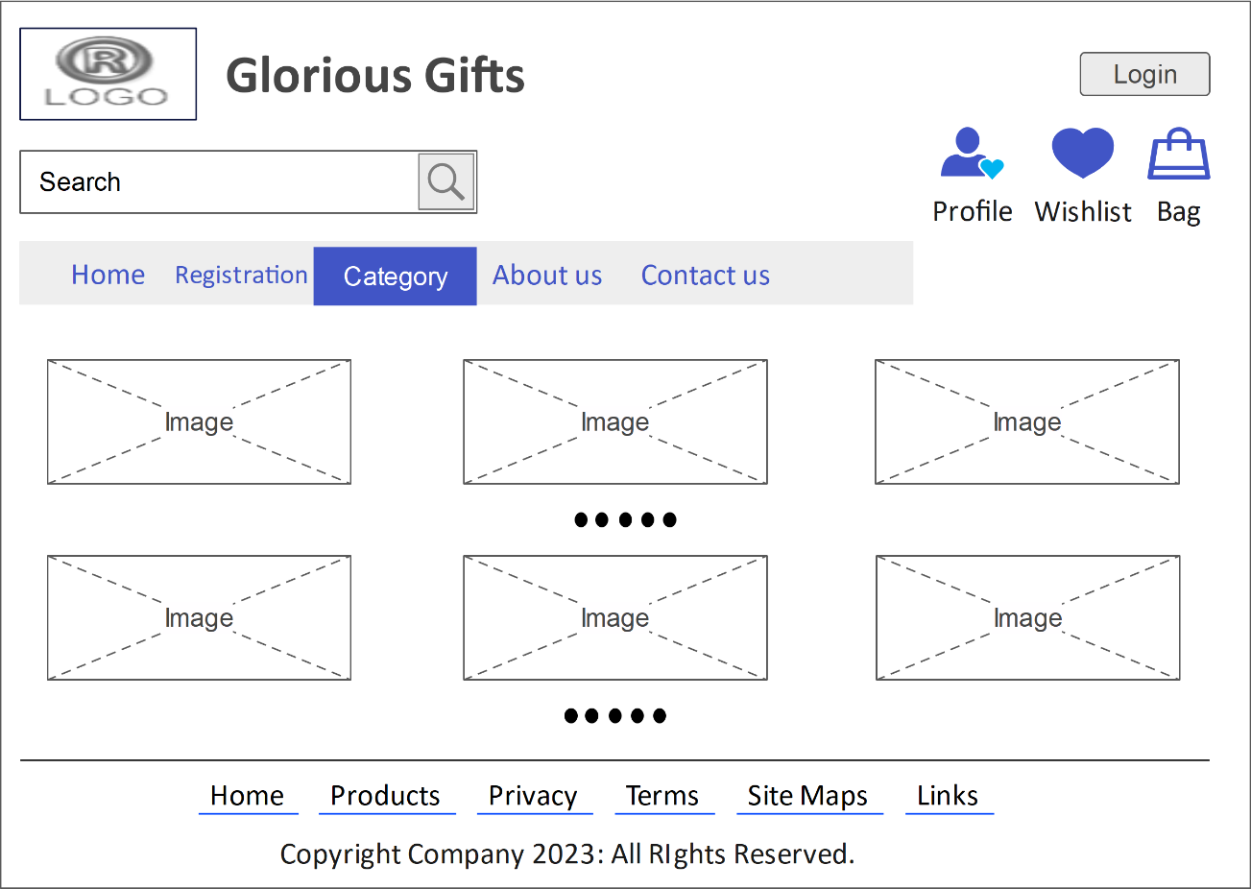

1. 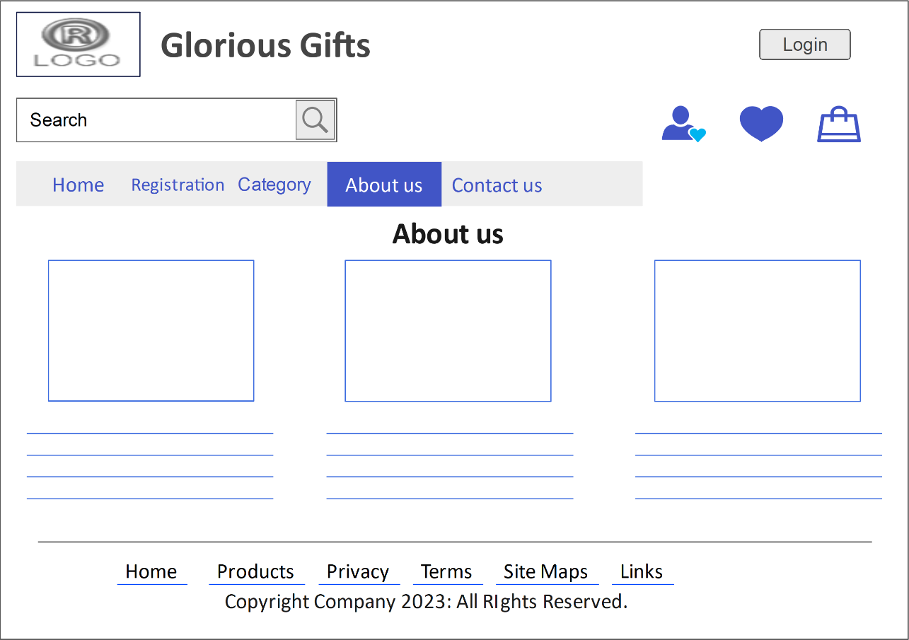**About us**

## [4.4] System Navigation: -

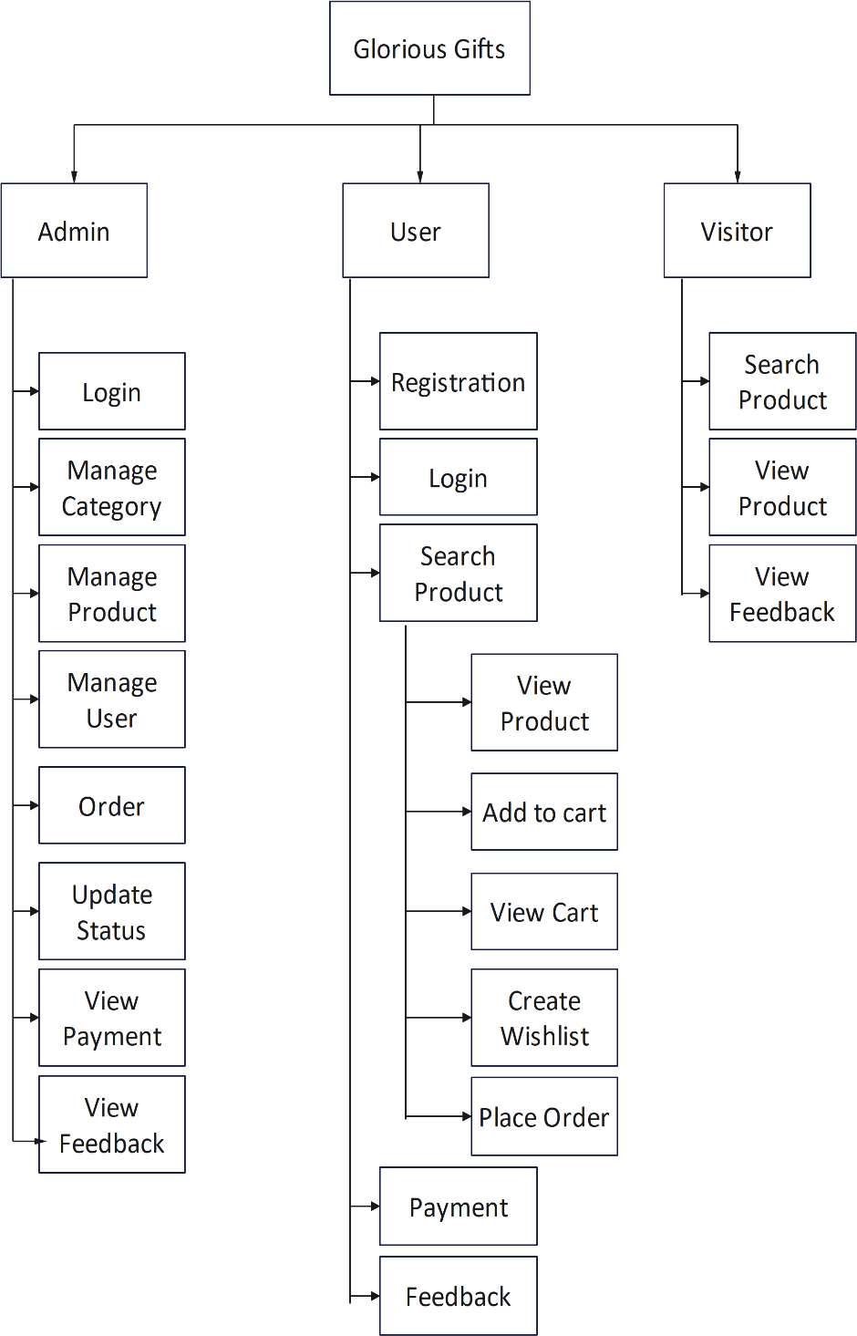

## Chapter 5

* **Admin Panel:**
* Home Page

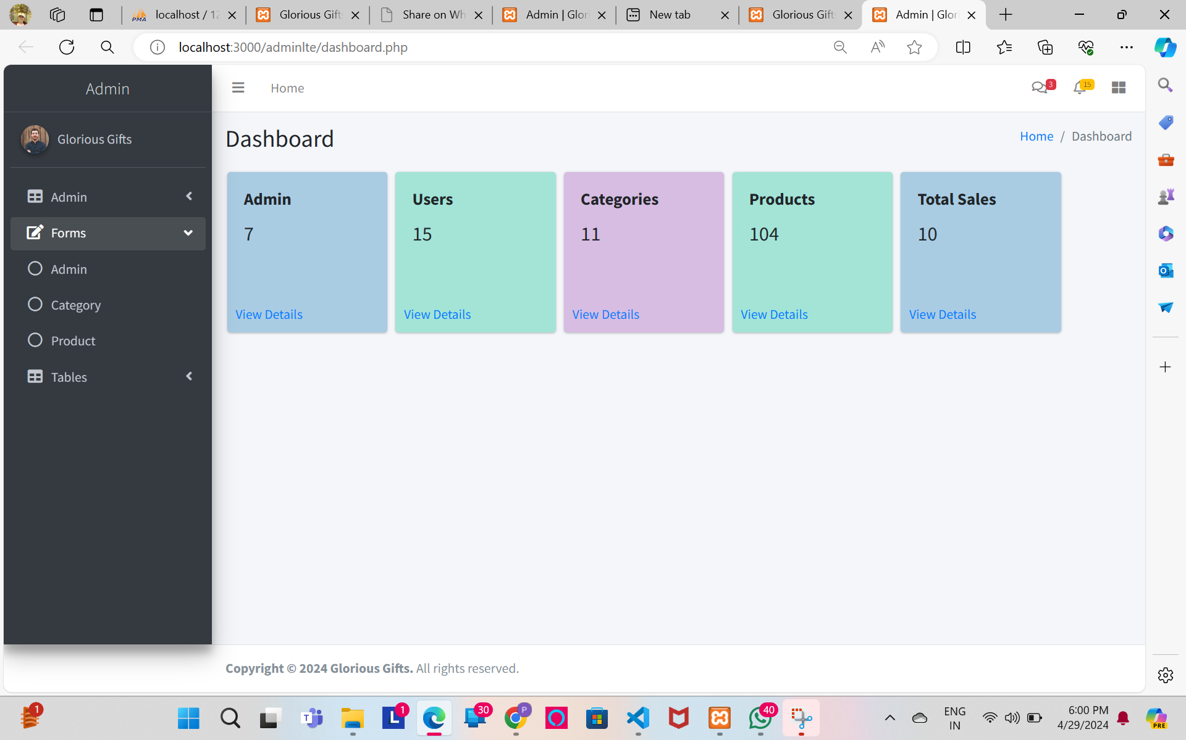

* Login

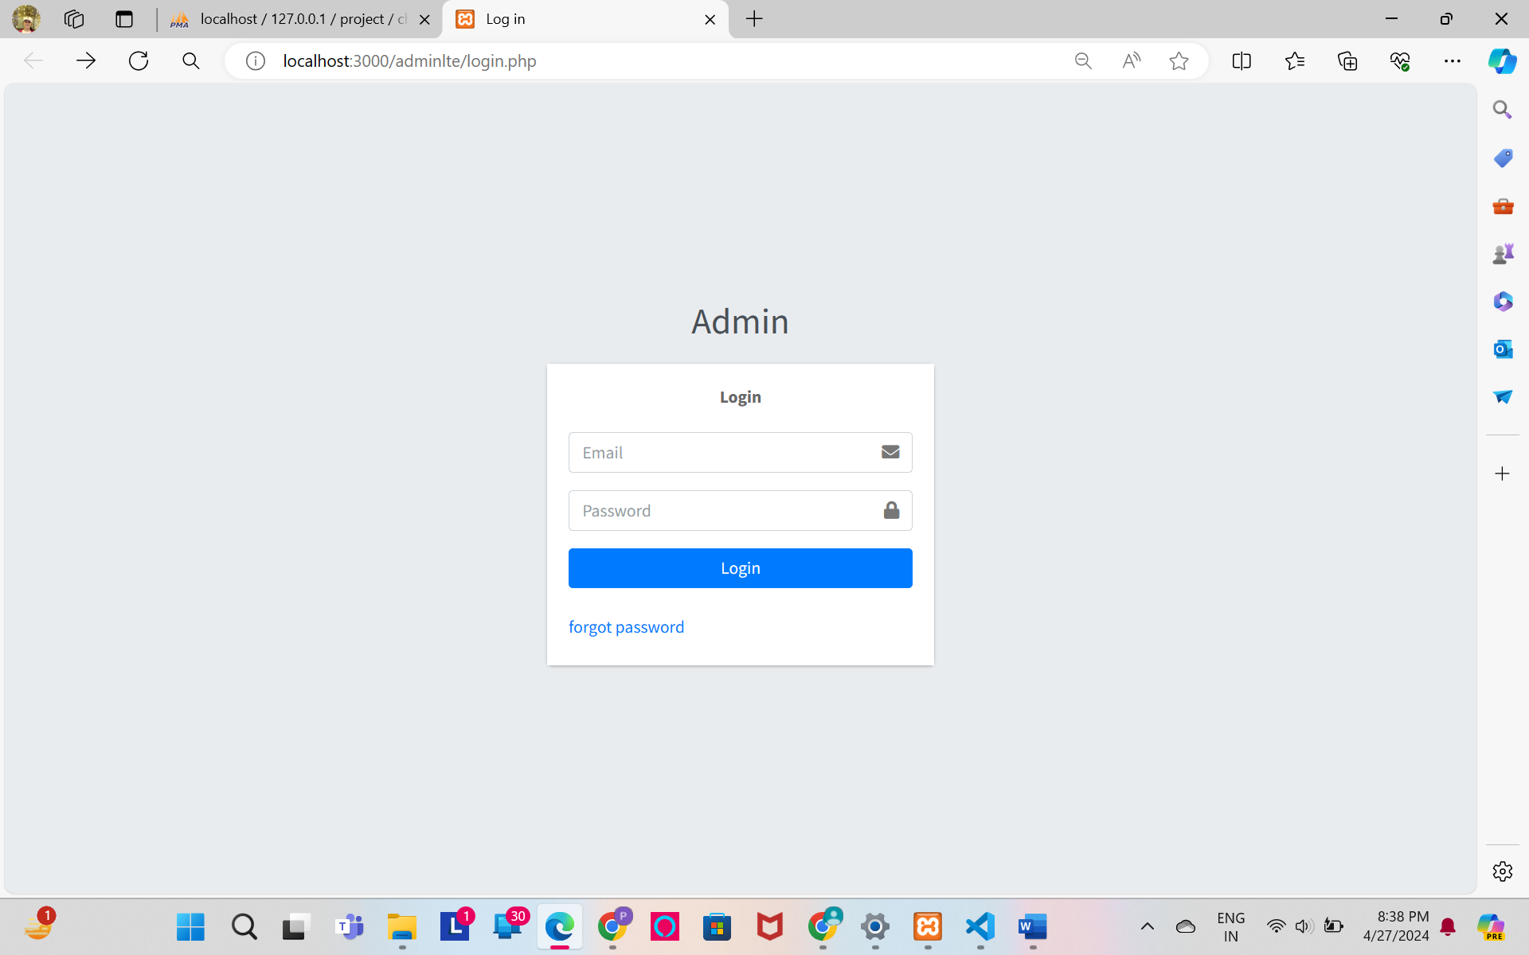

* Login with validation

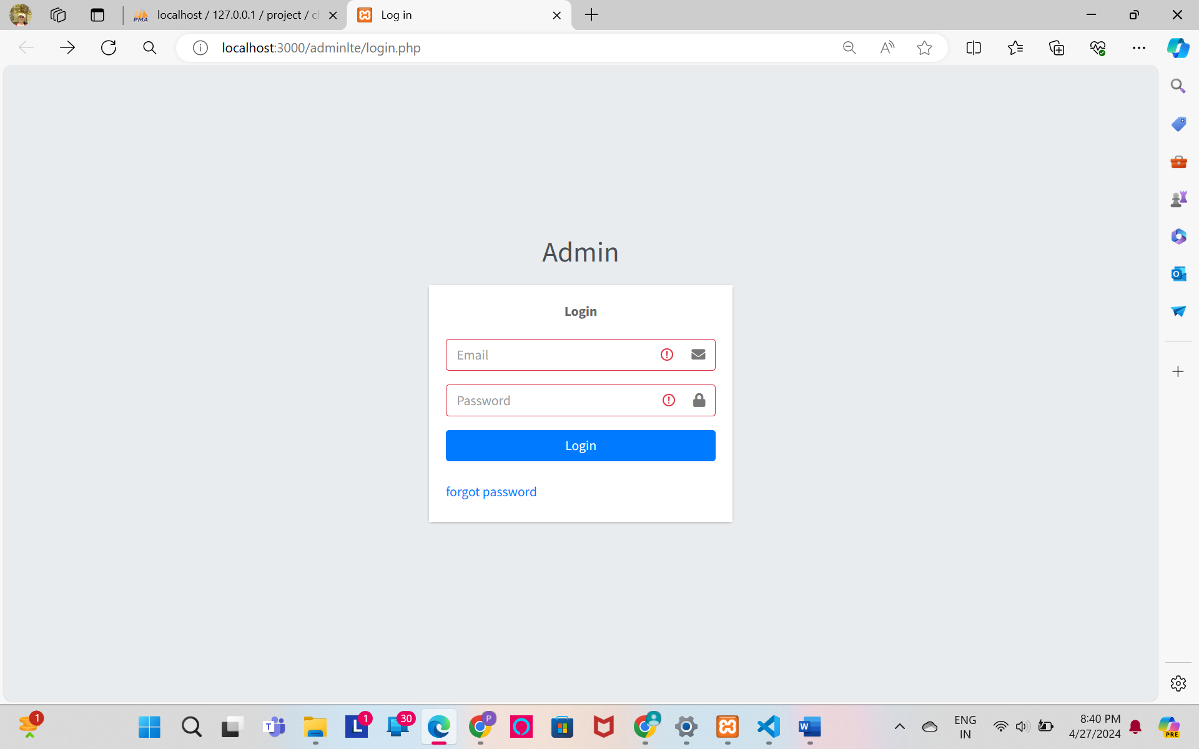

* Login with Data

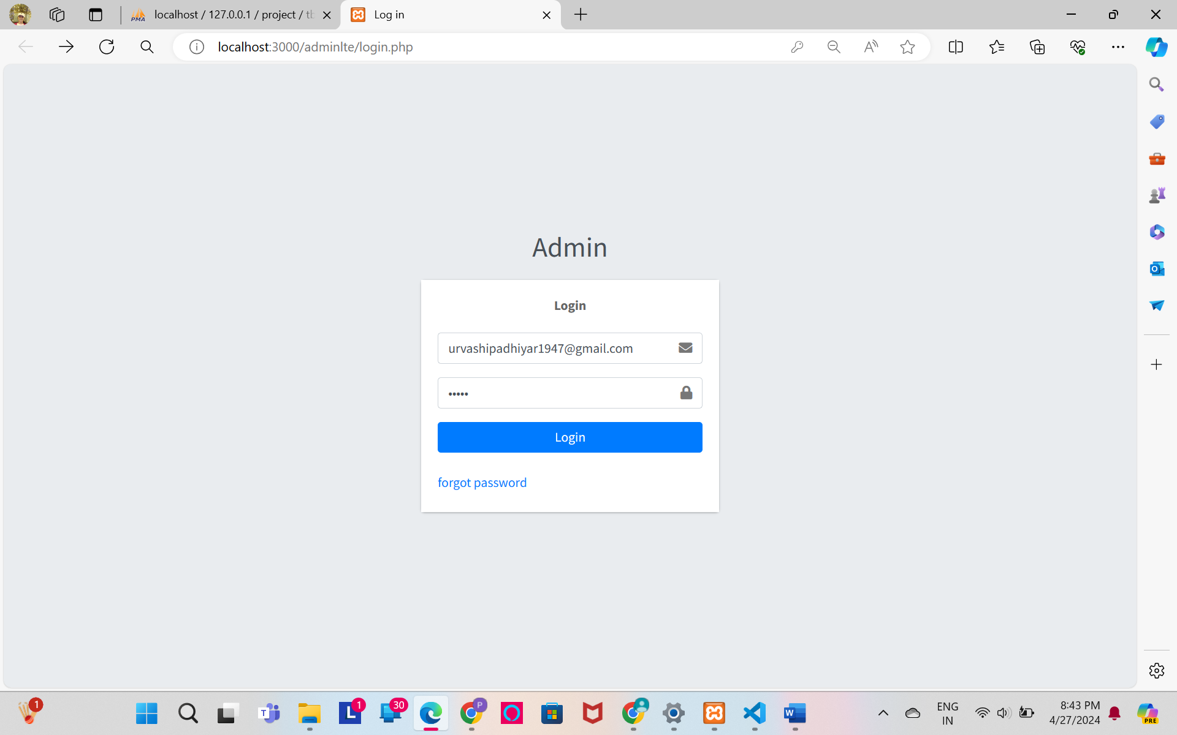

* Change Password

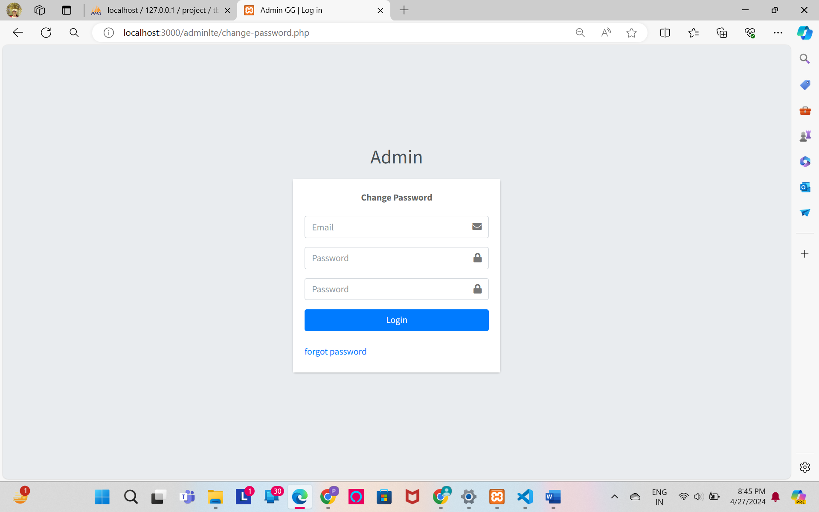

* Change Password With Data

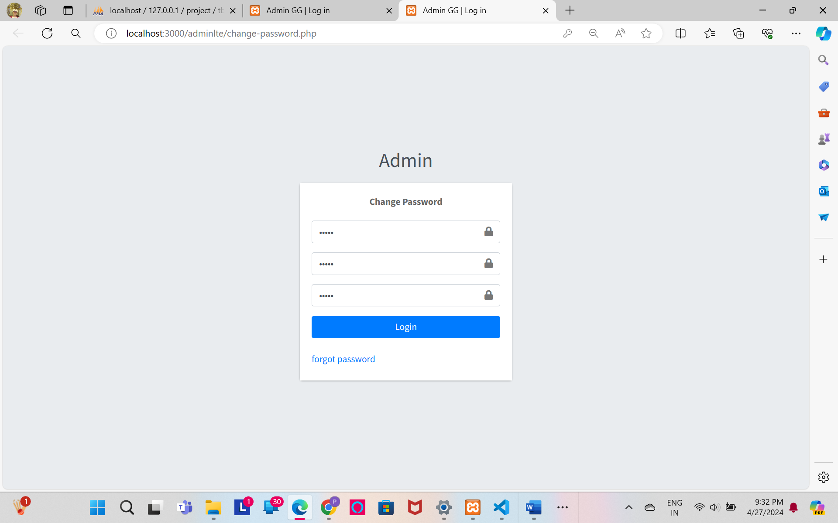

* Password Changed

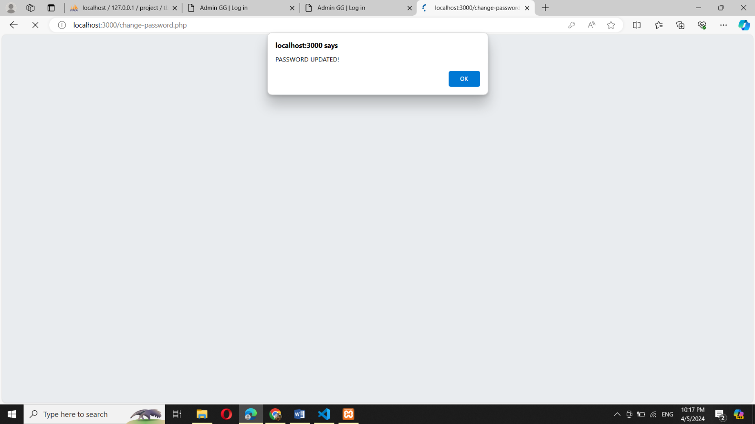

* Forgot Password

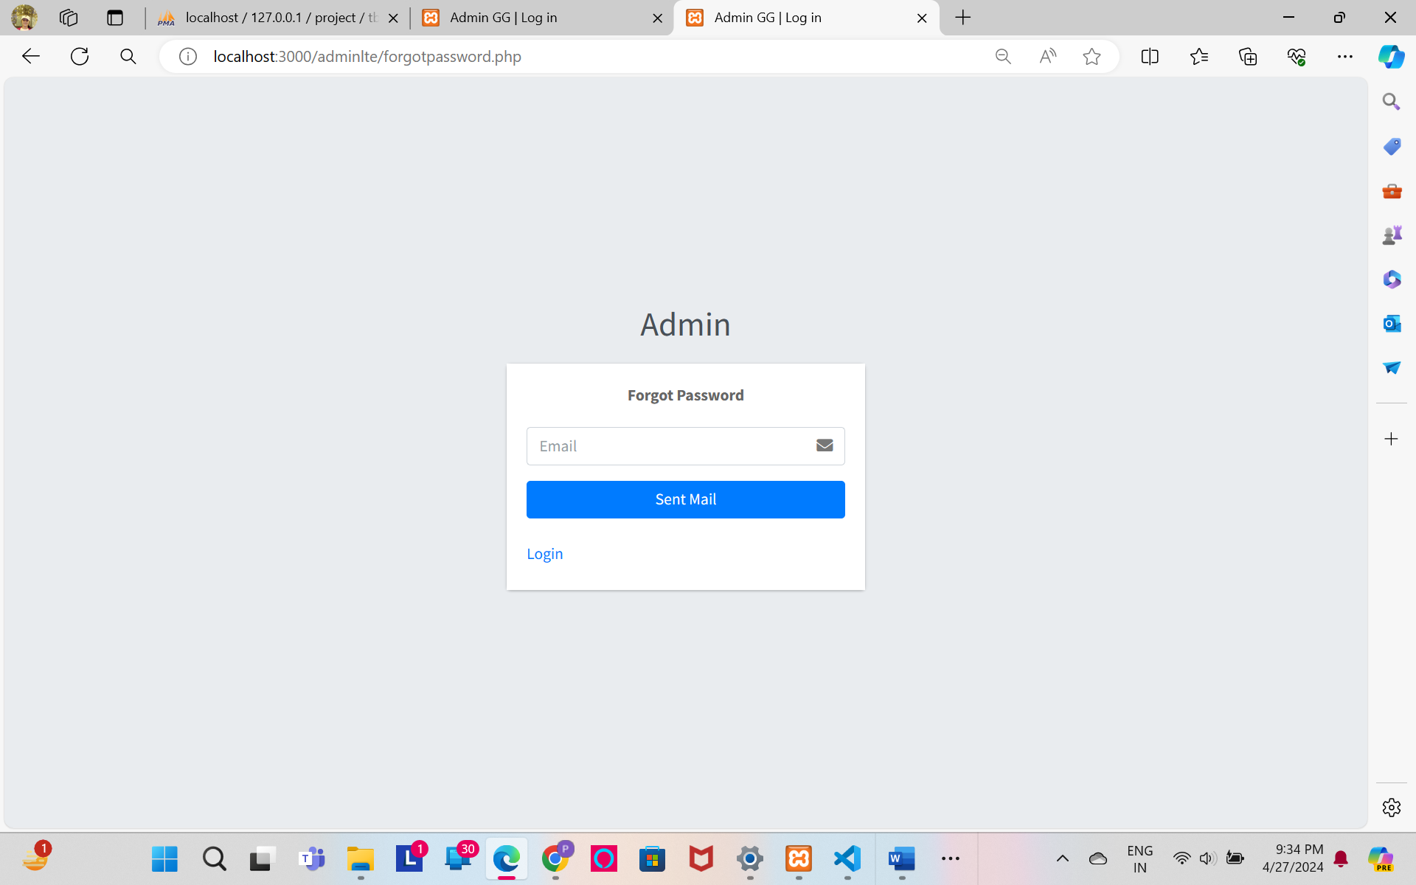

* Forgot Password With Data

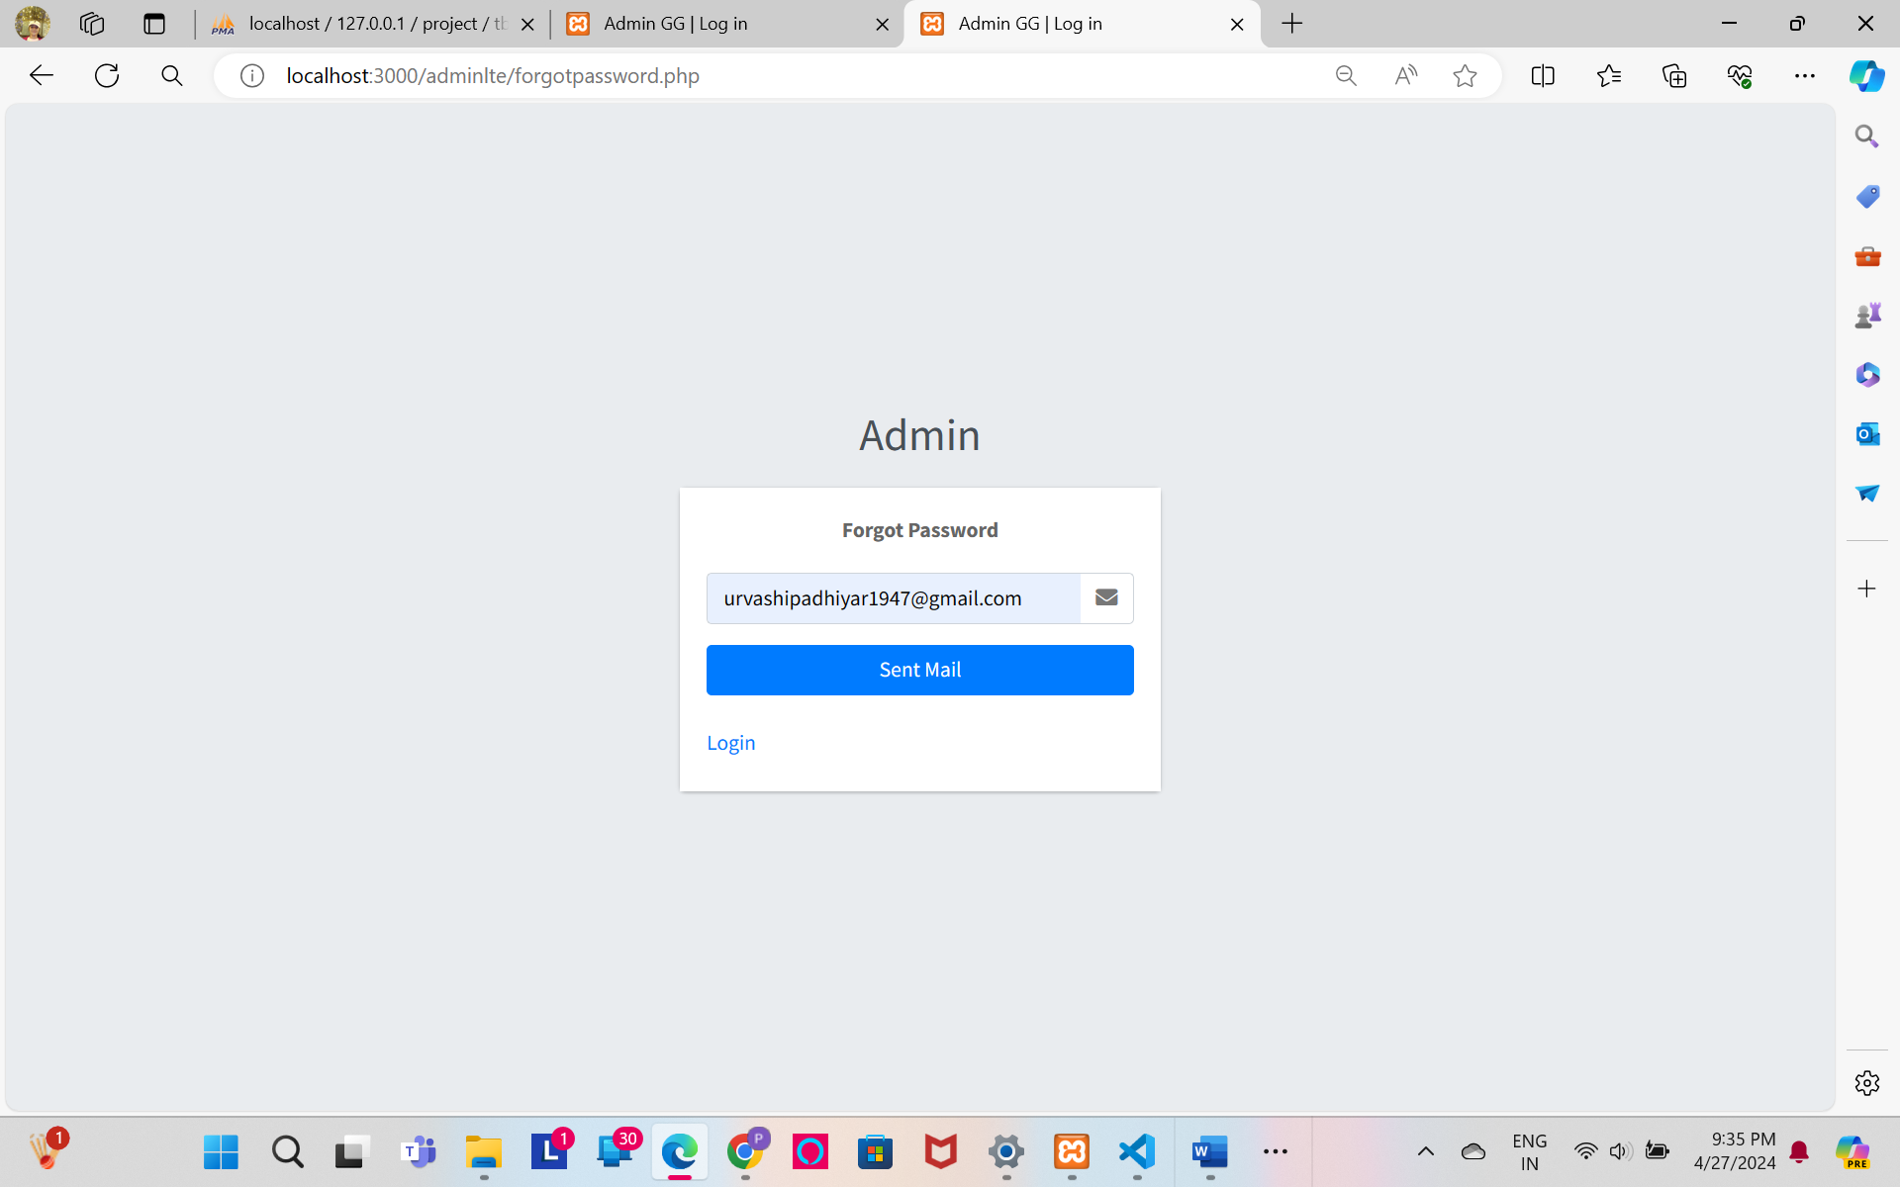

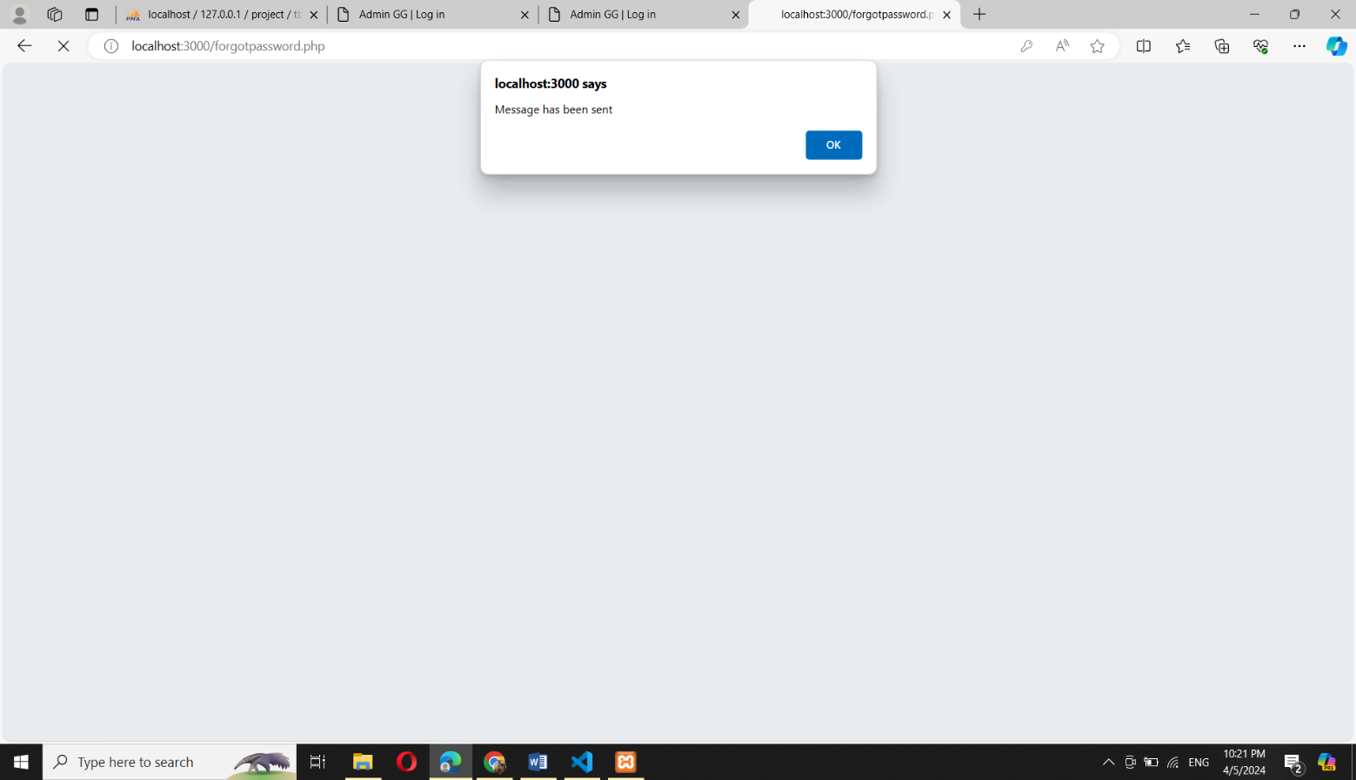

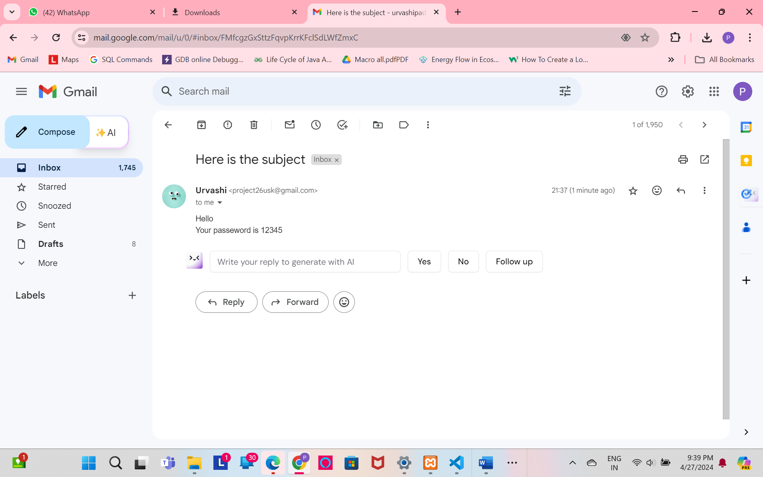

* Admin Form

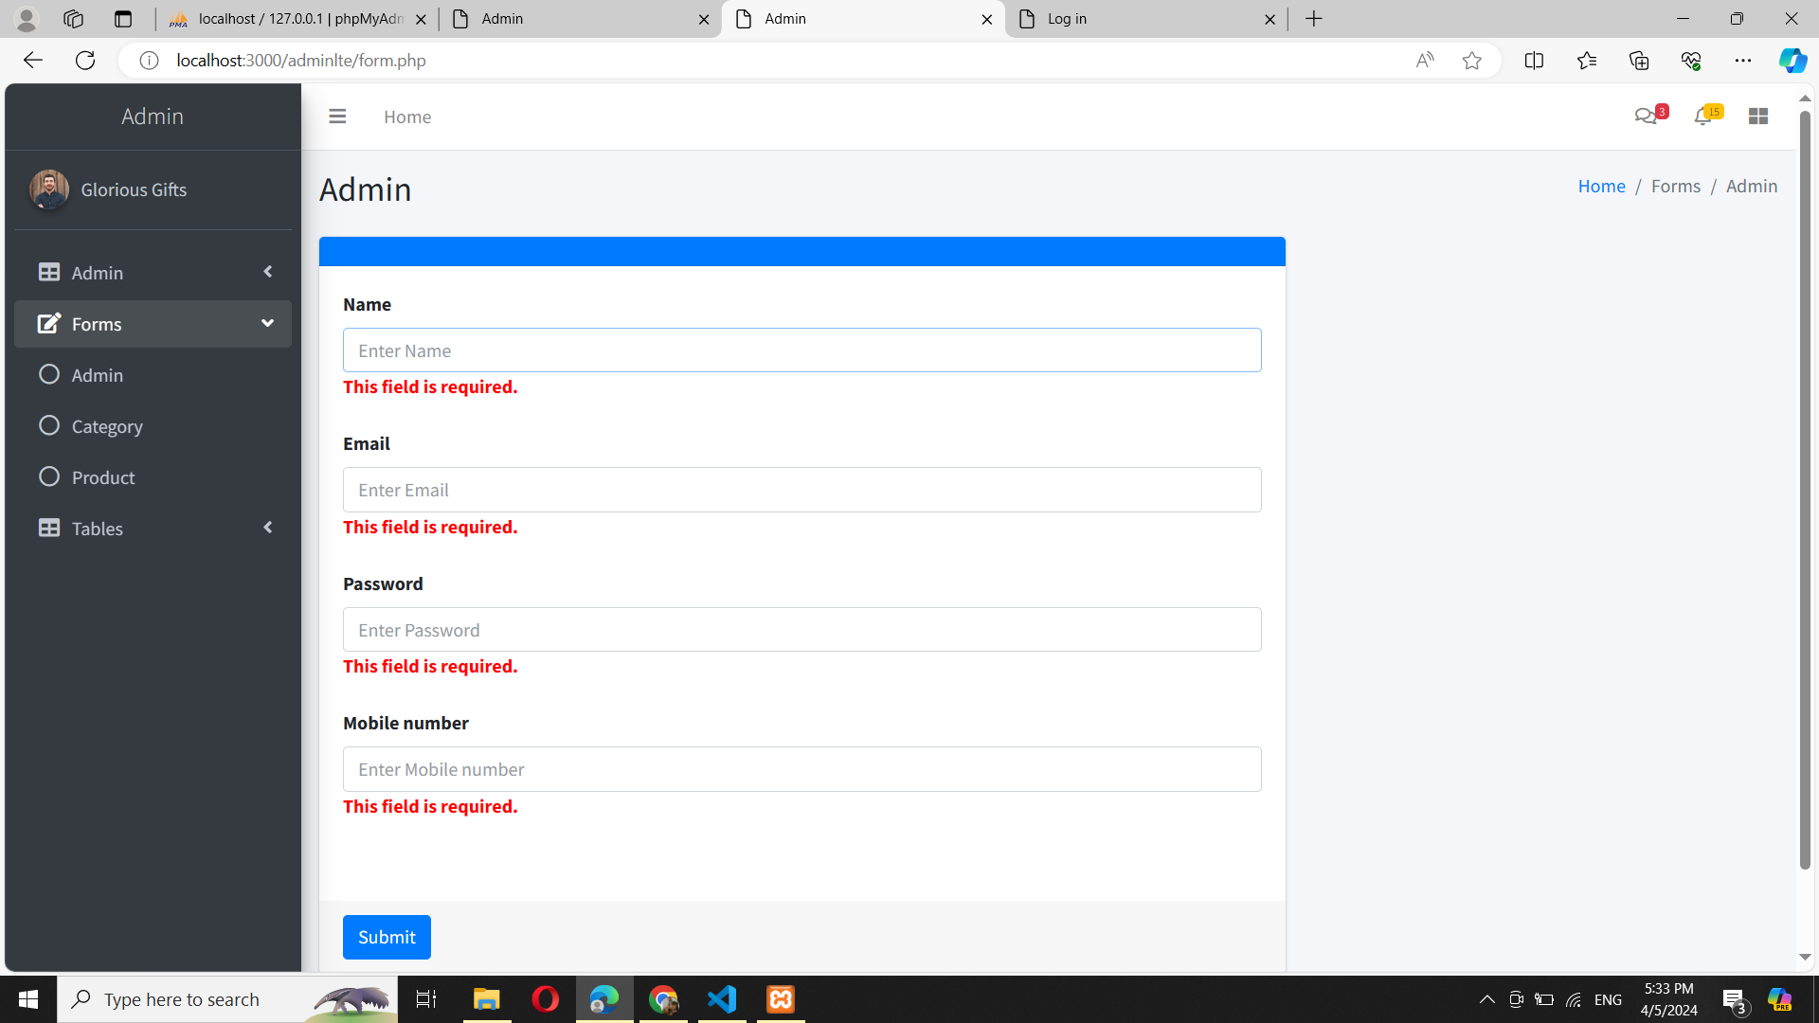

* Add Category

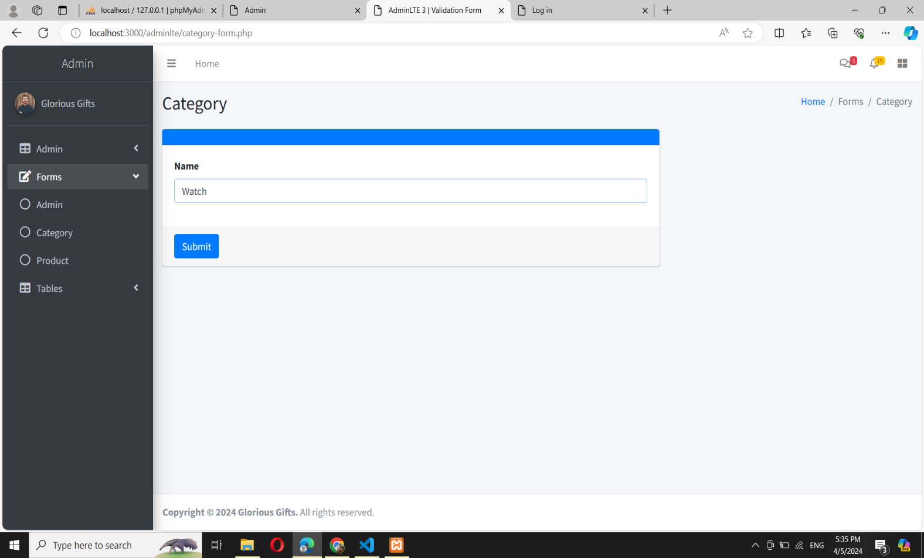

* Display Category

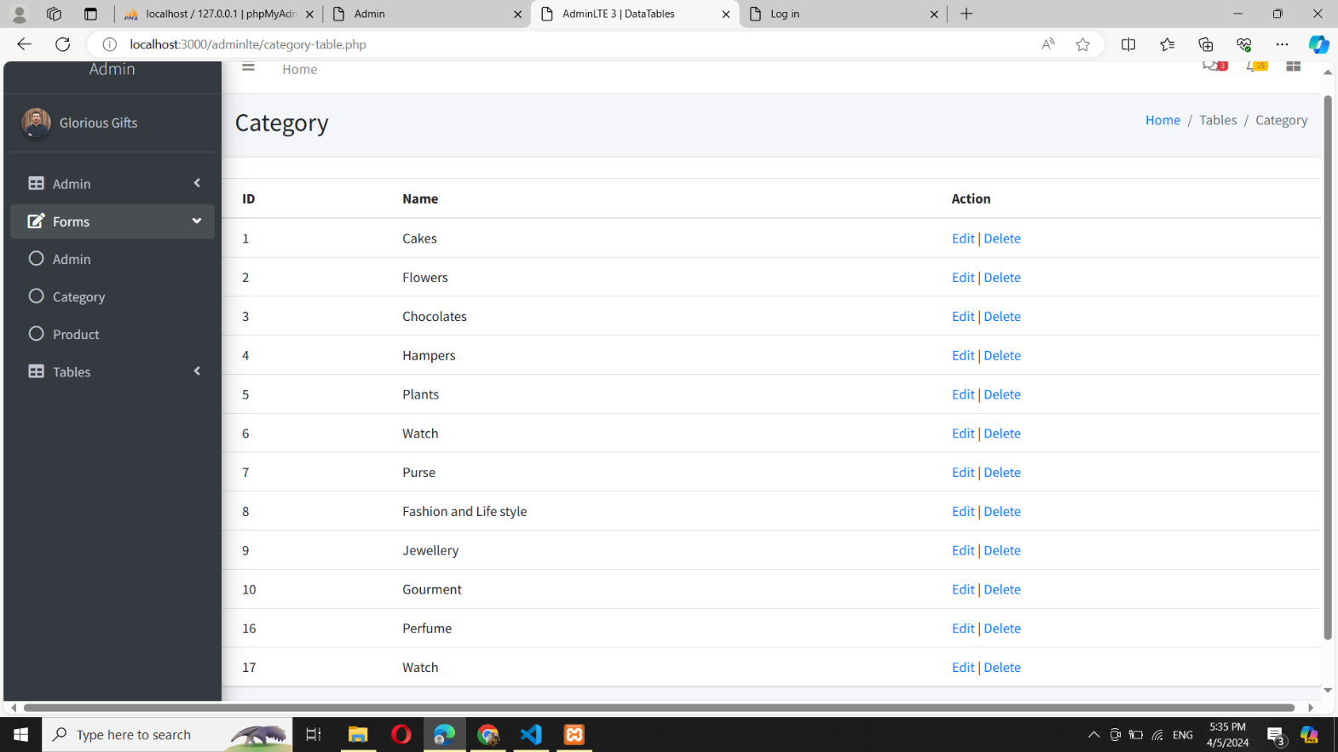

* Delete Category

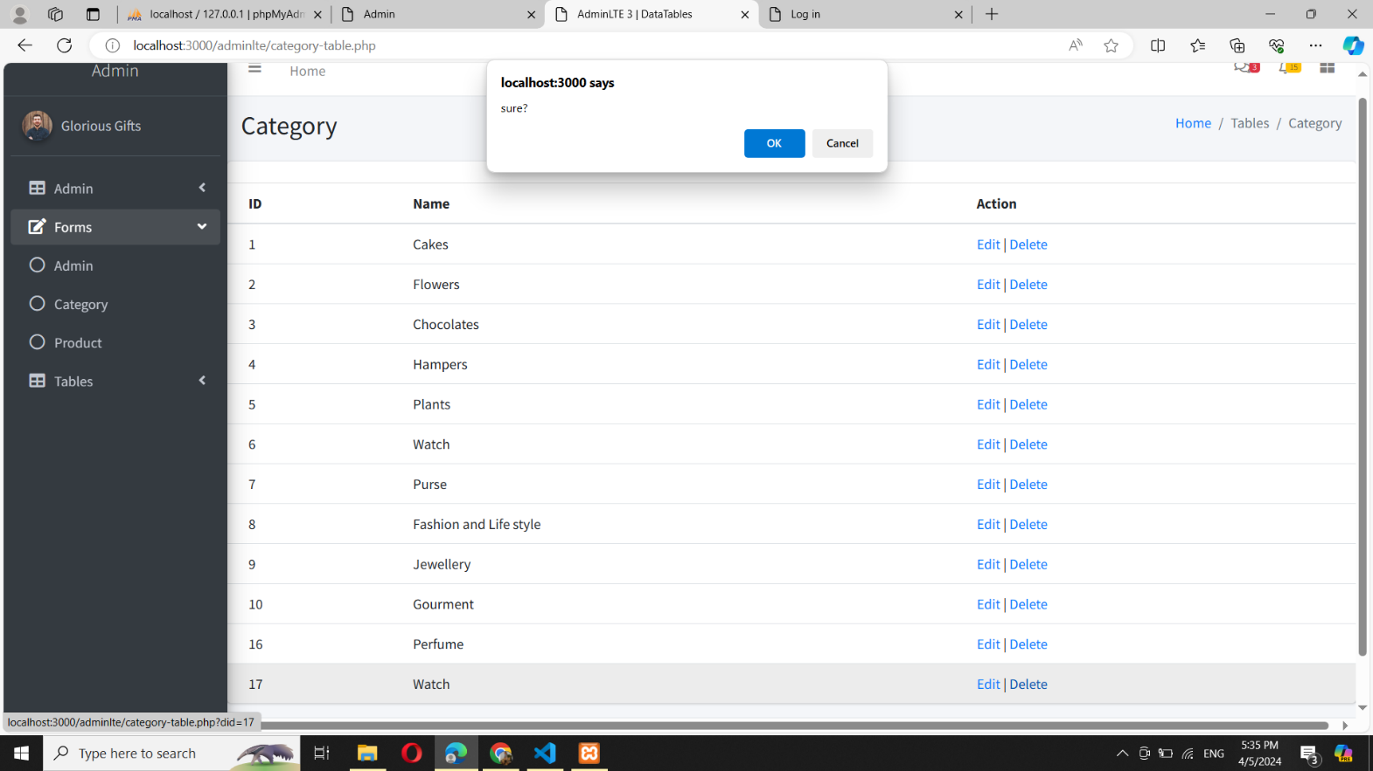

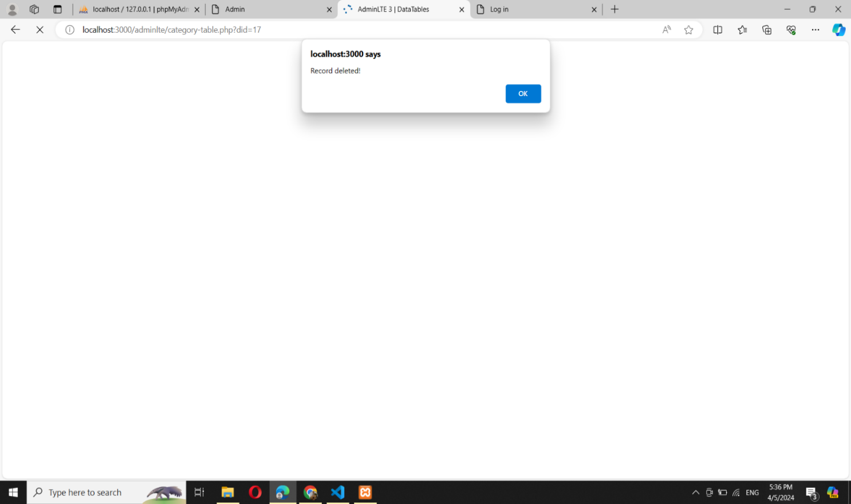

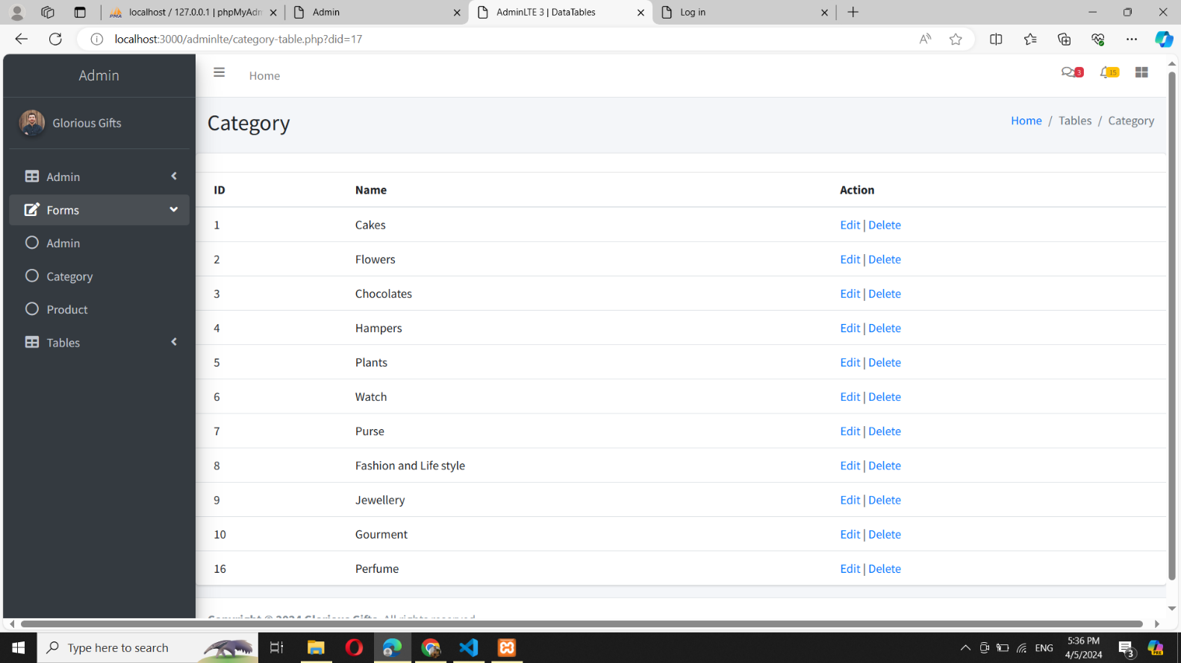

* Edit Category

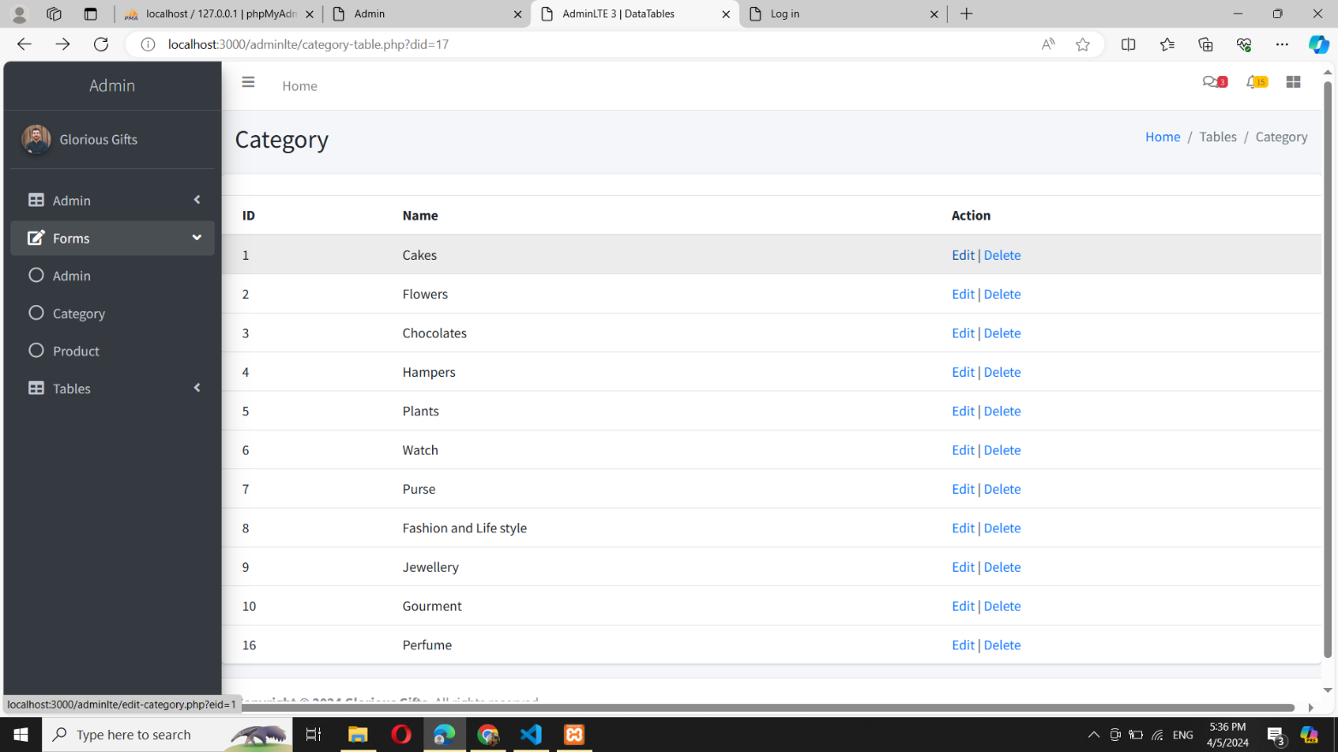

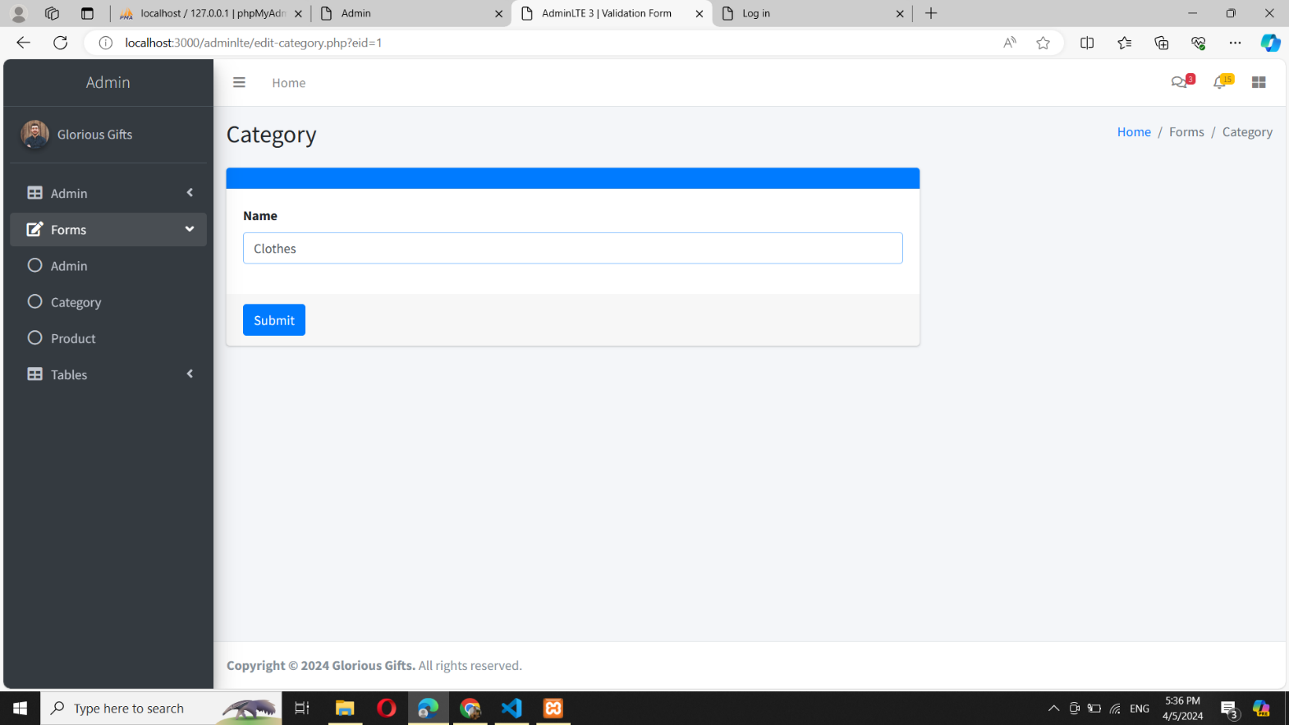

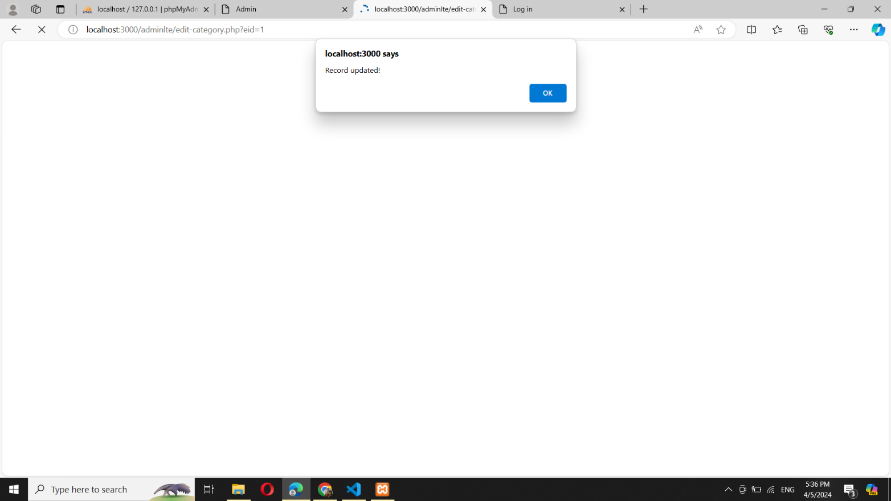

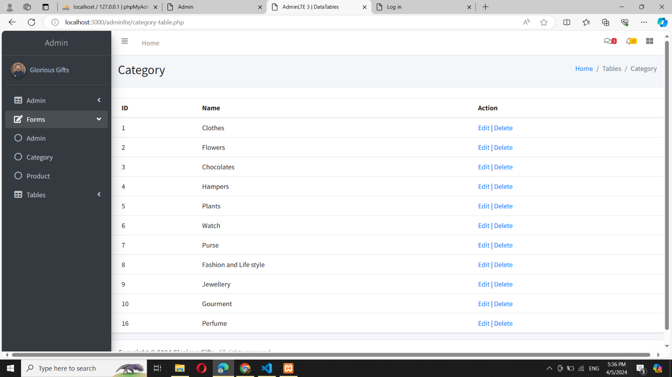

* Admin Table

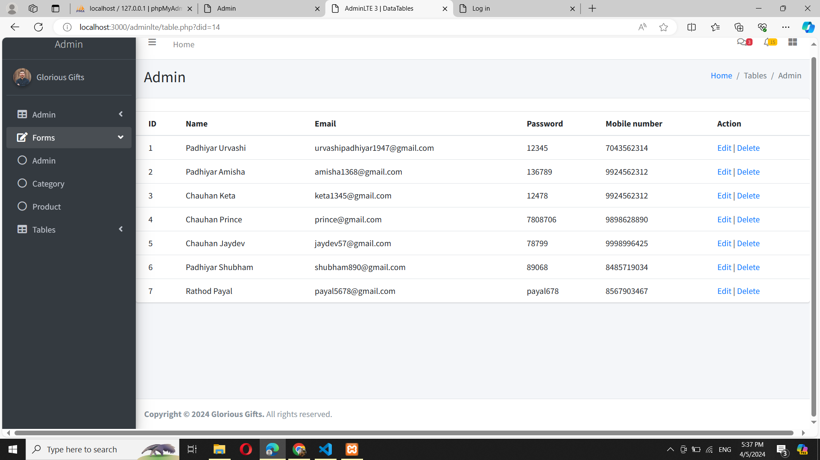

* User Table

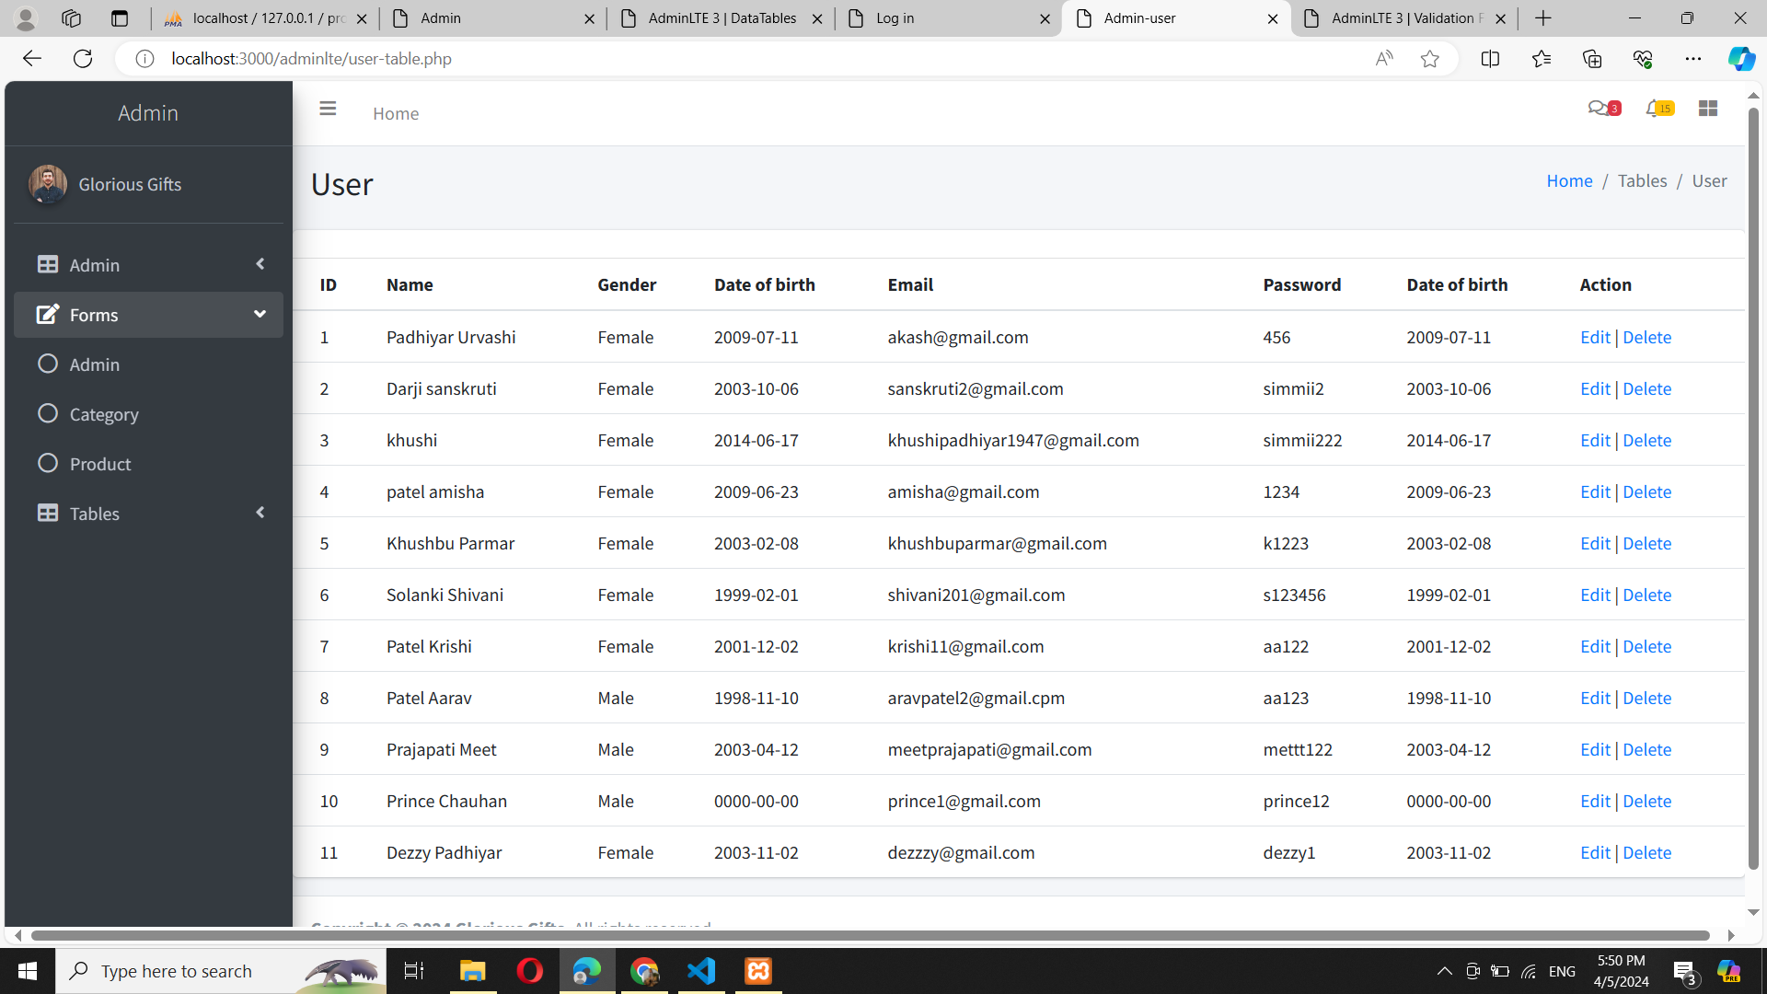

* Category Table

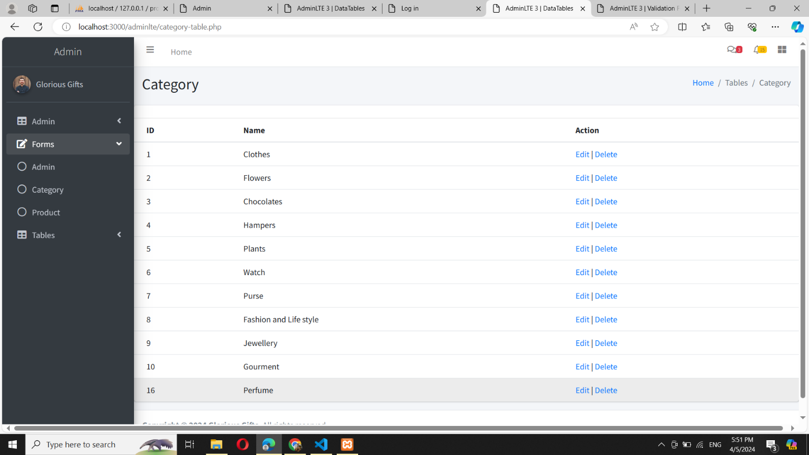

* Product Table

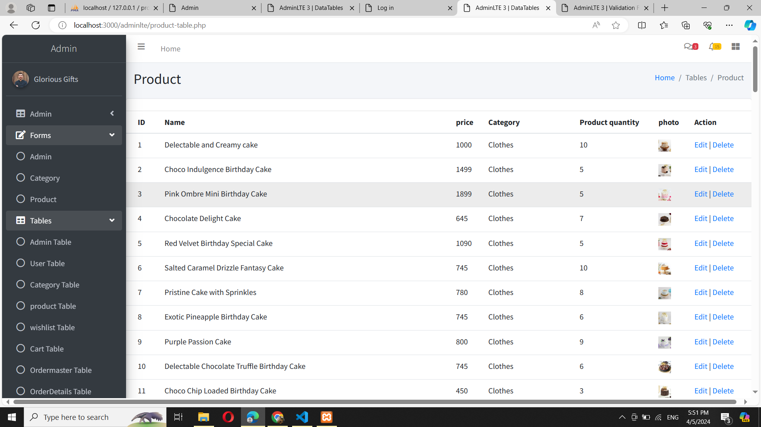

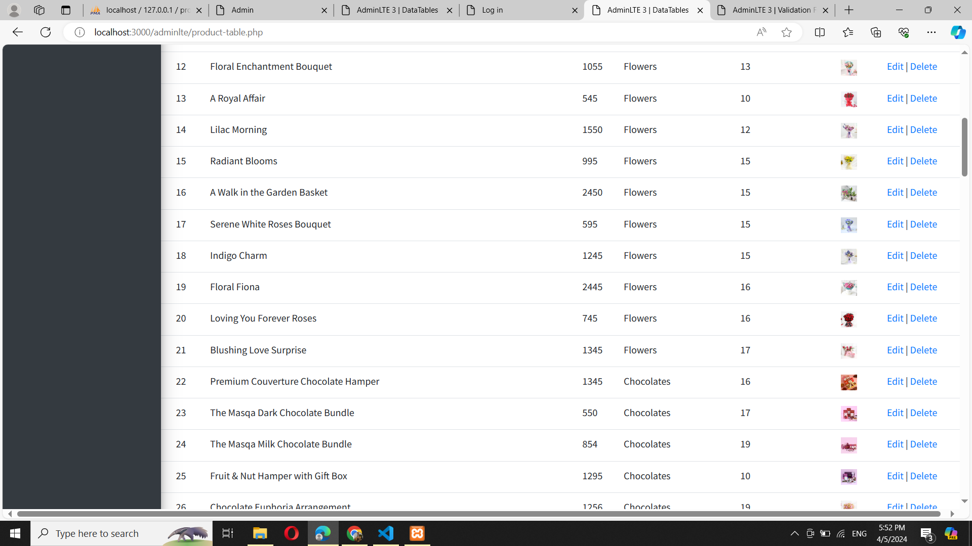

* Cart Table

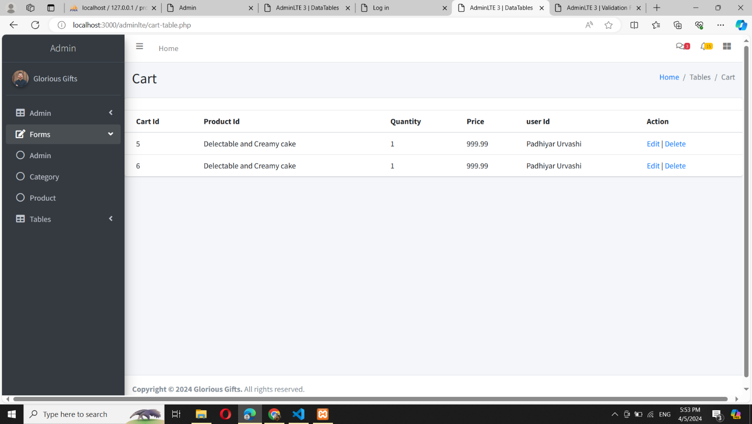

* Wishlist Table

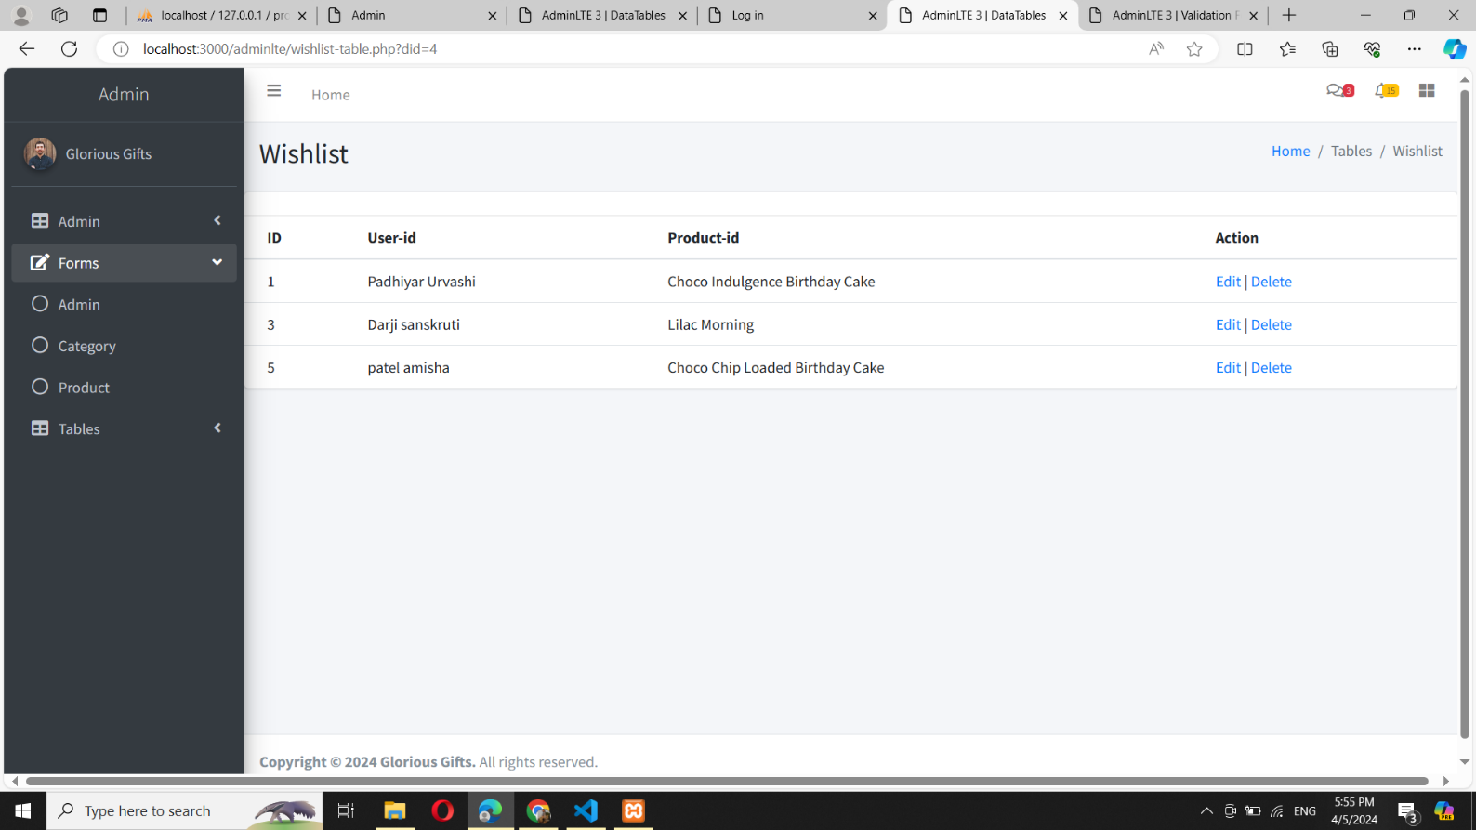

* Ordermaster Table

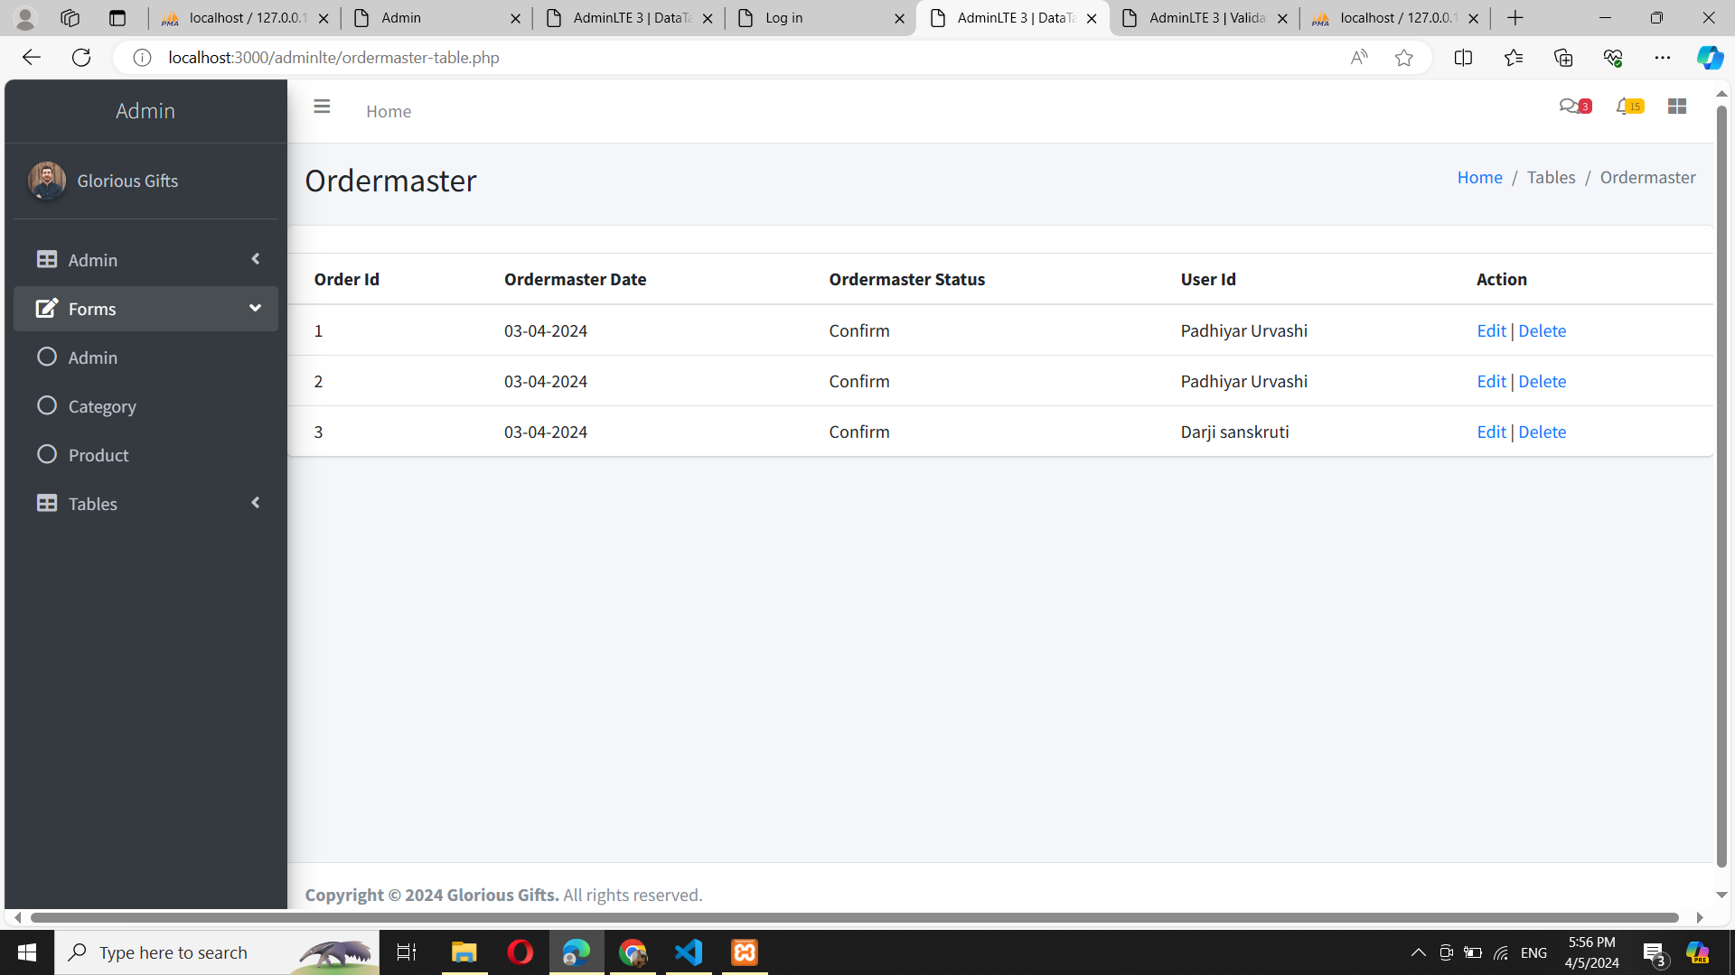

* Orderdetails Table

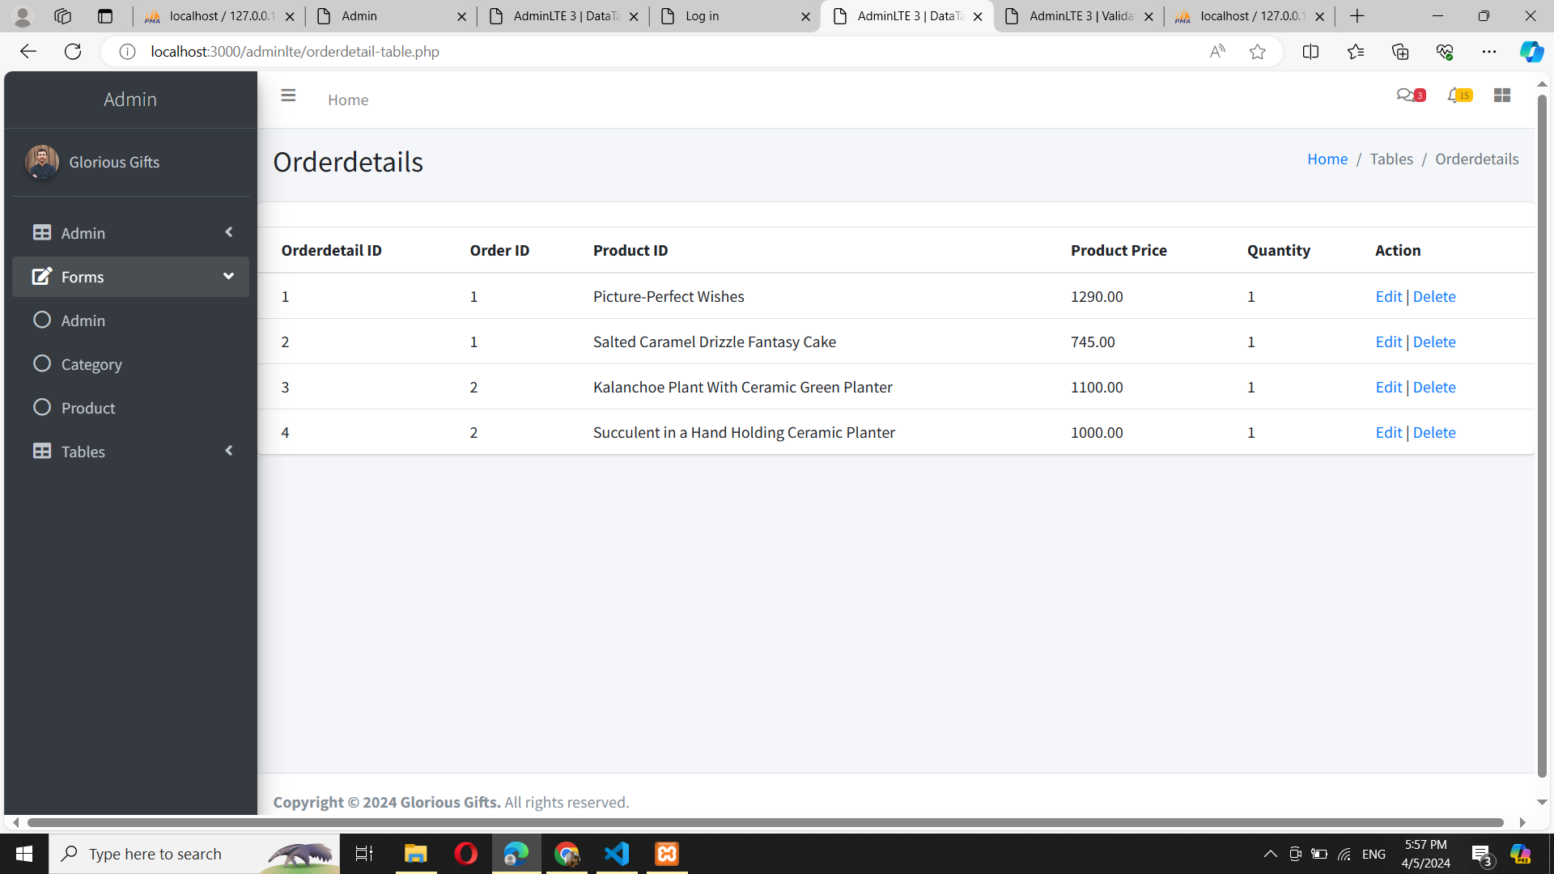

* Shipping Table

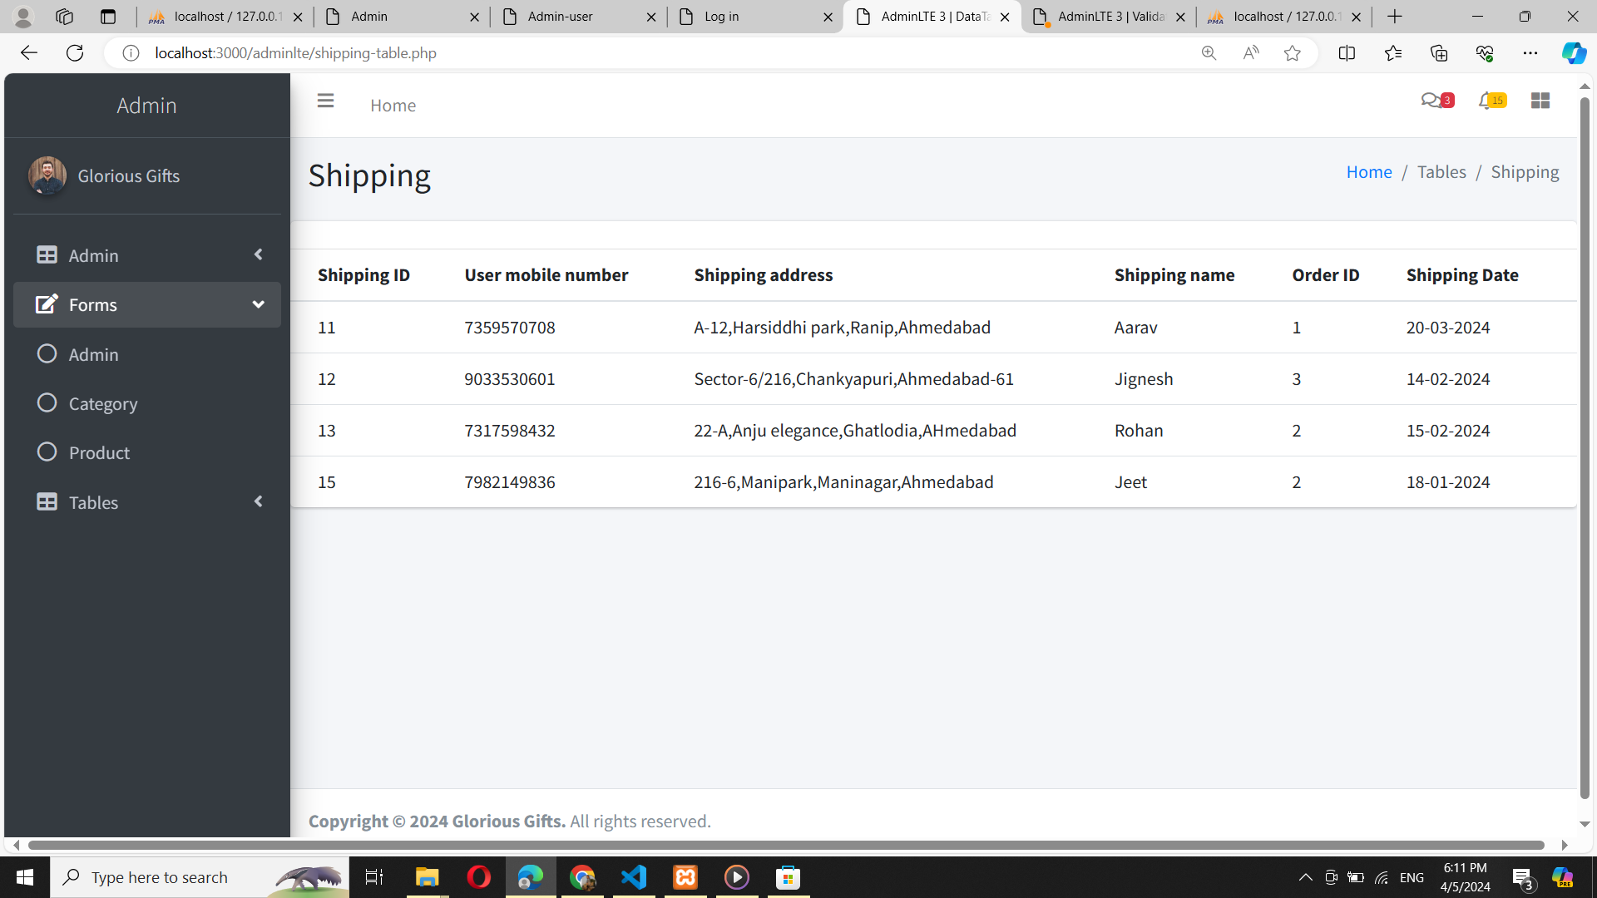

* Feedback Table

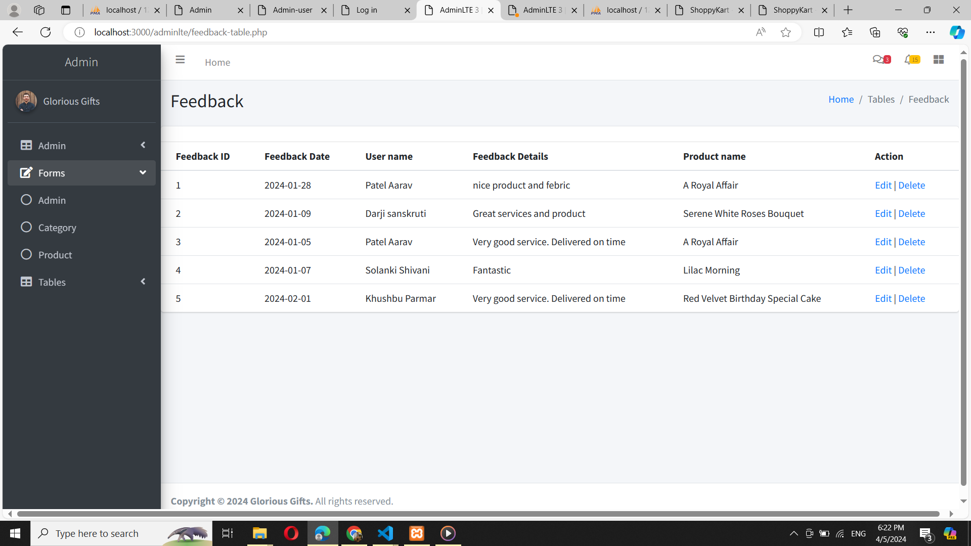

* Payment Table

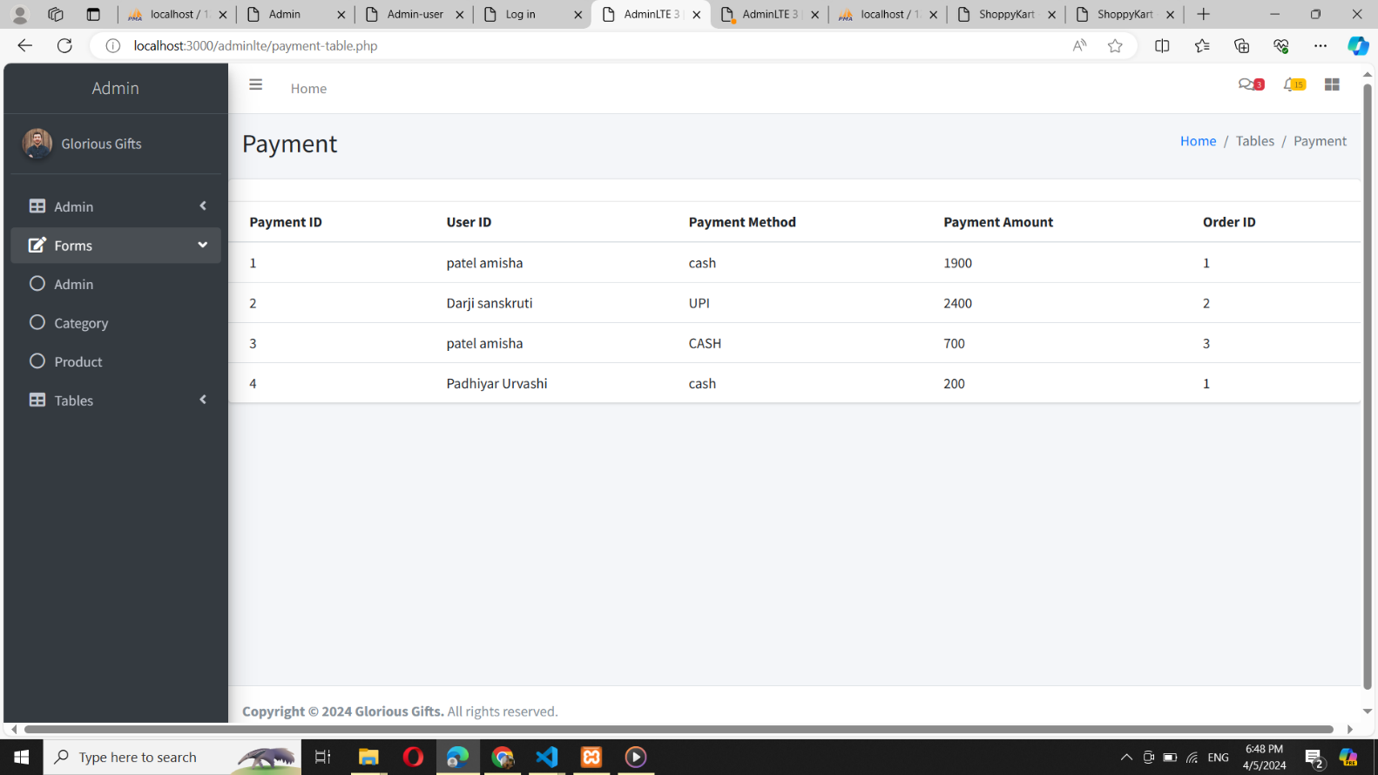

* **USER PANEL**
* HOME PAGE

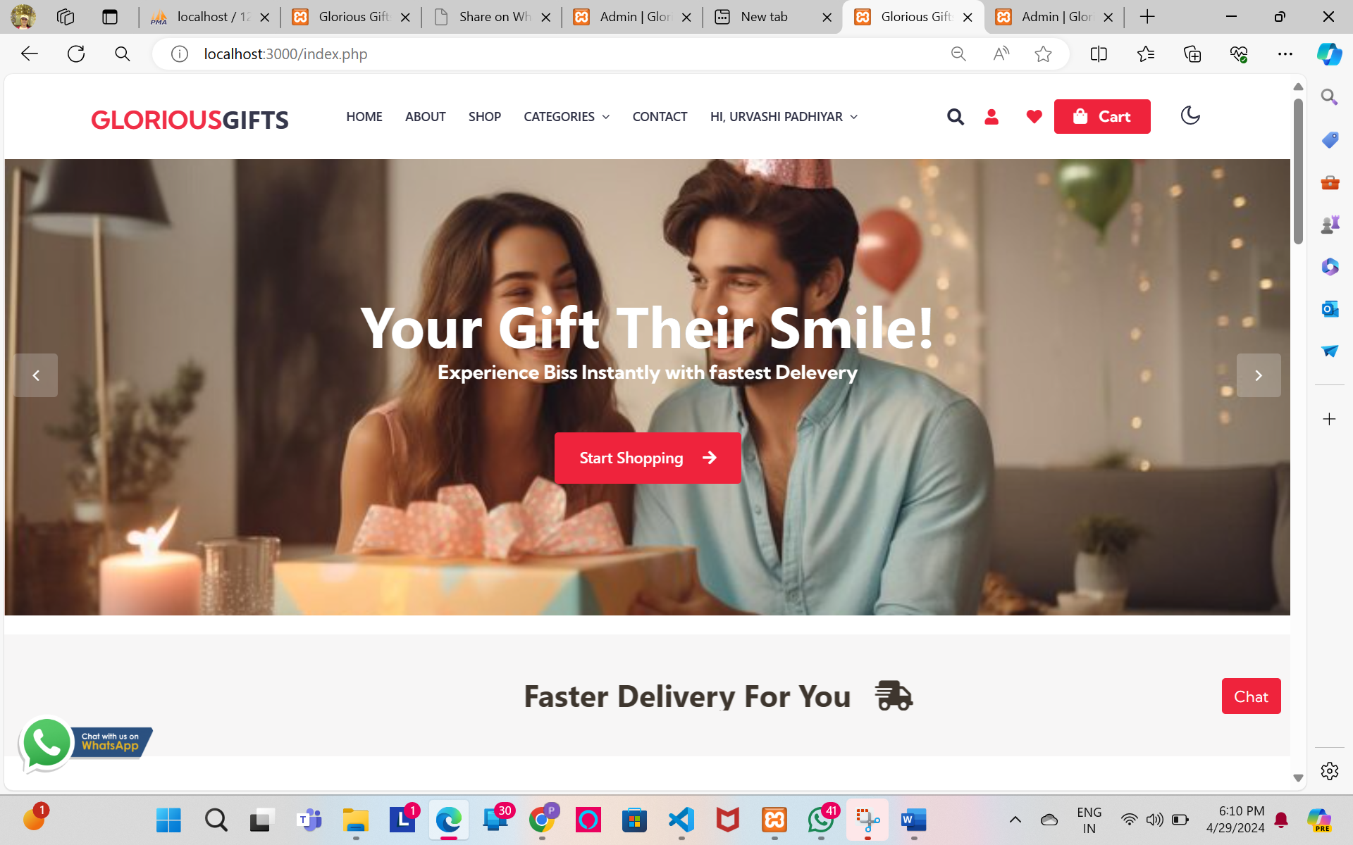

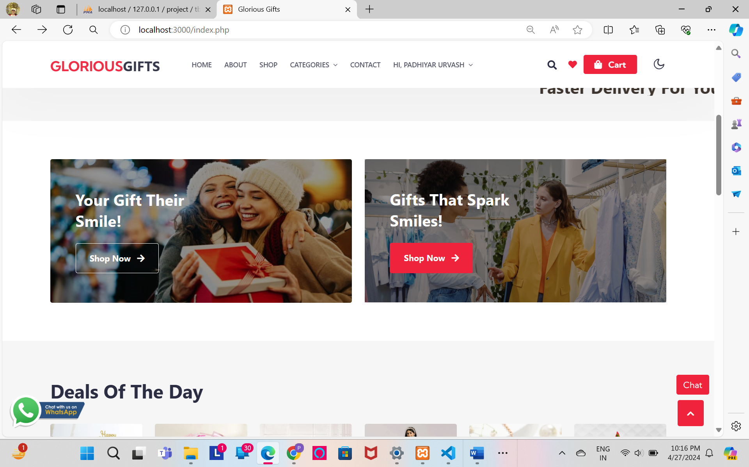

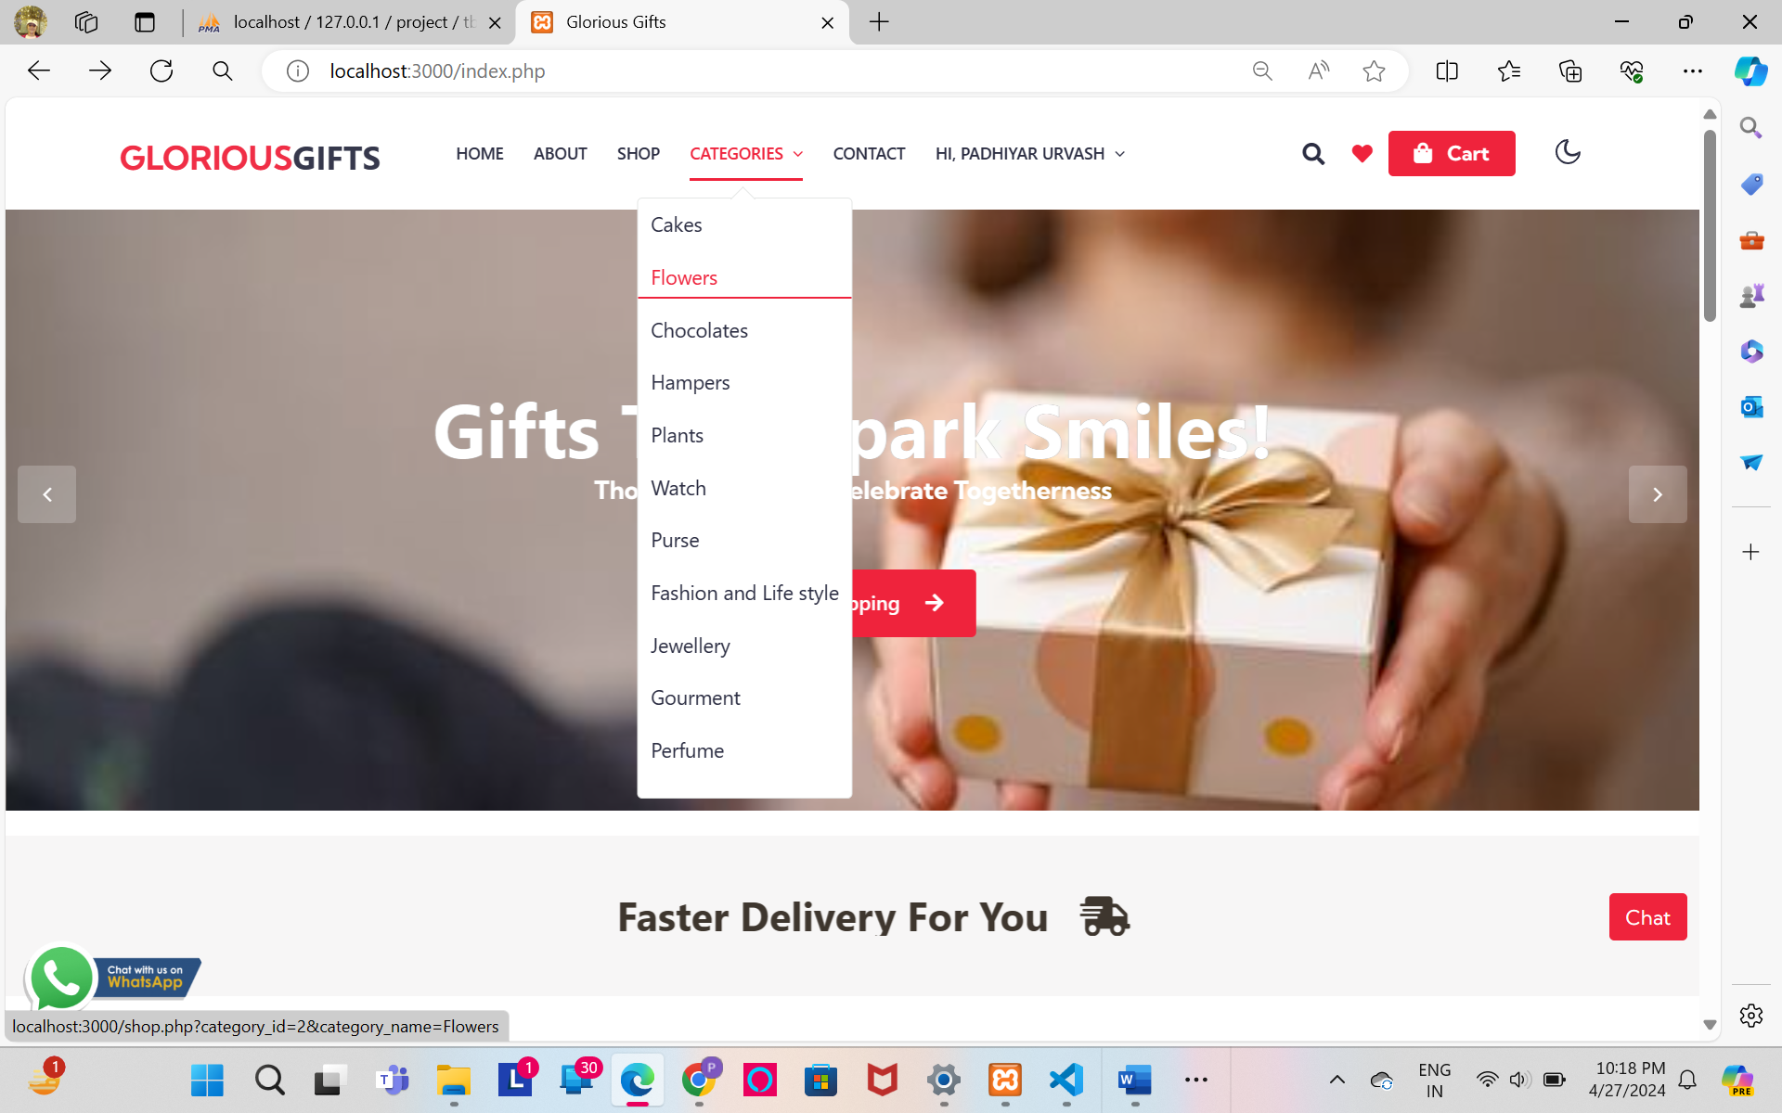

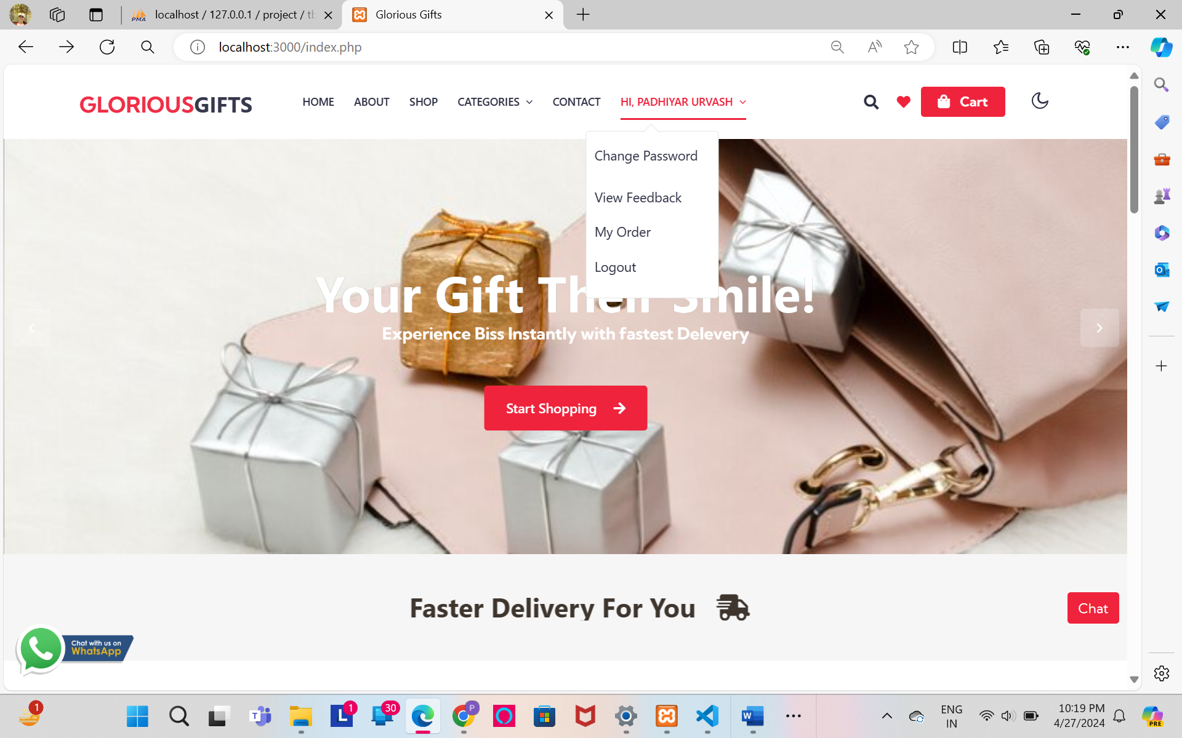

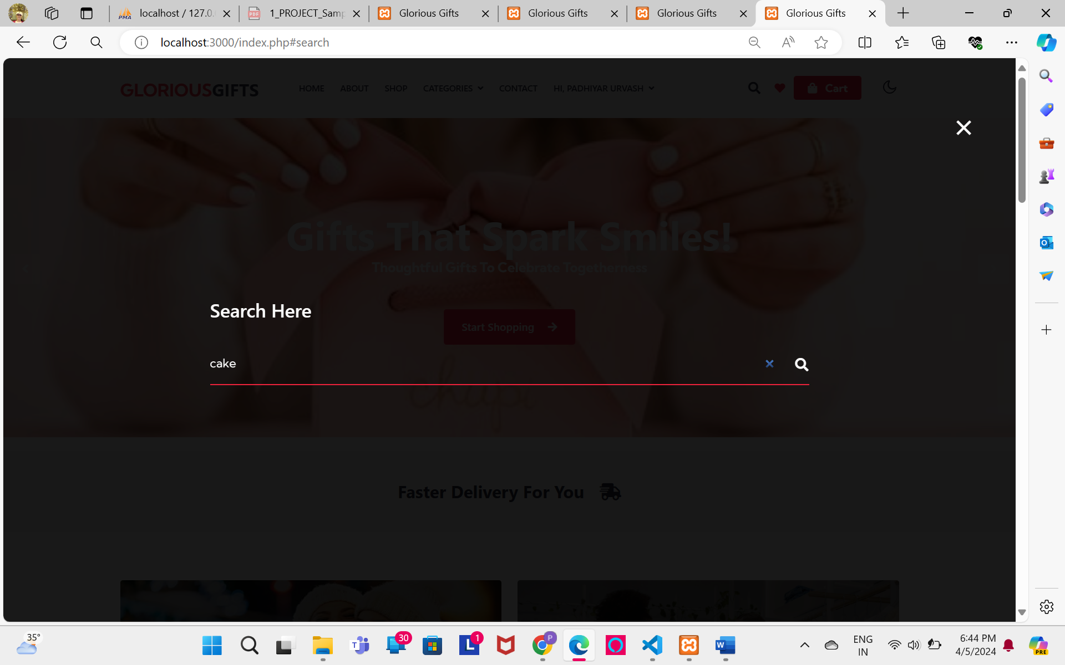

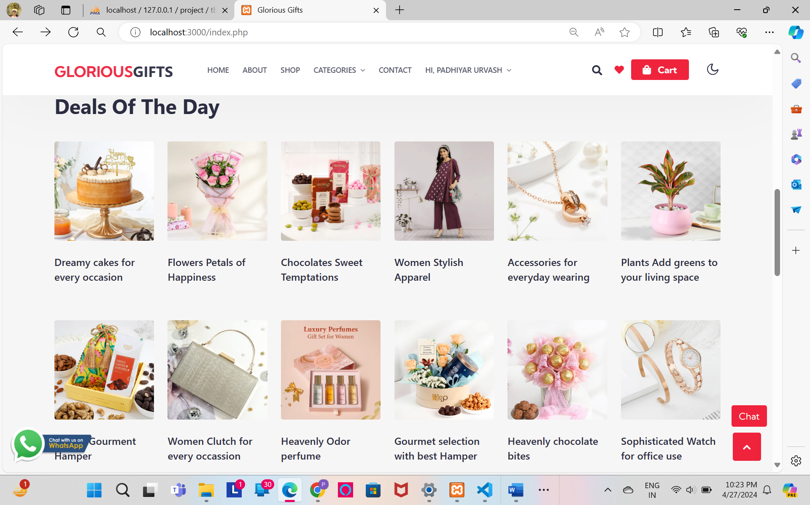

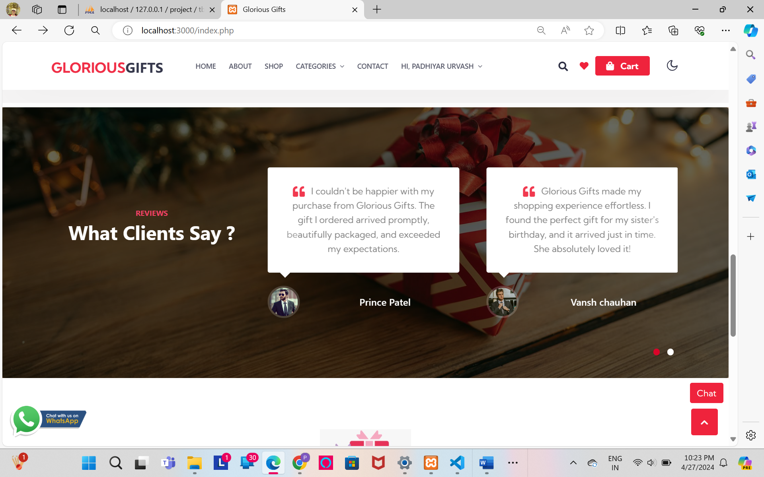

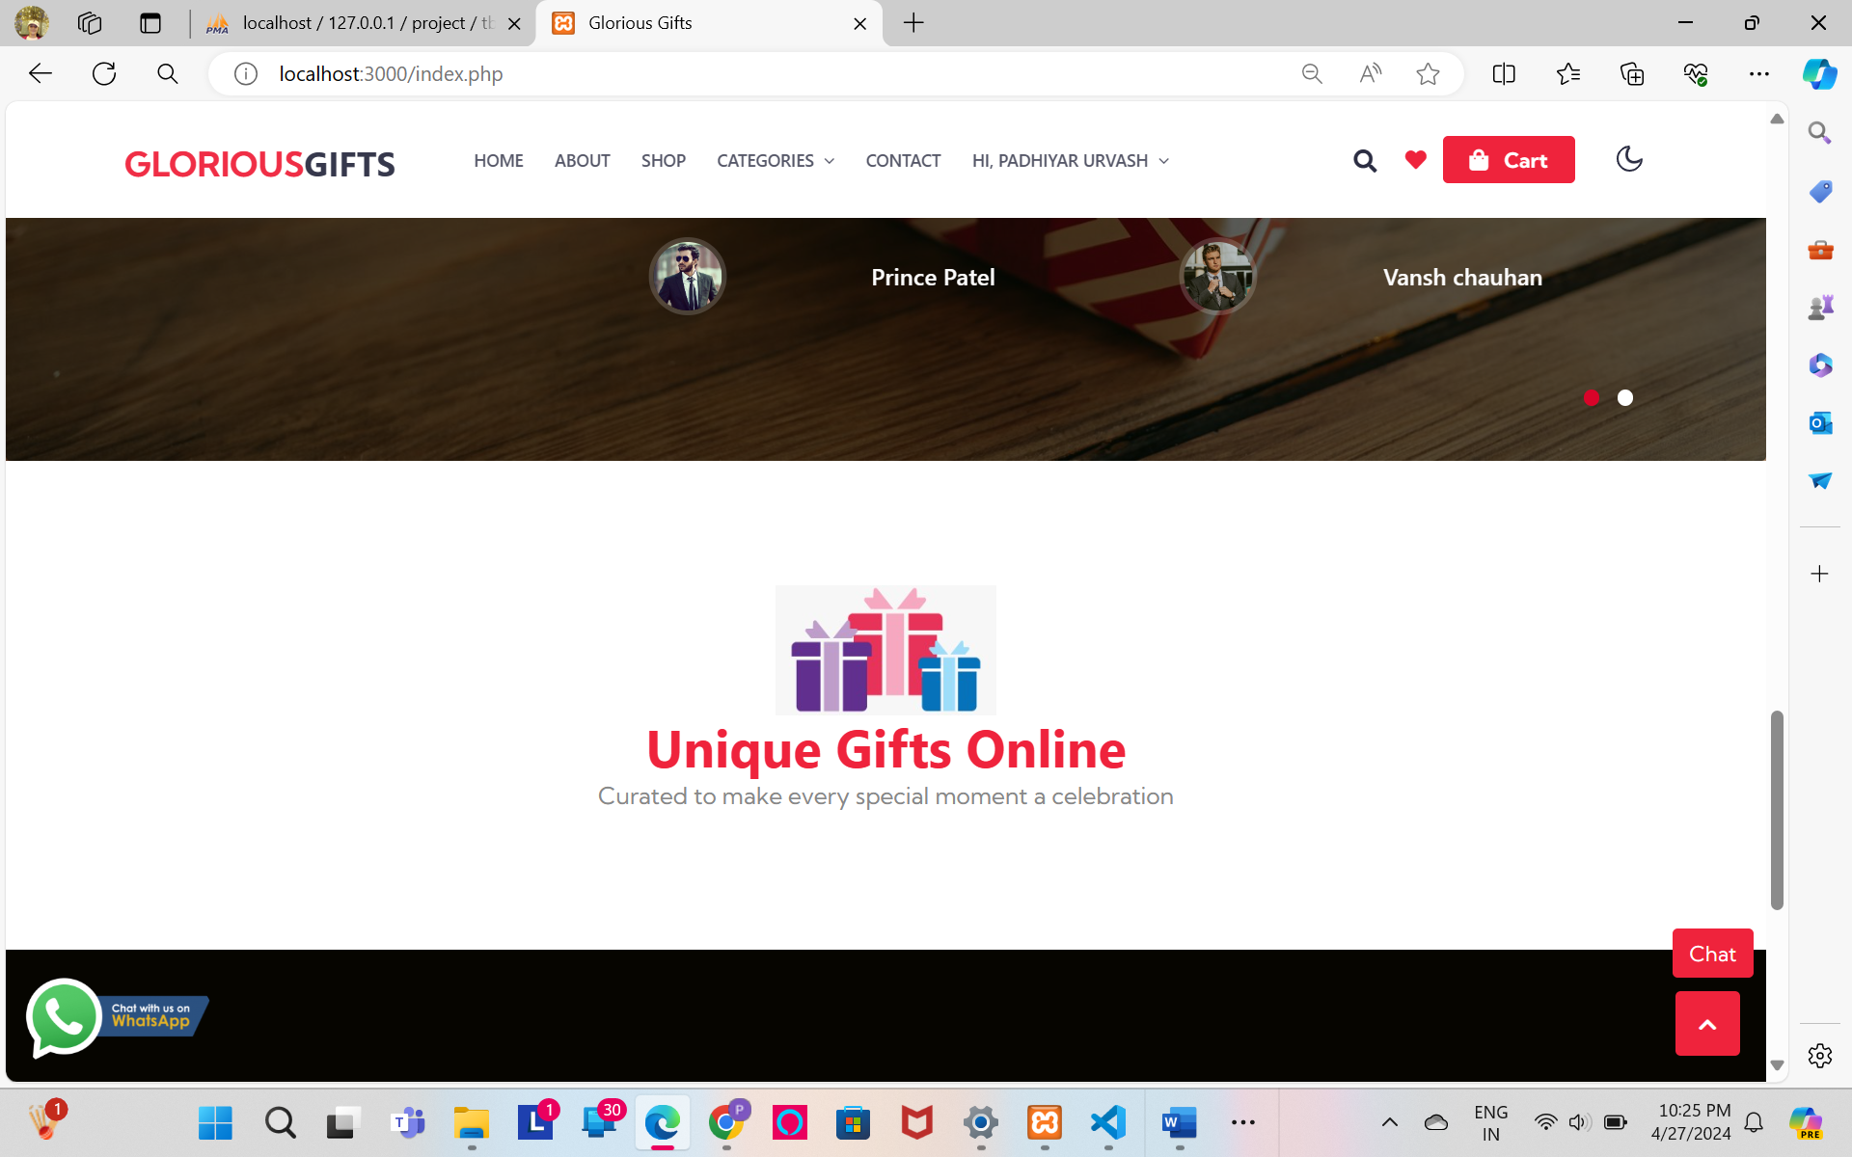

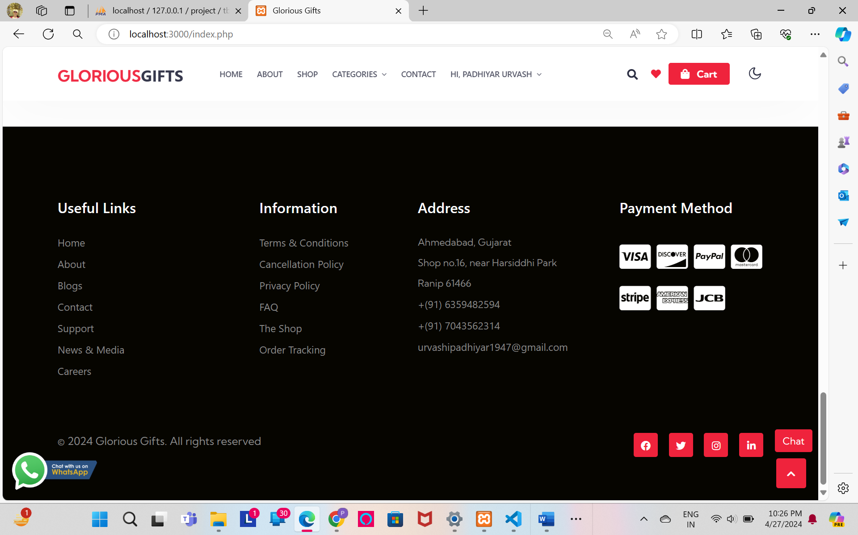

* About us

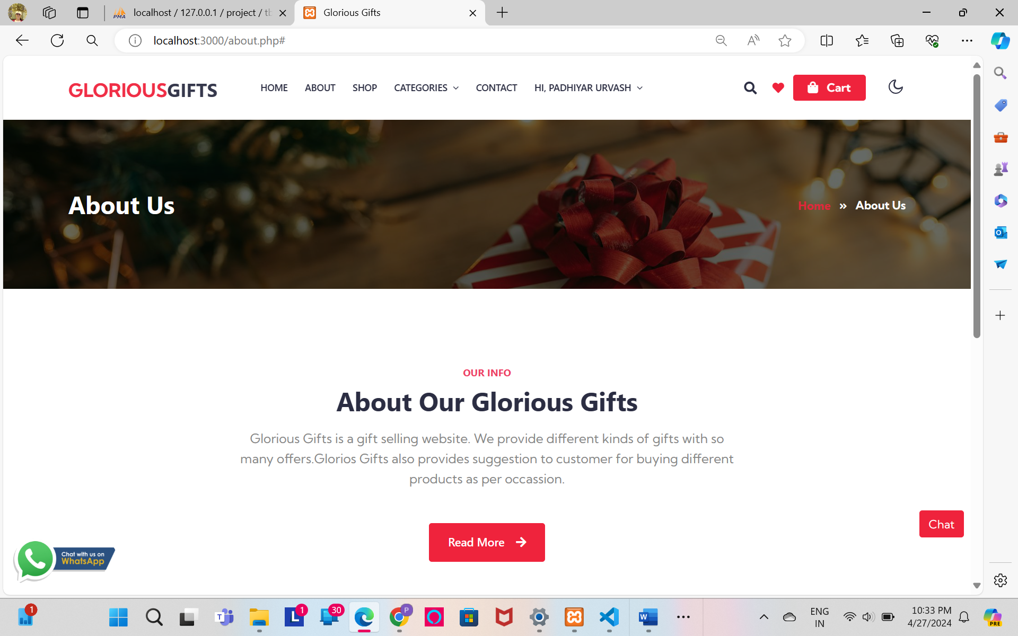

* Contact us

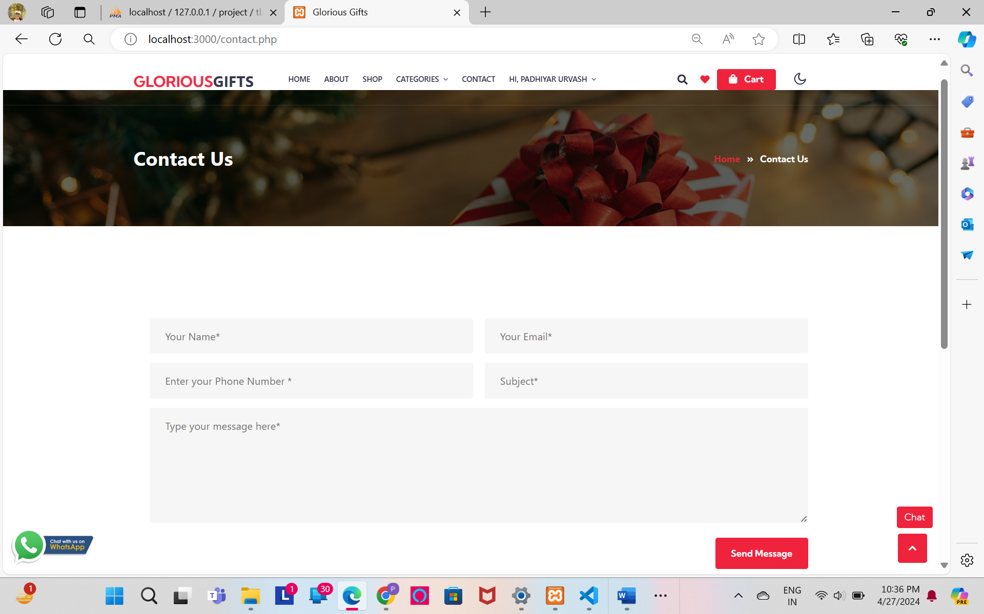

* Signup

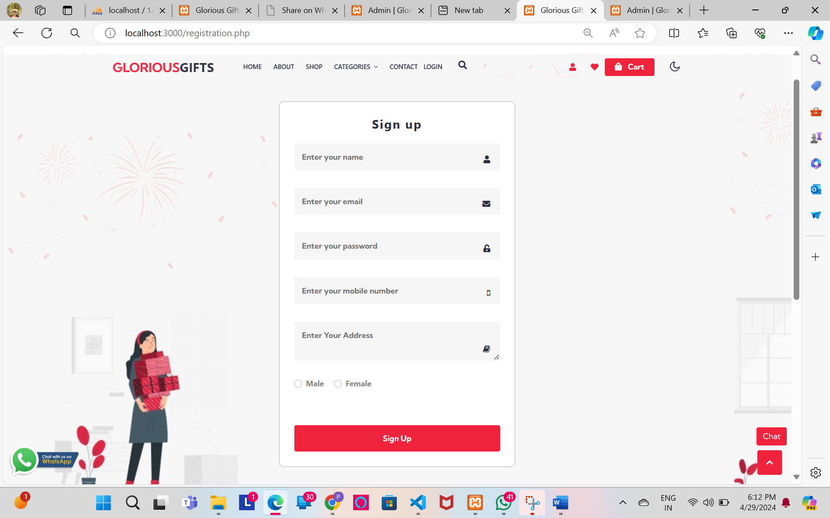

* Signup with Validation

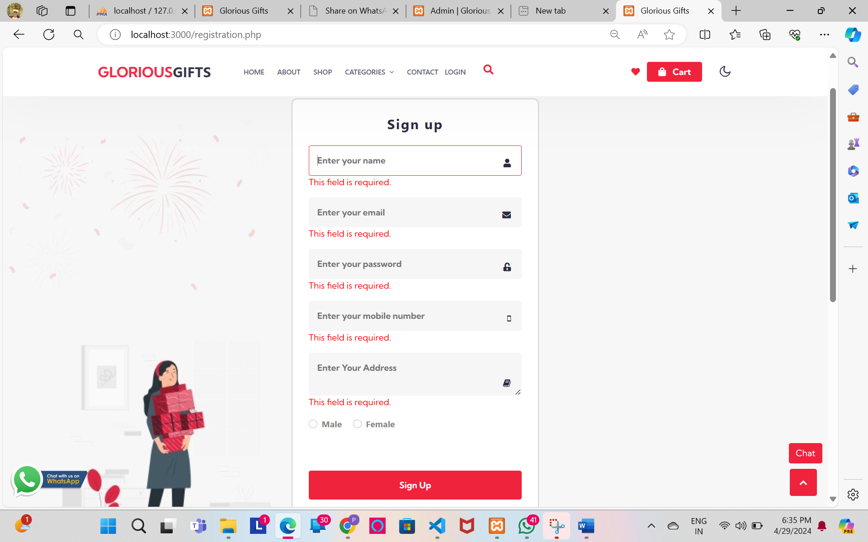

* Login

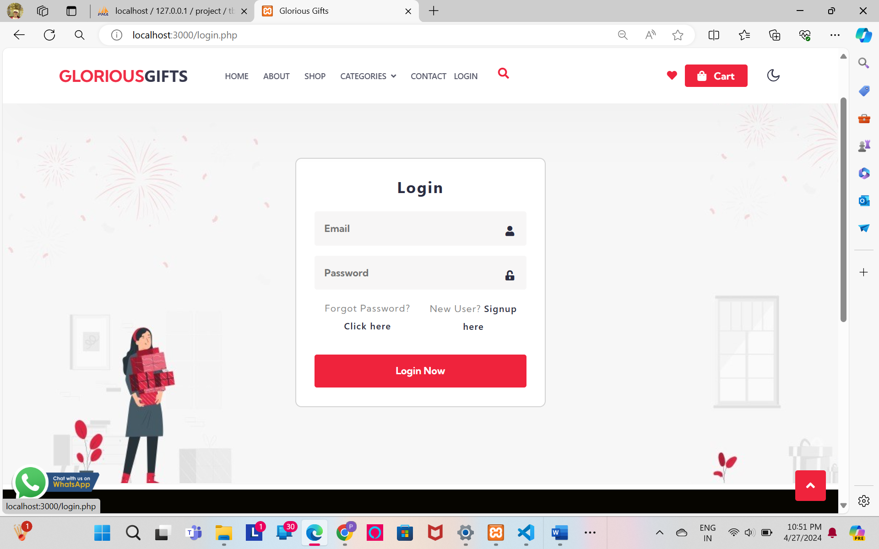

* Login With Validation

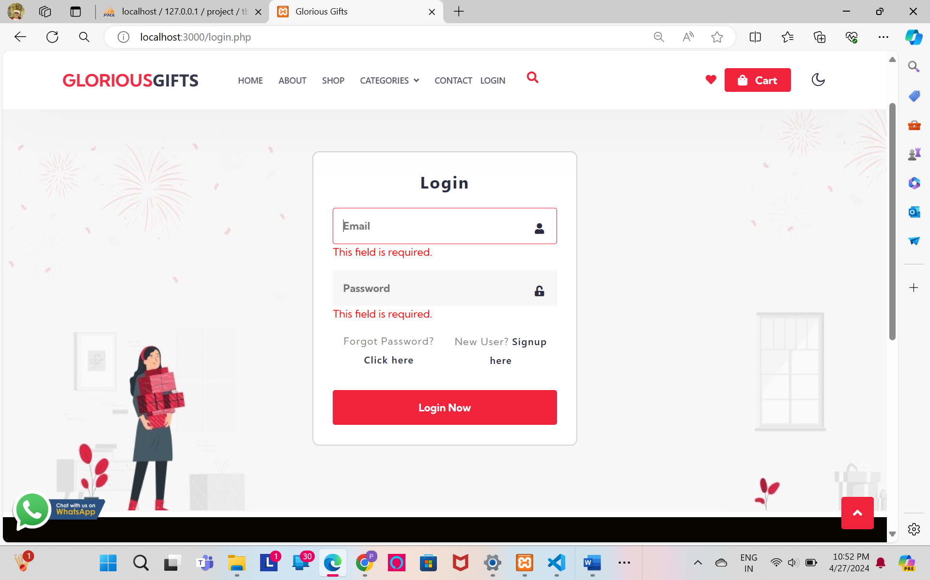

* Change Password

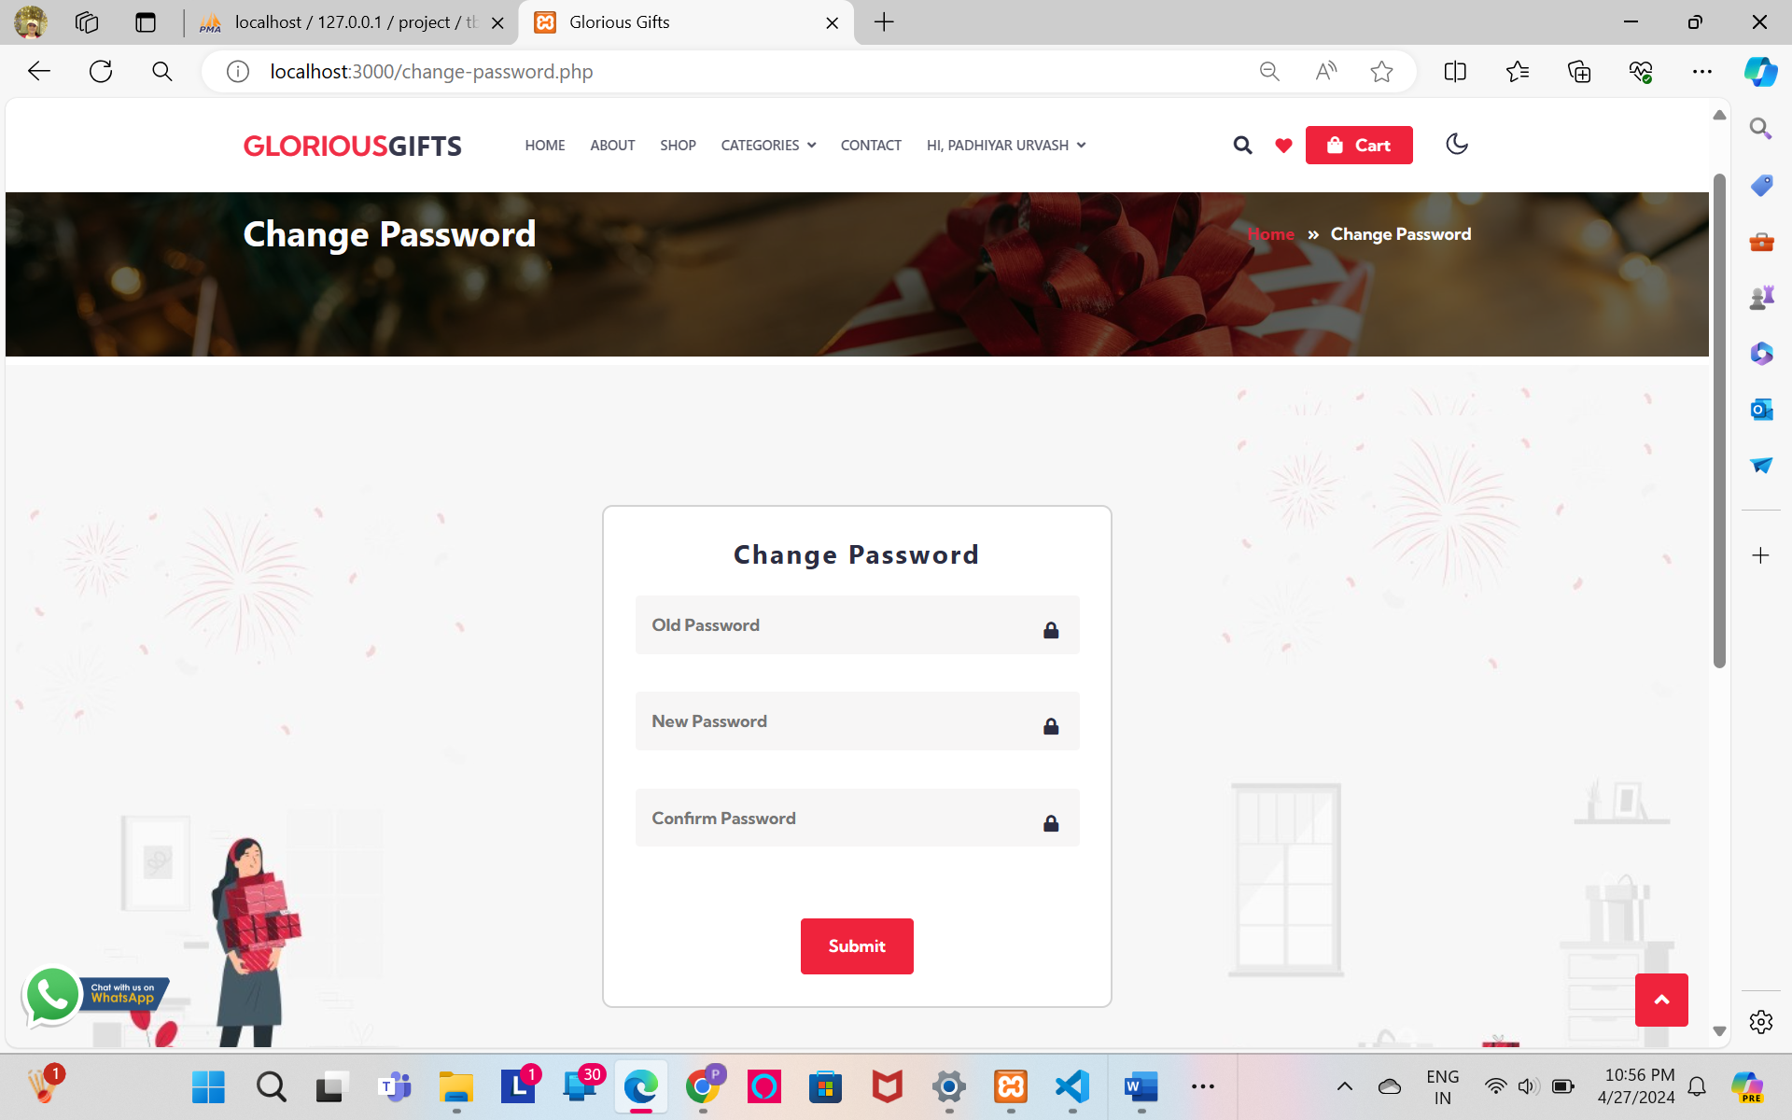

* Change Password Validation

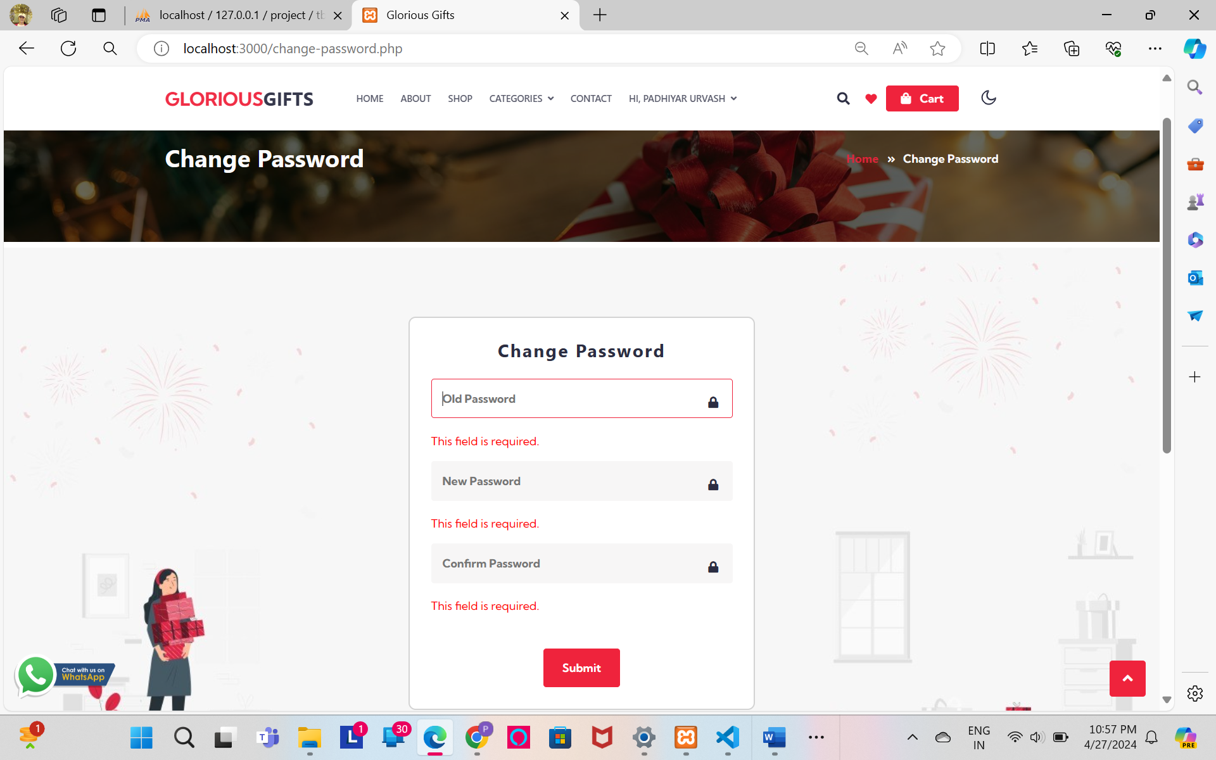

* forgot password

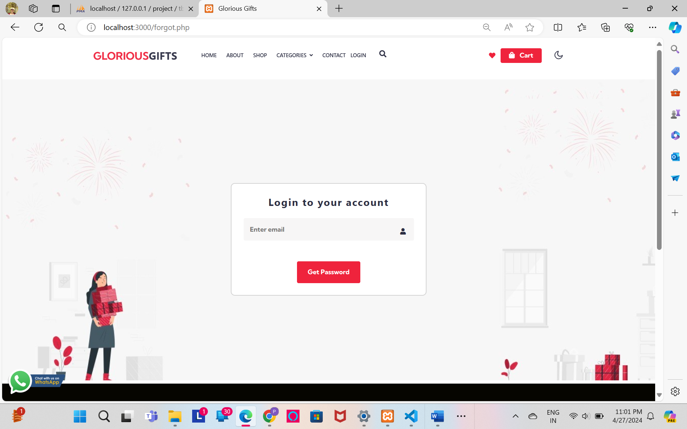

* forgot password with Validation

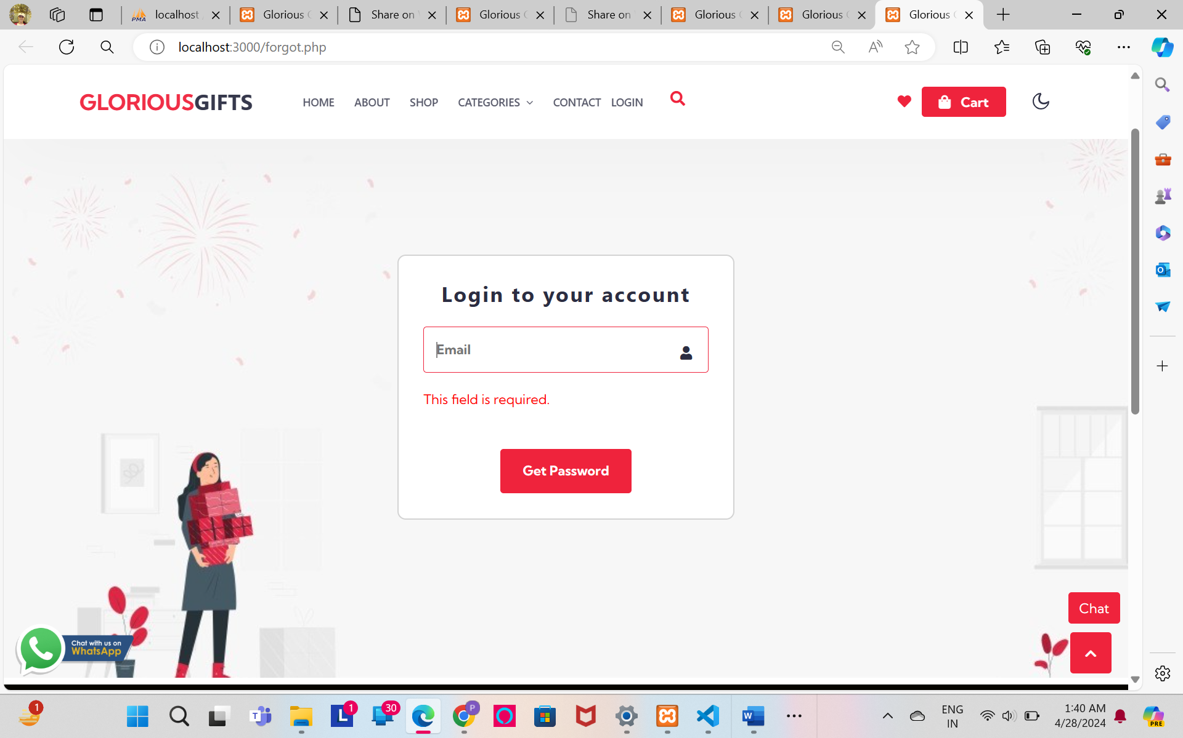

* + forgot password email:

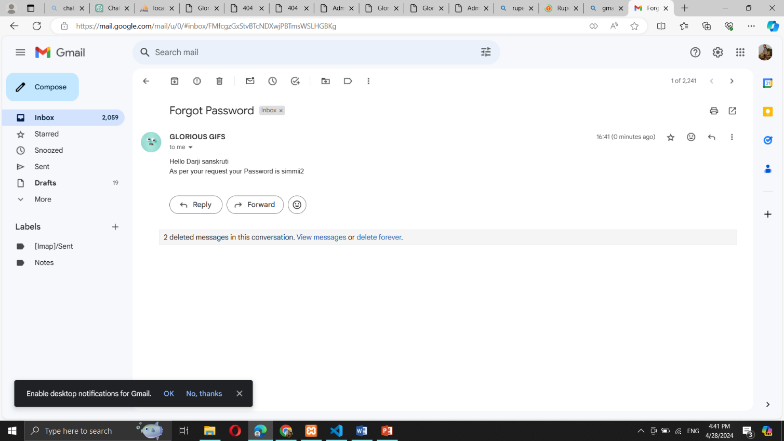

* + forgot password email:

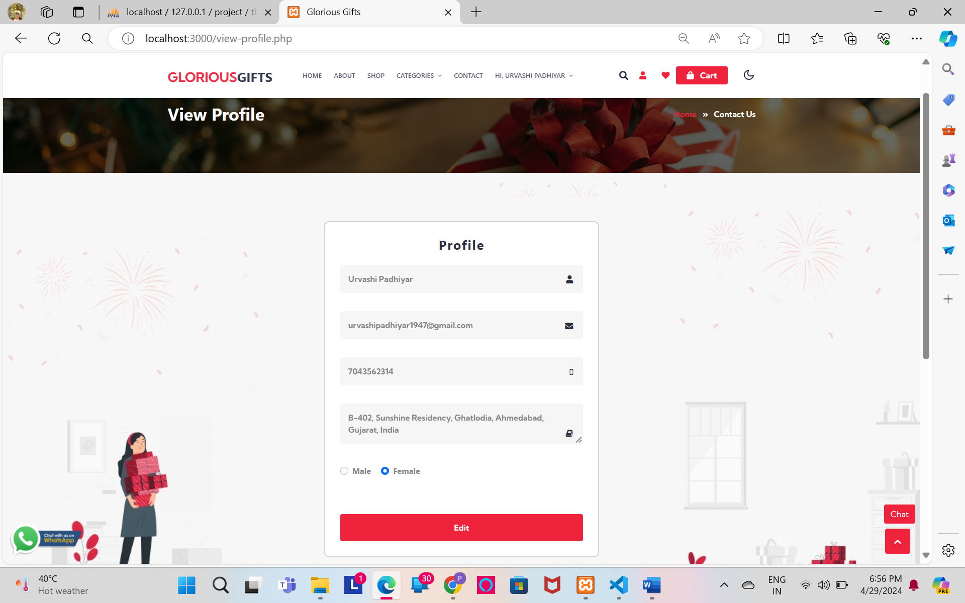

* Product List

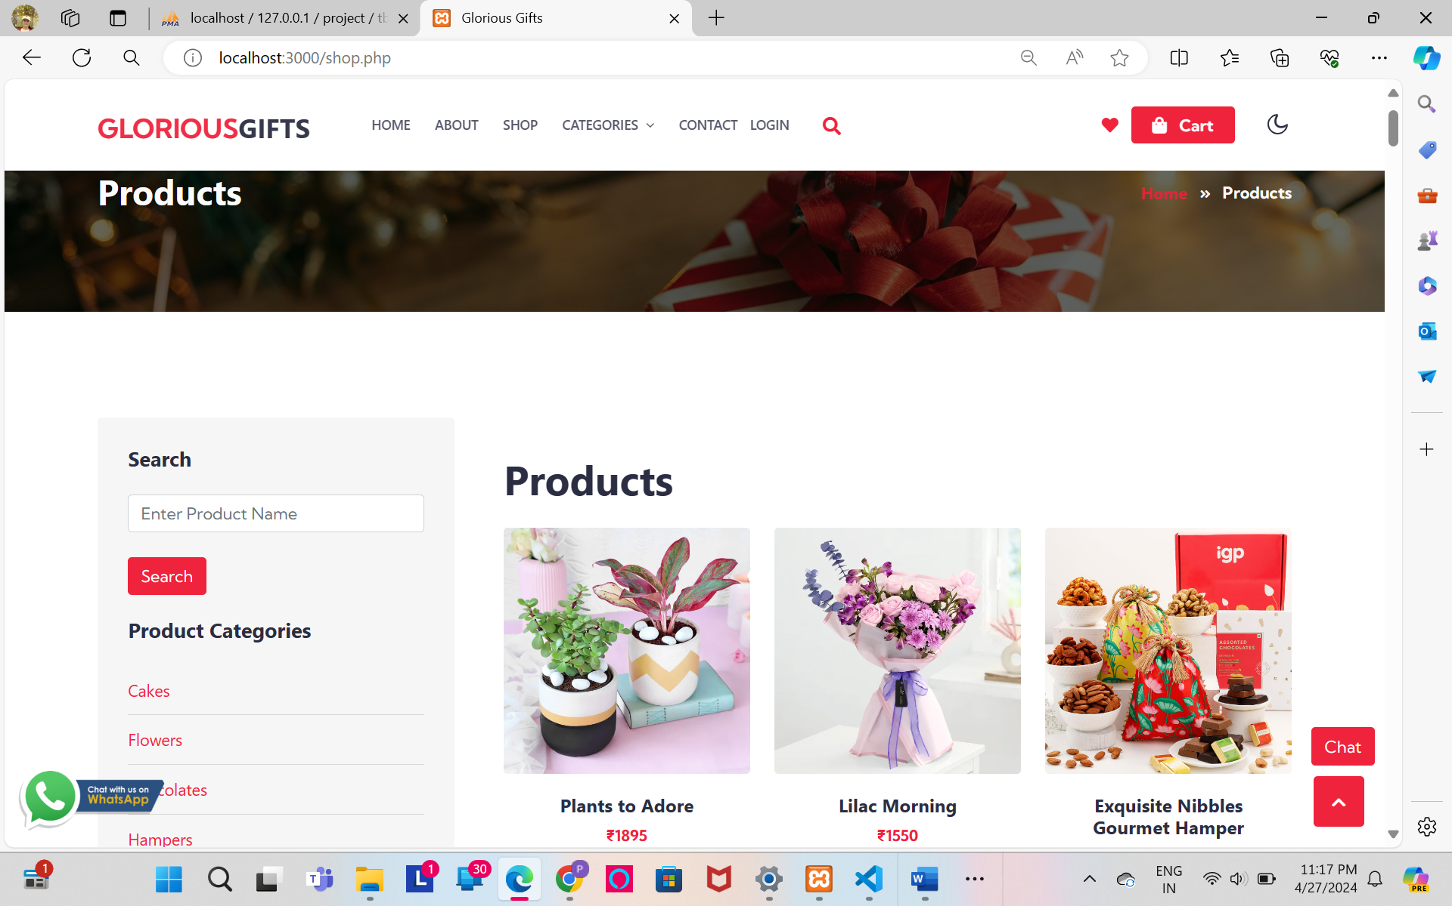

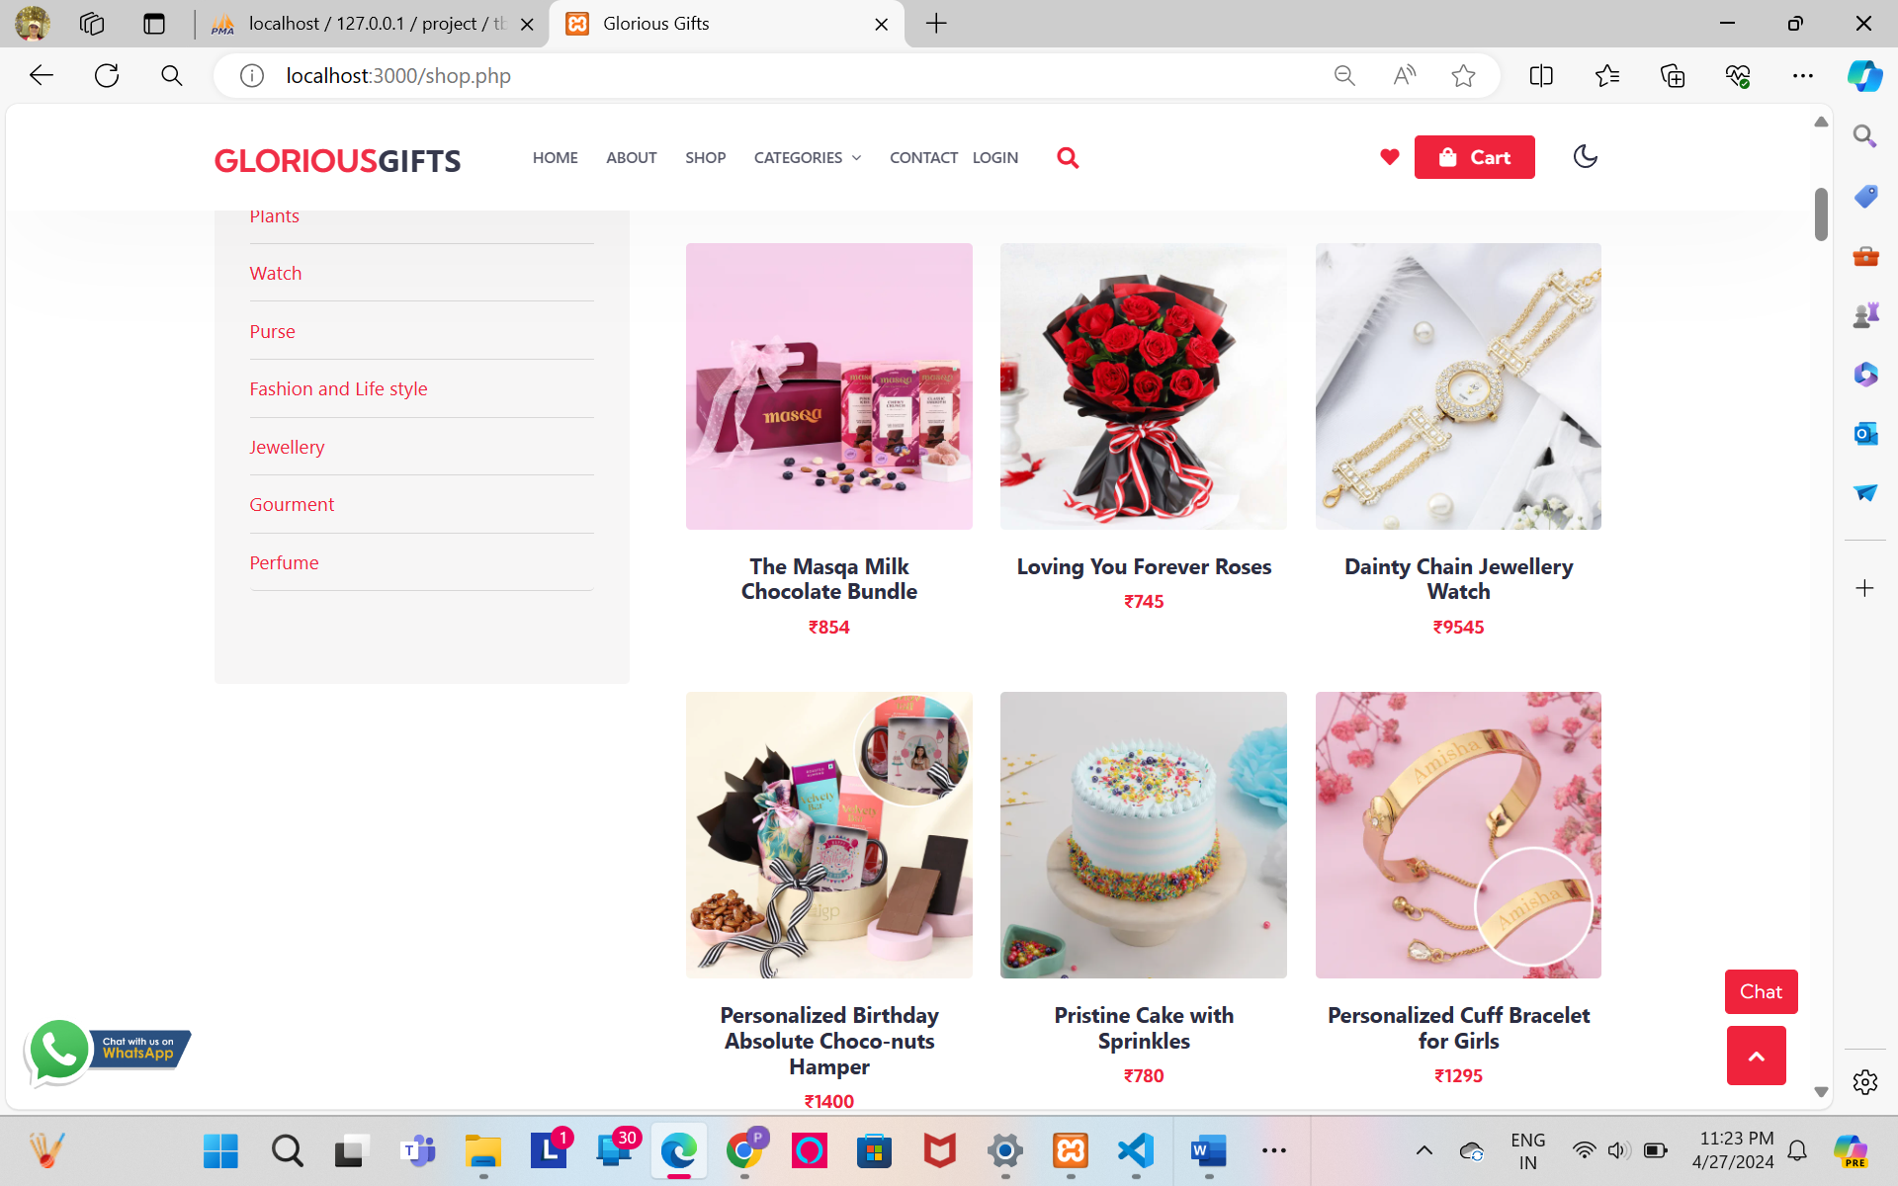

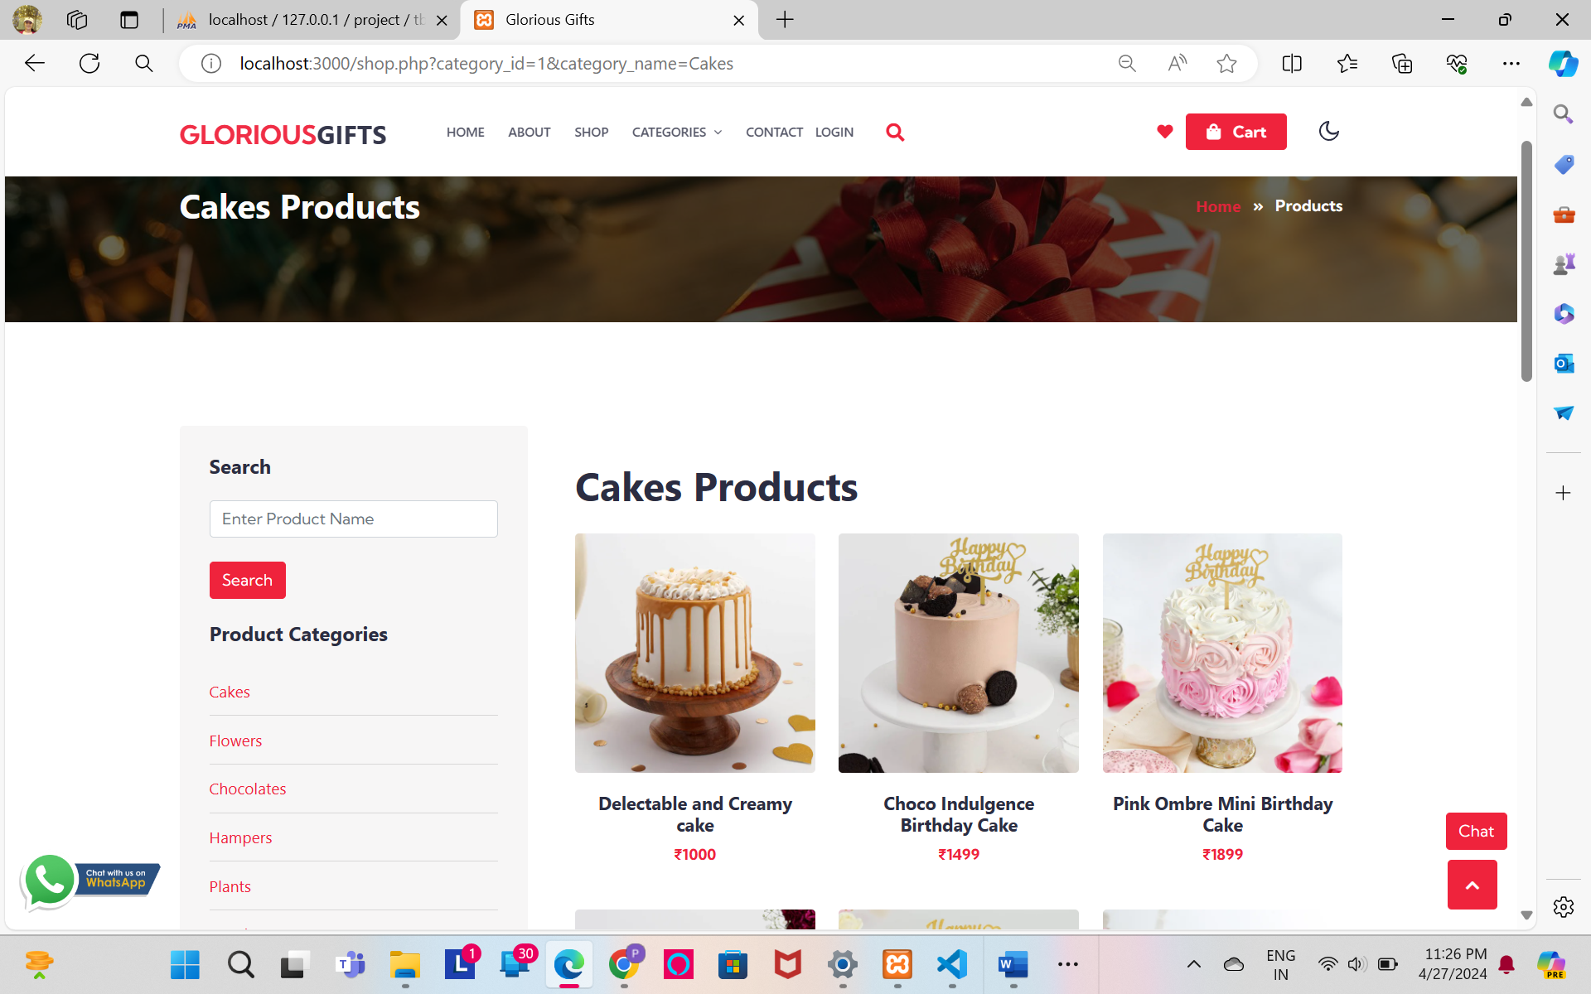

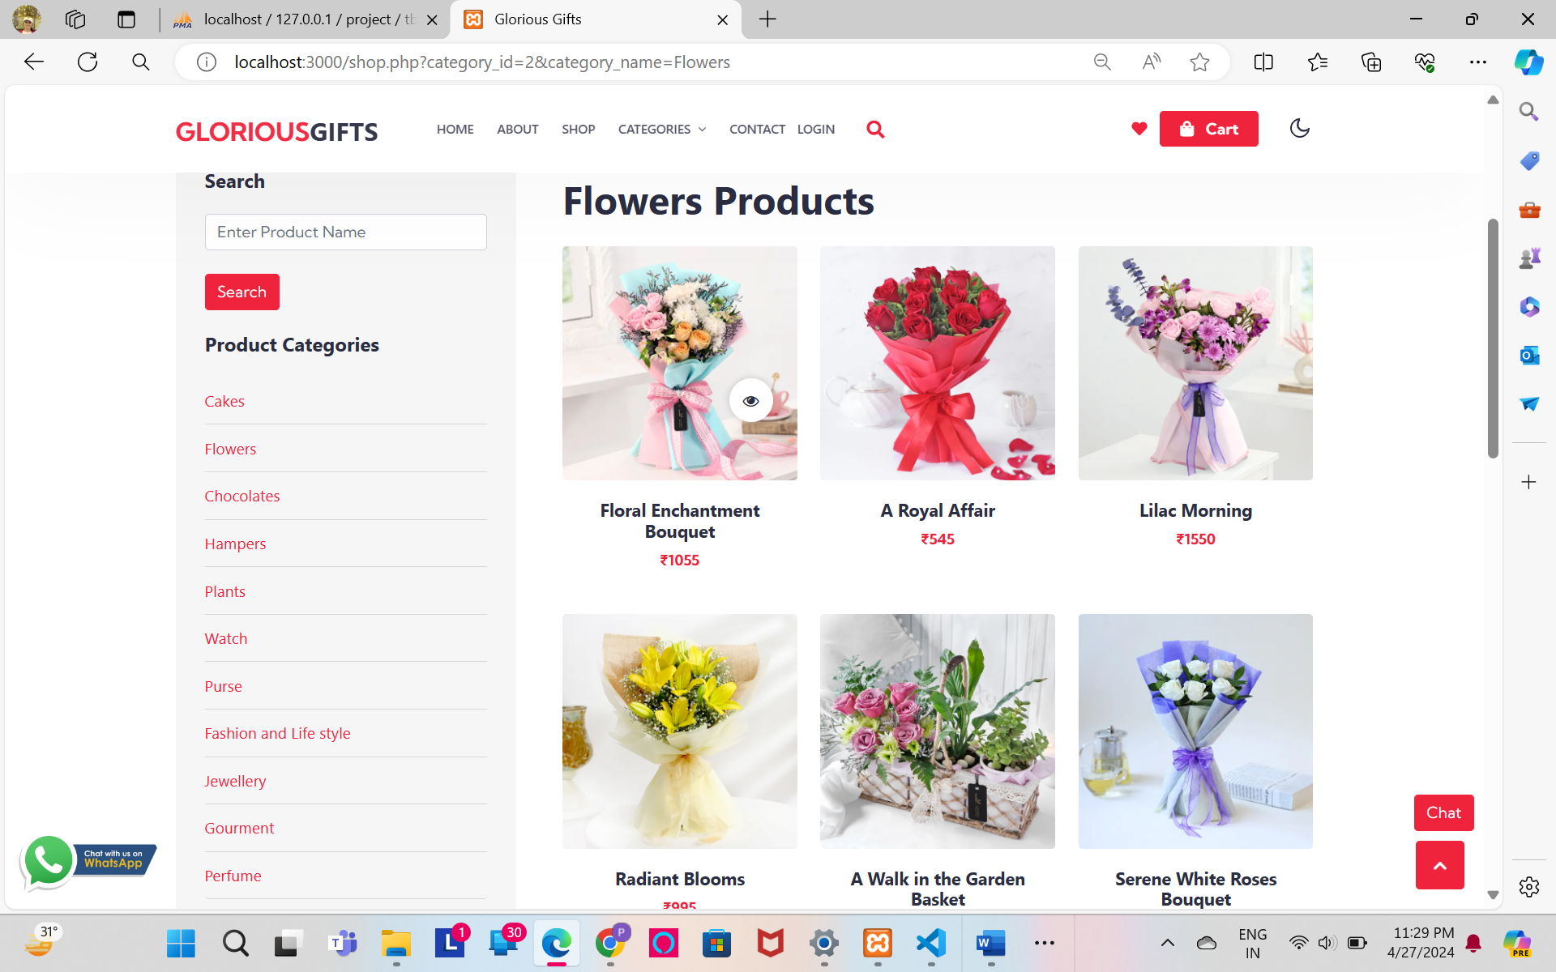

* Details

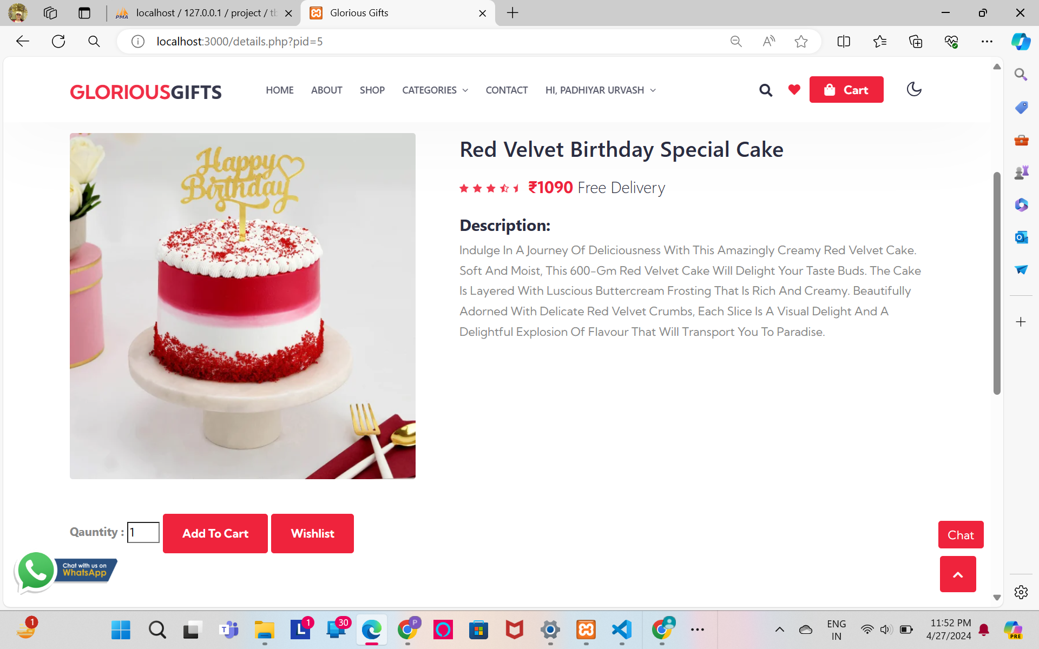

* Add to Cart

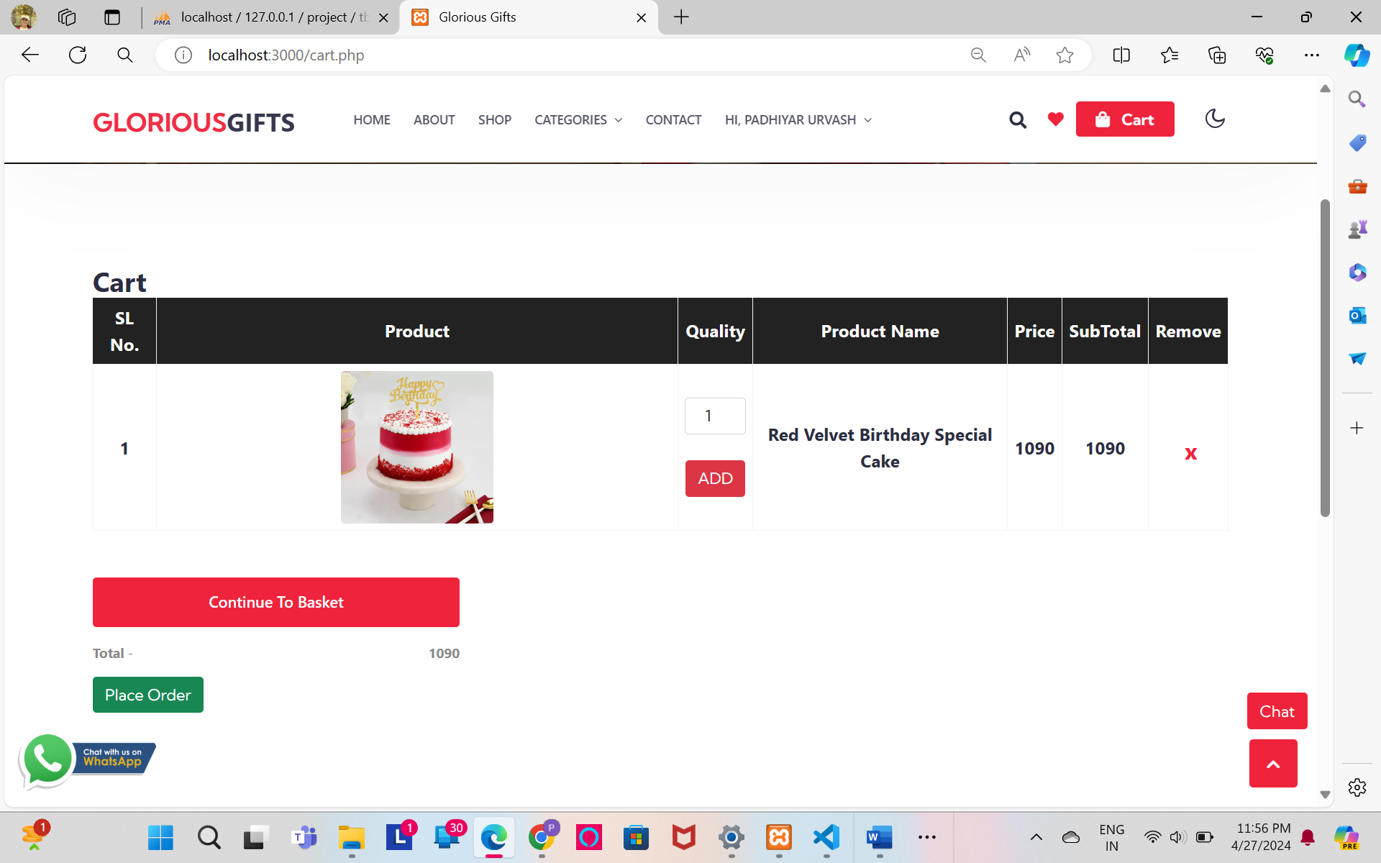

* Shipping
* Cash

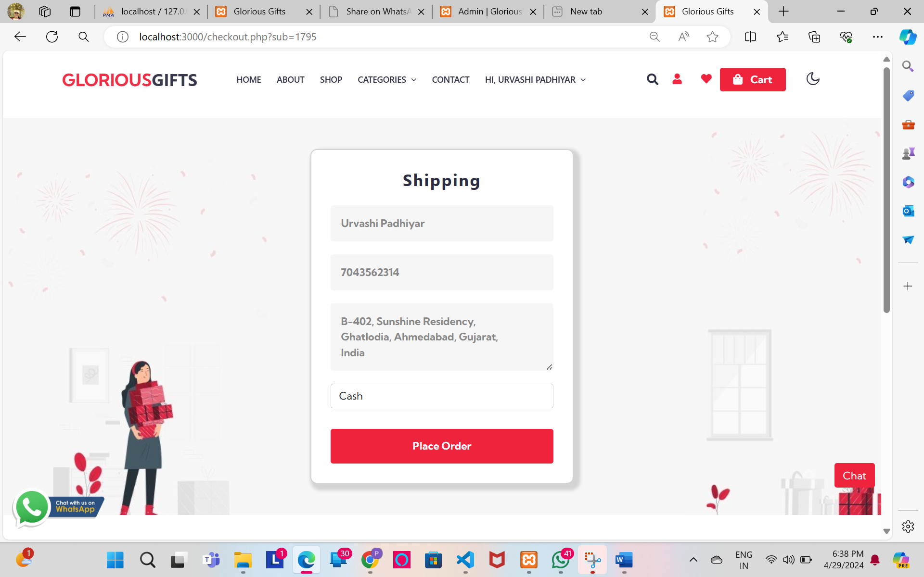

* UPI

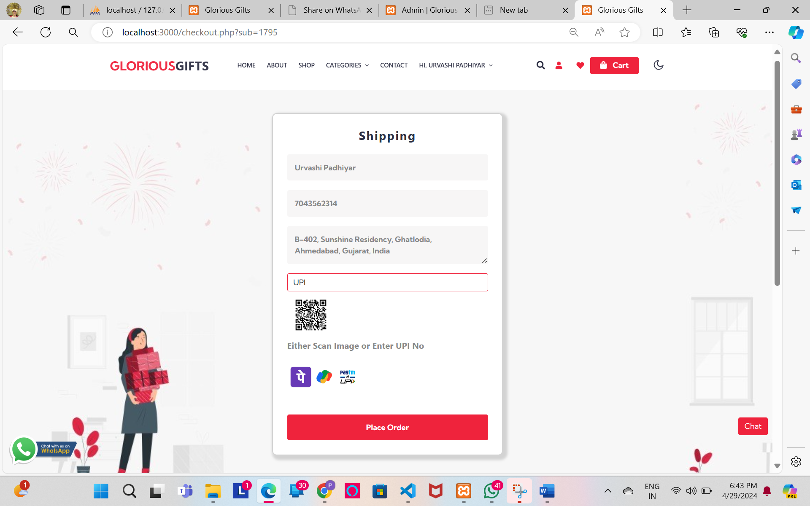

* Card

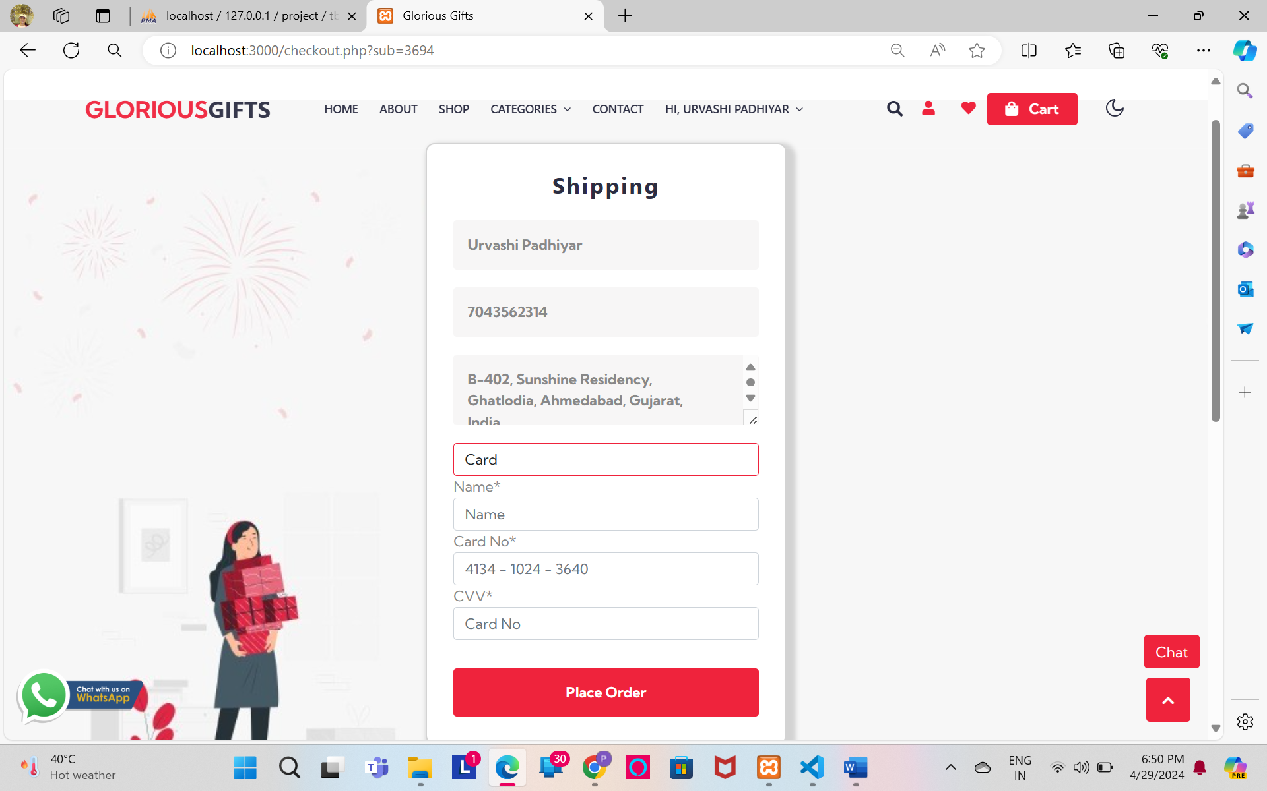

* Shipping Validation

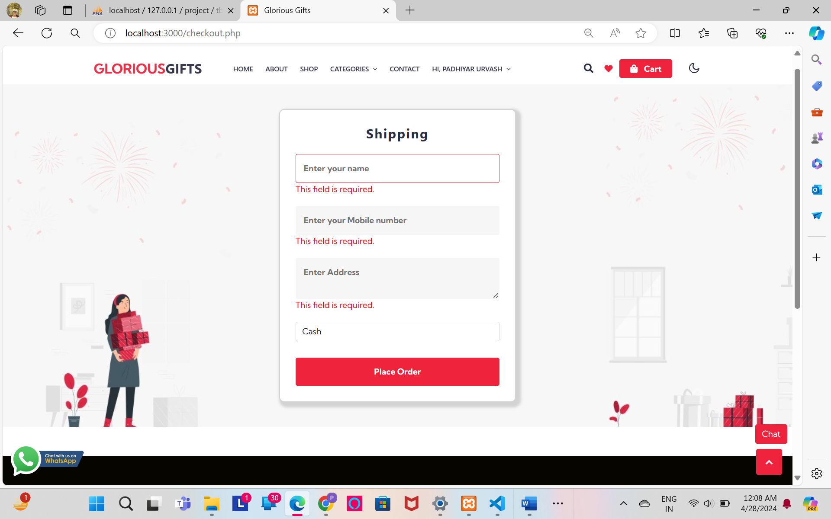

* Order Placed

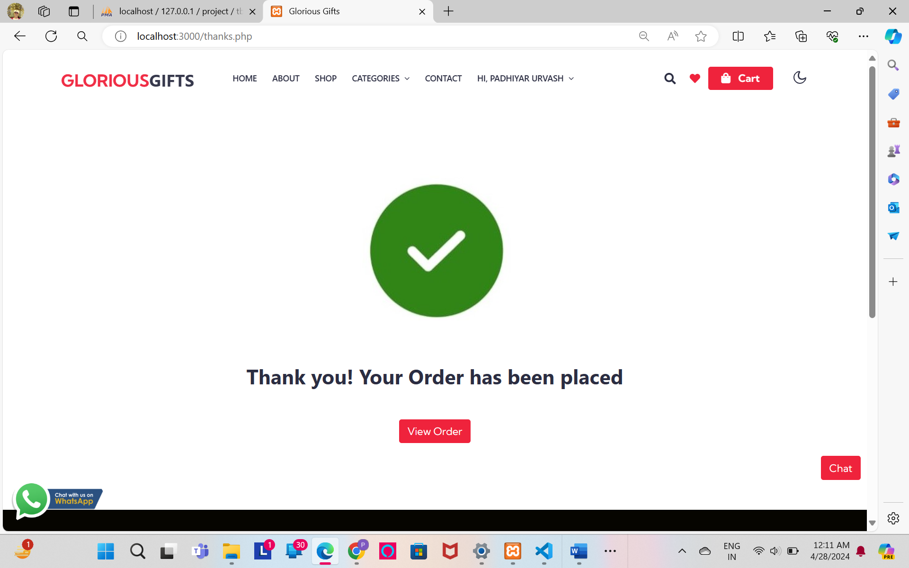

* View Order

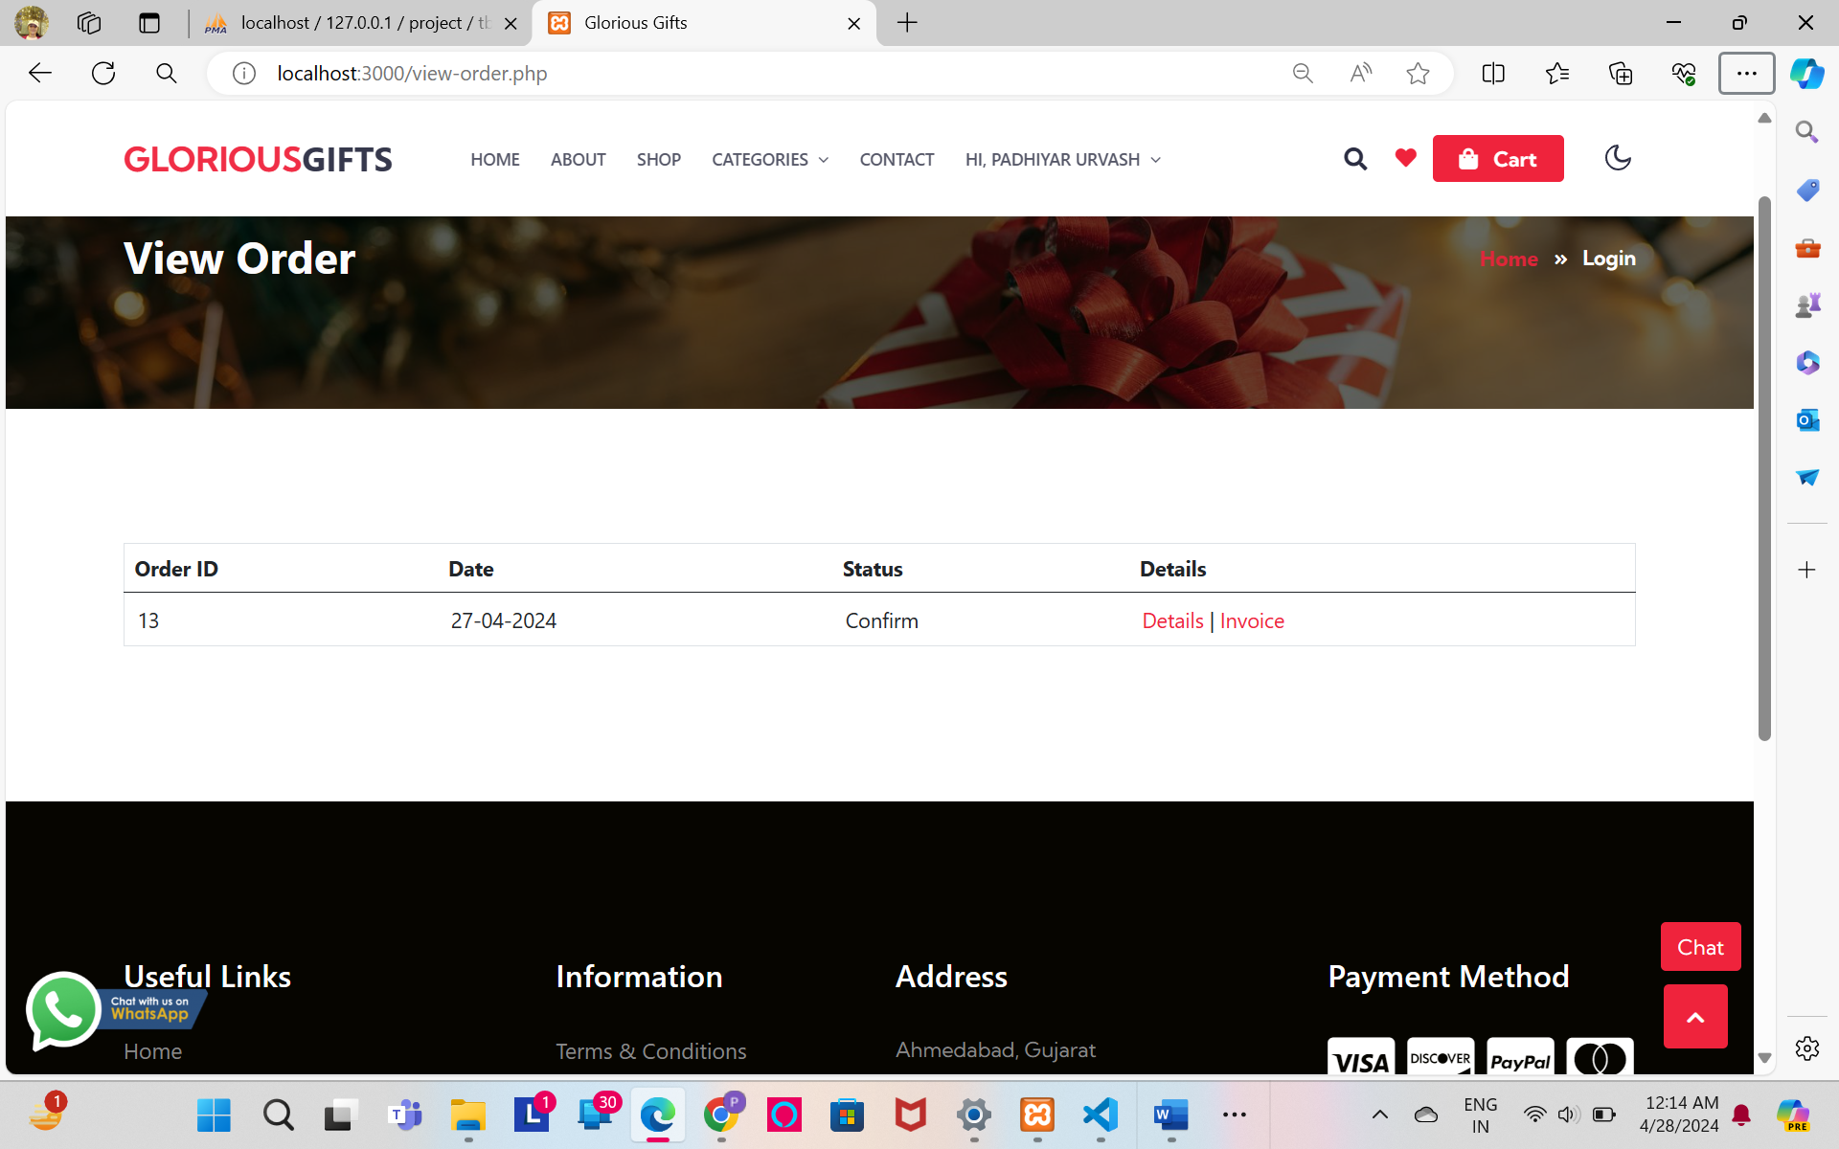

* Order Details

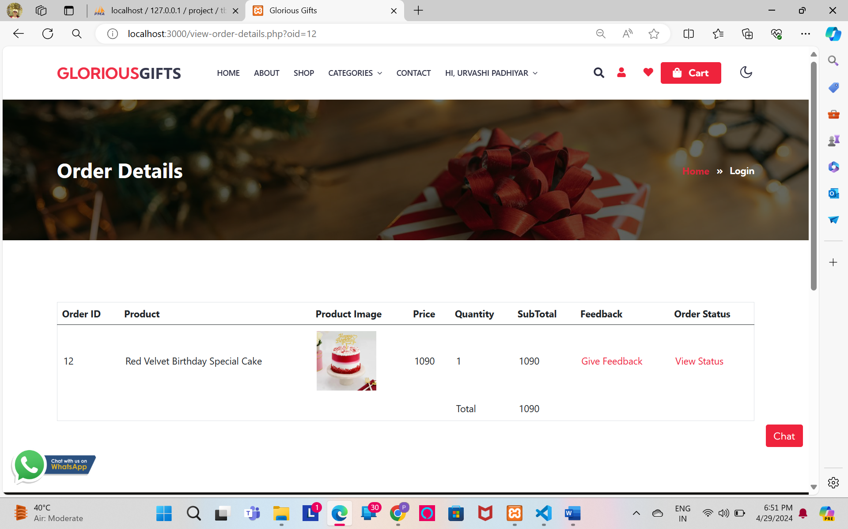

* Feedback

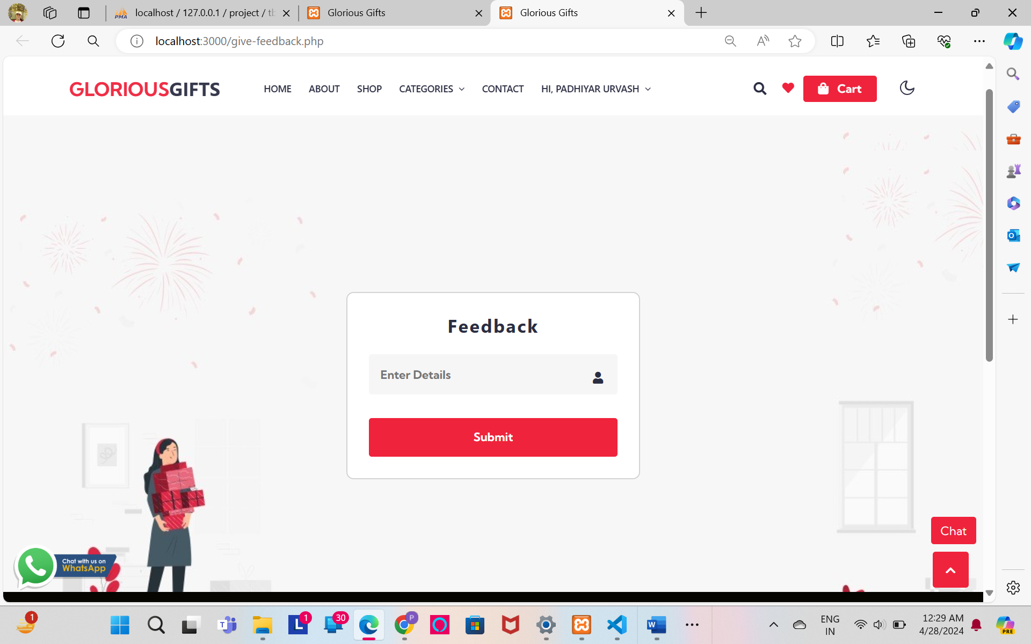

* Feedback Validation

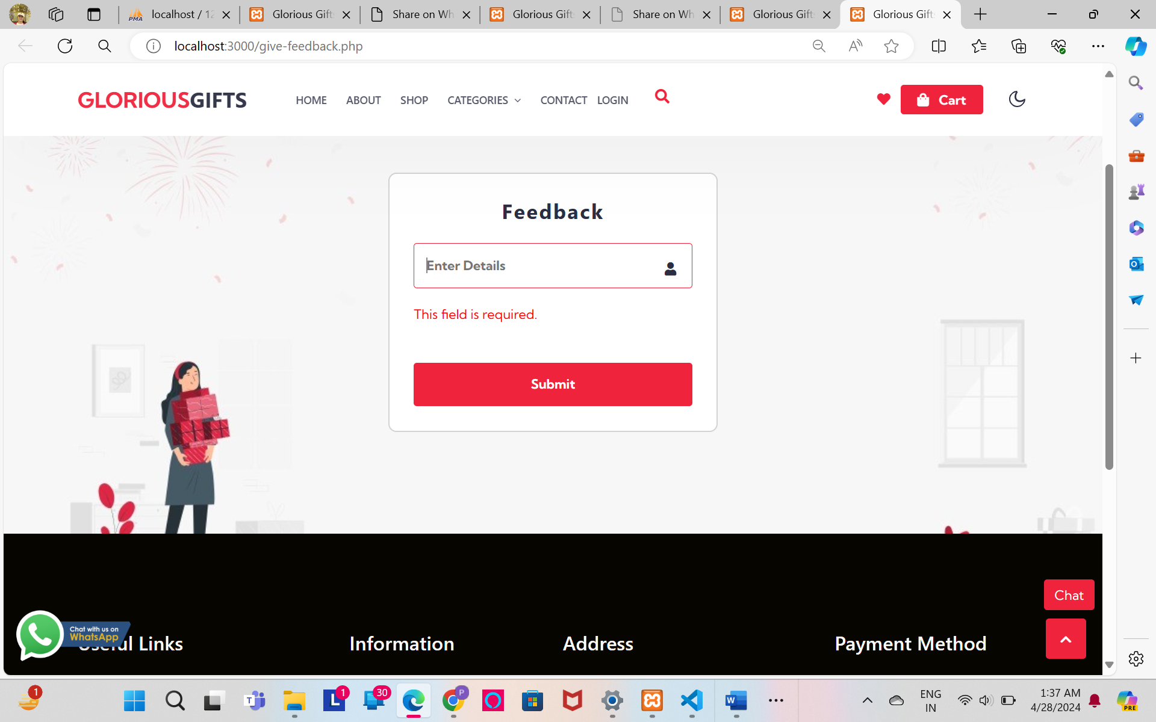

* Order Status

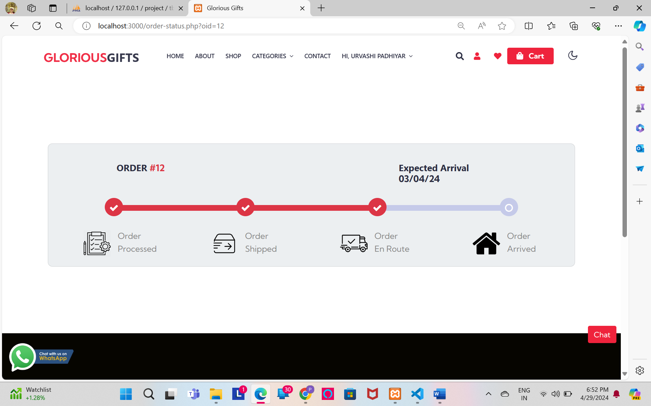

* Wishlist

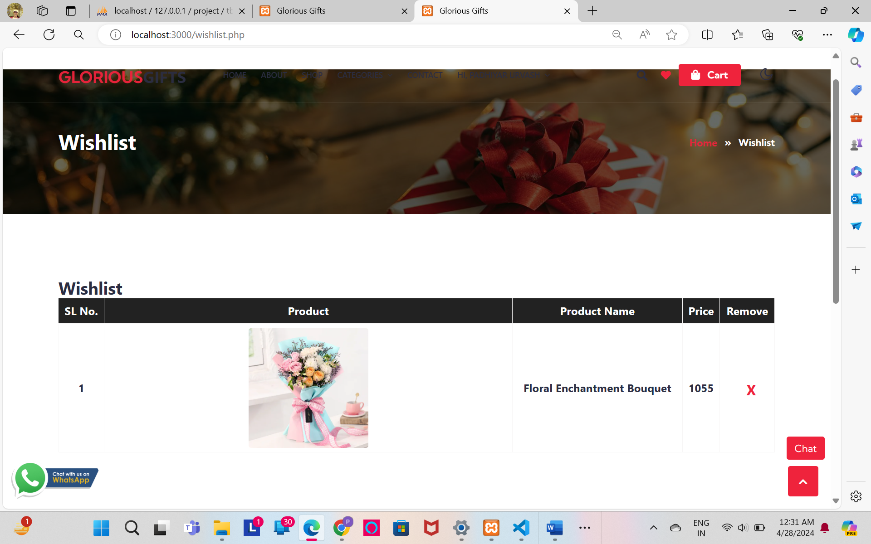

* Invoice

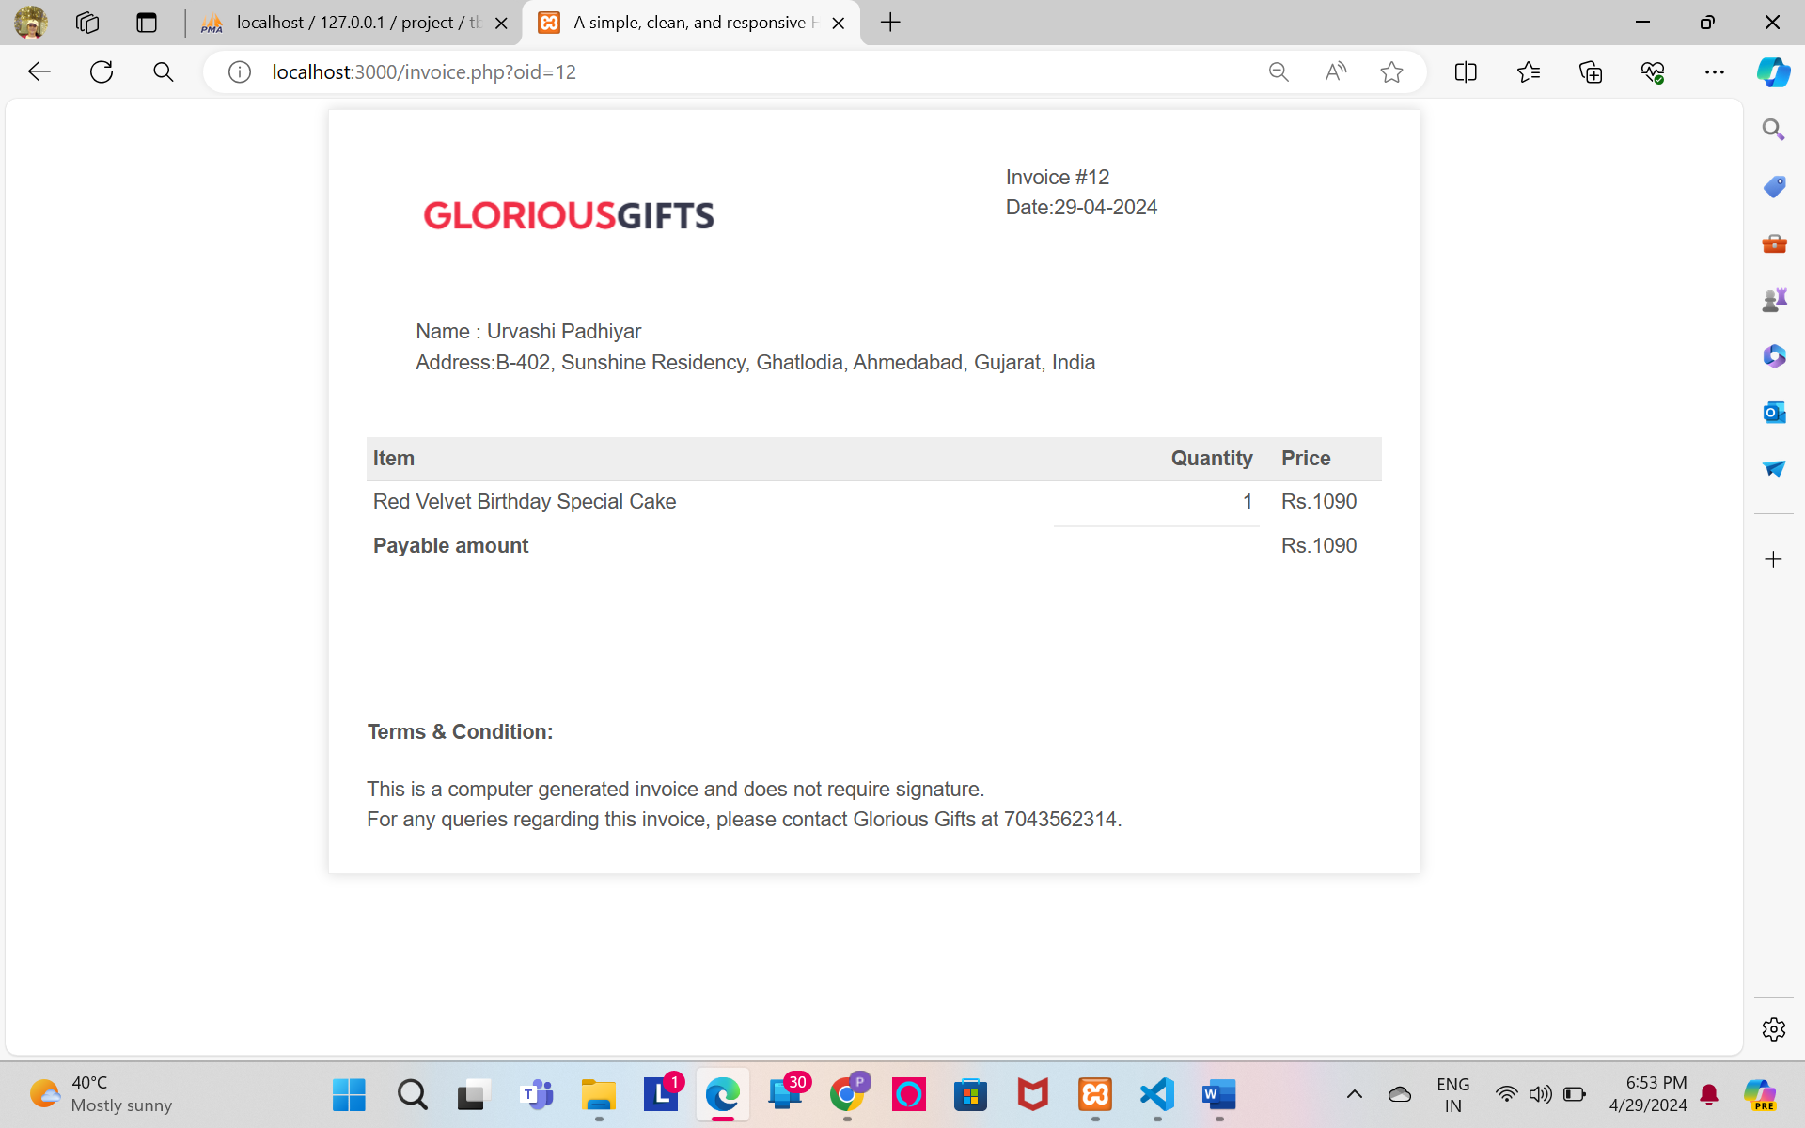

* Suggestion Box

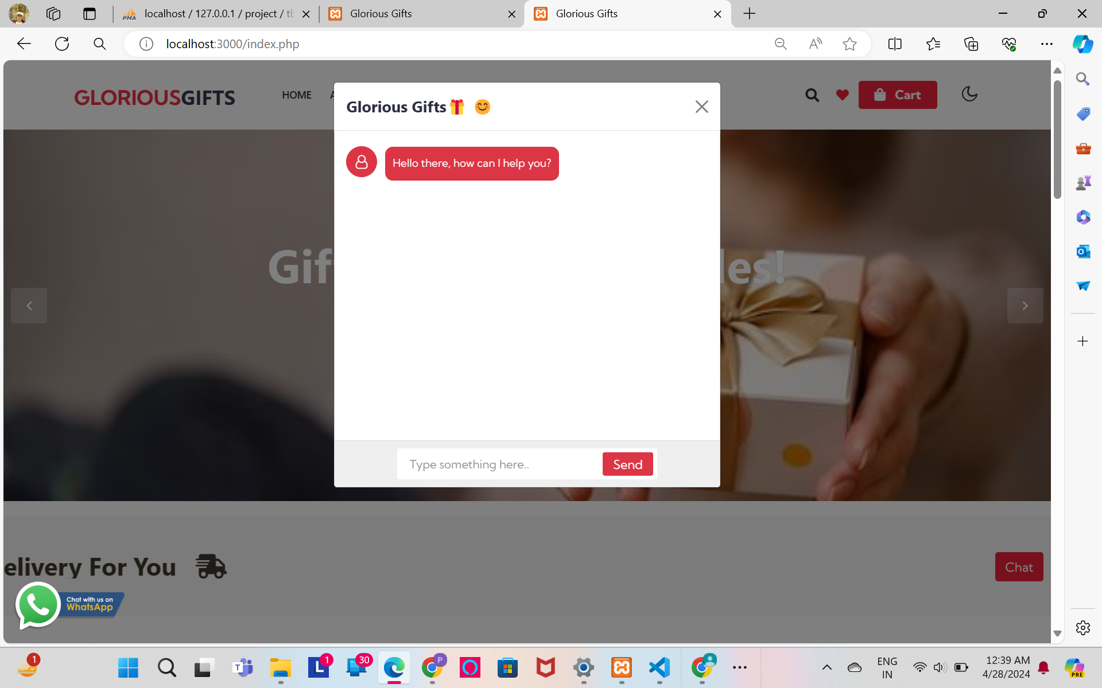

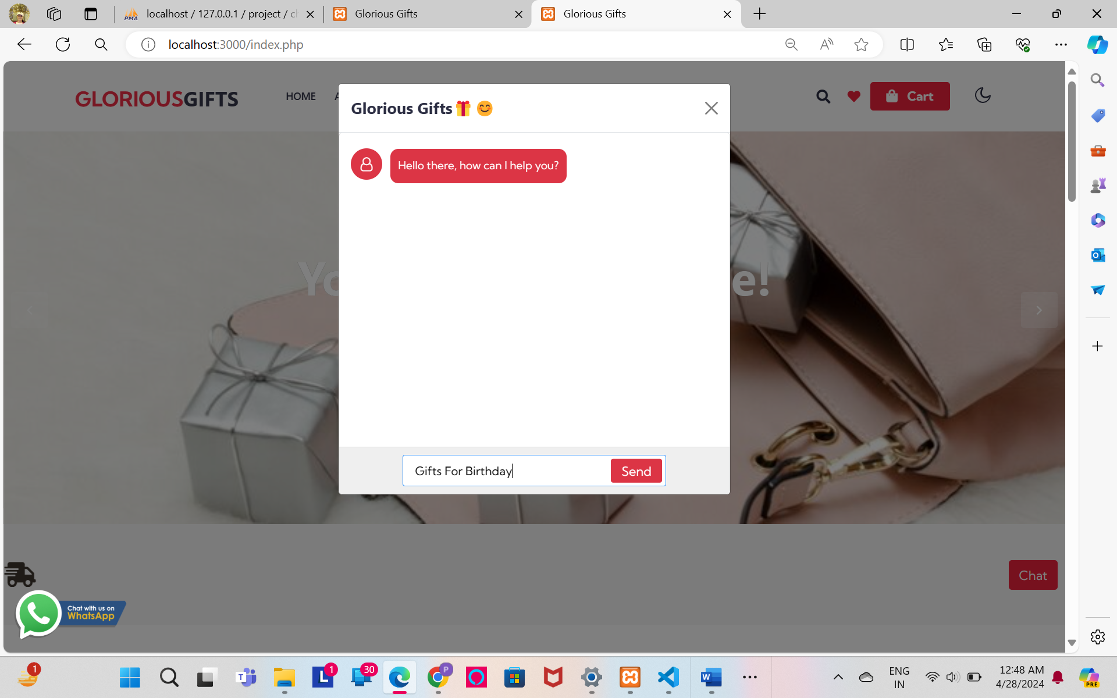

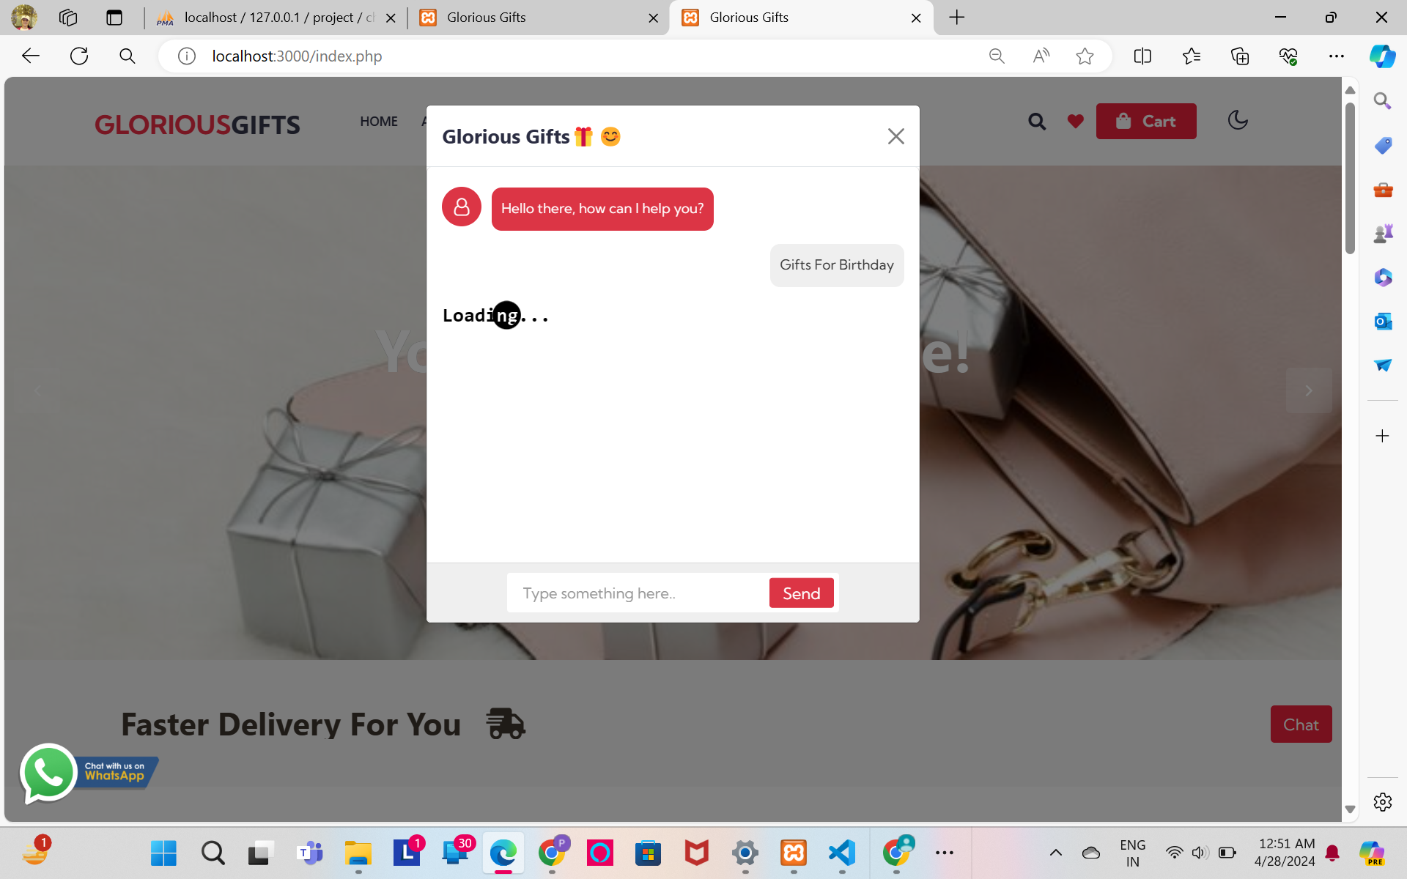

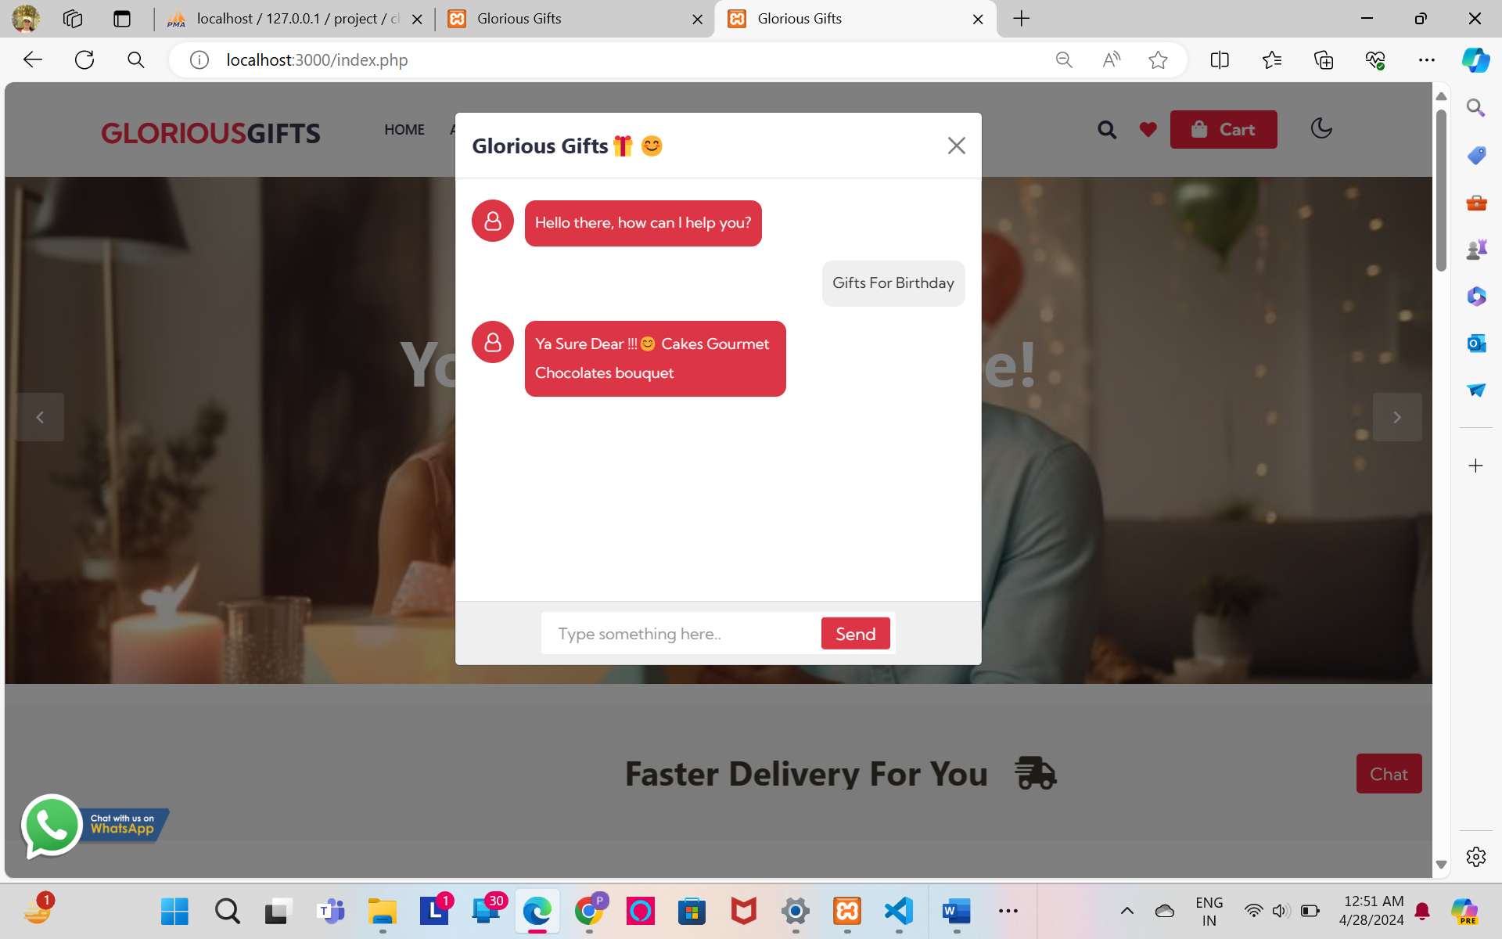

## 

* WhatsApp Conversation

## 

## Chapter 7

## Assumption:

## ▪ We assume that all the features that we are trying to provide for them to make

## their Shopping easy and seamless can be accomplished by using our system.

## ▪ Everyone should remember their email & password while login to the system.

## ▪ User has a primary knowledge of operating computer.

## ▪ User is having proper tools to run this Software/System.

## ▪ User should have basic knowledge of navigation and functionalities inside the

## system.

## Limitation:

## ▪ Customer cannot track the purchasing order.

## ▪ Exchange & return policies are currently not available.

## ▪ Only two Payment Method in System.

## ▪ Providing Service in only limited areas (Ahmedabad).

## ▪ Customer has to buy the product without seeing actually how it looks like The

## images shown in the system can be different from the actual product on the basis

## of color and material, it can feel different in real.

## Future Scope:

## ▪ Customer will track purchasing order.

## ▪ Give more facilities in system

## ▪ Will add more payment methods in System.

## ▪ Provide service in more cities.

## ▪ User can directly chat with representative with different methods.

## Conclusion:

## ▪ We have taken enough care to make the project user friendly and more

## interactive. Major focus is to provide products information, order details,

## payment information easily without any conflicts or any ambiguity.

## Our system give fully satisfaction about the products and you can fully trust on us.

## Bibliography: -

Bibliography are special reference works that are used to identify as many published works on a giving subject as possible, and serve as compilations for other authors or researches.

## References:

Books

* Software Engineering – A practitioner’s Approach -By Roger S.

Pressman

* Analysis and Design of Information Systems -By James A. Senn Website
* [www.w3schools.com](http://www.w3schools.com/)
* [draw.io (diagrams.net)](https://app.diagrams.net/)
* <https://www.igp.com>
* <https://www.winni.in/>
* https://www.amazon.com/